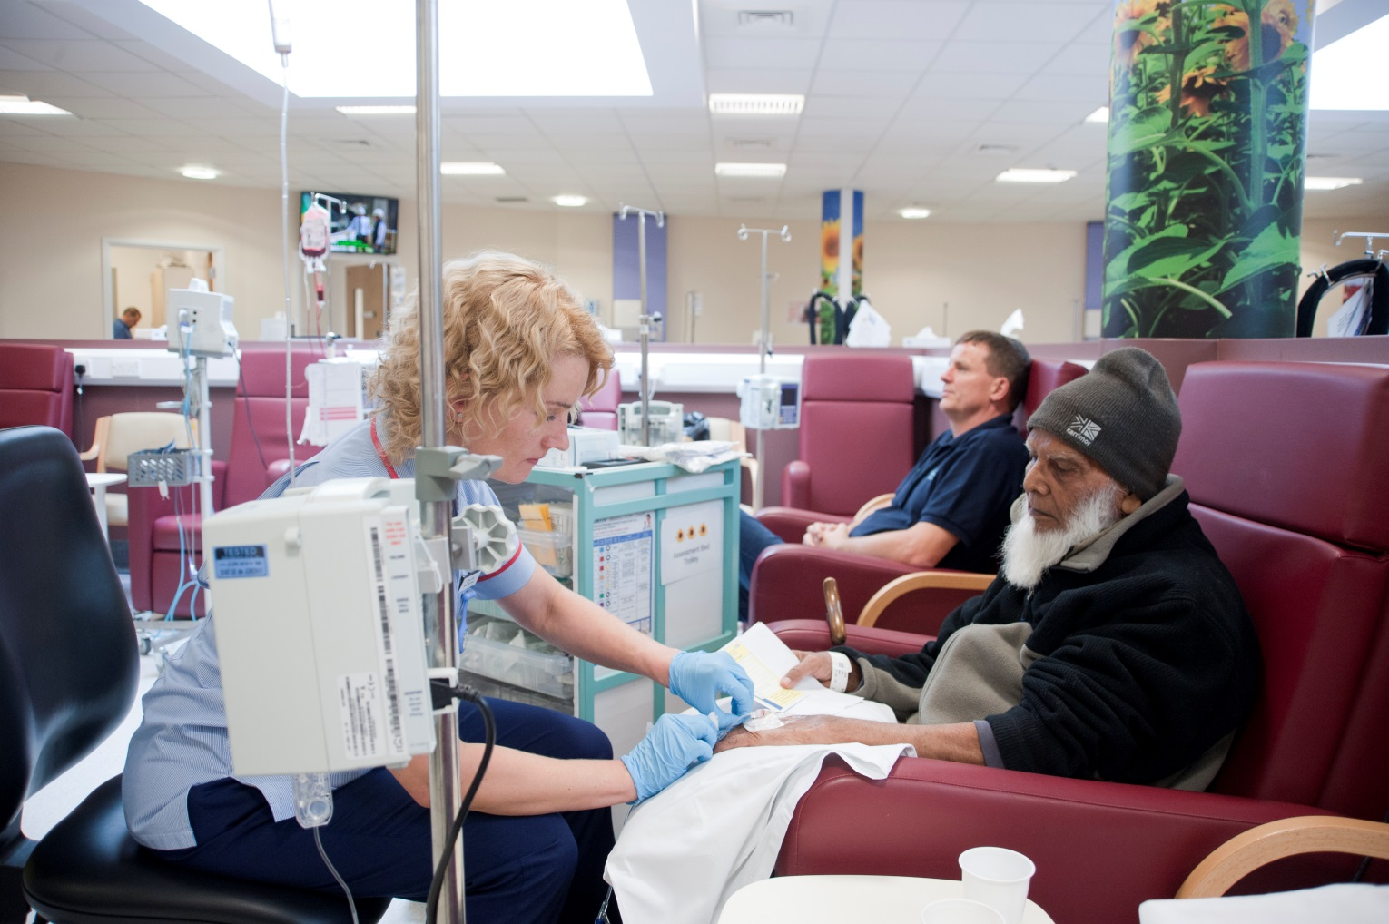
www.bhrhospitals.nhs.uk
@BHR_hospitals
Barking, Havering and Redbridge University Hospitals NHS Trust

IMPROVING OUR CANCER SERVICES

IMPROVING SERVICES FOR OUR PATIENTS
We have one of the busiest adult oncology and haematology departments in the country, and we are proud of the improvements we have made for our cancer patients.
We are constantly looking for new ways to improve the care and experience of our patients, and ensure we are able to meet the increasing demand now and into the future.
So we are changing the way we deliver our services – because it’s important to us that we treat YOU, the whole person.

WHAT ARE WE PLANNING TO DO?

Chemotherapy services
We will deliver all our treatments from our Sunflower Suite at Queen’s Hospital. This will help us to provide an improved service and a better experience as all of our specialist teams and facilities are based here.

Living With and Beyond Cancer hub
We know that patients benefit from having their health and wellbeing needs taken care of at a different location to their clinical treatment.

So we will use the Cedar Centre at King George Hospital as a dedicated Living With and Beyond Cancer hub.

We’ll be running a range of courses to help you, from before you start your treatment, to after it’s finished, alongside a variety of other services.

We’ll still provide some health and wellbeing services at Queen’s Hospital, such as our Macmillan Information Centre and complementary therapies.

WHEN WILL THE CHANGES HAPPEN?
From 12 November, we will deliver all our treatments from Queen’s Hospital. We will open the first phase of our Living With and Beyond Cancer hub at King George in early December.

WHAT WILL CHANGE?
You will still be treated by the same nurses and your treatment will be the same. The only thing that changes is that patients being treated, or planned to be treated, at King George Hospital, will now have their treatment at Queen’s.

WHY DID YOU DECIDE TO DELIVER TREATMENTS AT QUEEN’S AND NOT KING GEORGE?
Currently, all of our patients are treated at the best location depending on their treatment needs, and not by postcode.

We treat most of our patients at Queen’s as they have more complex needs - this is where our specialist medical teams are based, as well as our inpatient and outpatient facilities, Radiotherapy Centre and clinical trials unit.
Therefore the best option for patients is to centralise services there.

WHAT ARE THE BENEFITS?
By centralising our services we can use our resources as efficiently as possible.

This means we can reduce delays in waiting for treatment. At the moment, our Pharmacy team have to make up the drugs at Queen’s and transport them to King George. This can lead to delays for patients at both hospitals. It also means we can fill additional prescriptions if needed while you’re with us.

As our Pharmacy team won’t have to make up treatments for King George at the beginning of each day, we can start treatment earlier at Queen’s, from 8.30am instead of 10am, giving us plenty of additional capacity.

And because we operate longer opening hours at the Sunflower Suite, we are able to offer you a wider choice of suitable appointments. At the moment we operate 8am to 8pm Monday to Friday, and 9am to 5pm on Saturdays. We also have the option of opening on a Sunday if demand requires it.

Other benefits include our new Living With and Beyond Cancer hub, which we can now provide from the Cedar Centre. We’ll be looking for ways to develop the hub as we go along so we’d love you to share your ideas of what you’d like to see offered.

WHAT ABOUT PARKING?
We have a dedicated car park for our cancer patients close to Sunflower Suite. It is free to park when you attend Sunflower for your treatment.
There are also public transport routes serving both hospitals. You can find out more on our website - www.bhrhospitals.nhs.uk/plan-your-journey.

We will continue to provide patient transport for anyone who is assessed as needing it.

GET IN TOUCH
If you have any questions or concerns please get in touch with one of the team:

Jodi Brooking, Team Leader or
Karla Cheeseman, Senior Sister on 01708 435 285
or
Fiona Kenton, Matron on 01708 435 000 ext 6839.

Alternatively please email your questions and share your ideas for our Living With and Beyond Cancer hub to cancerservices@nhs.net.

