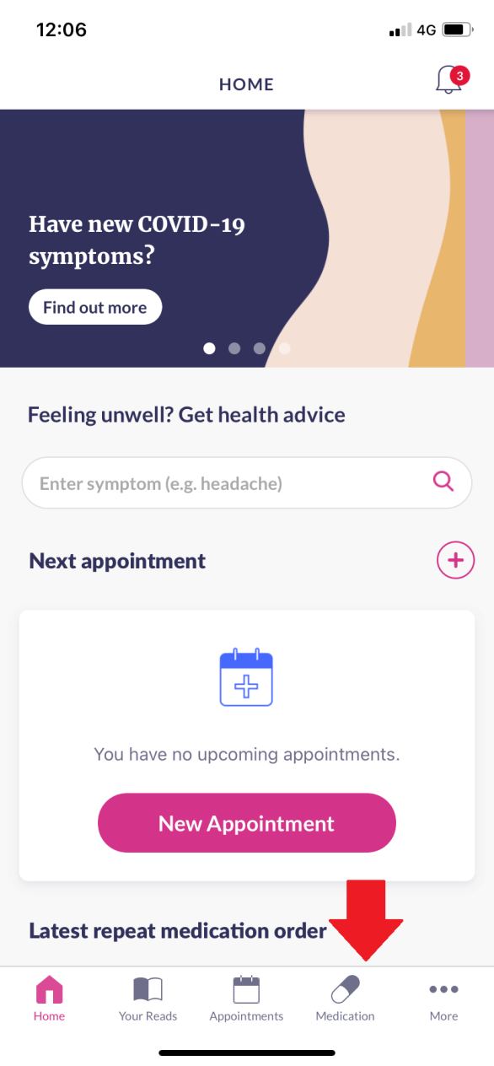 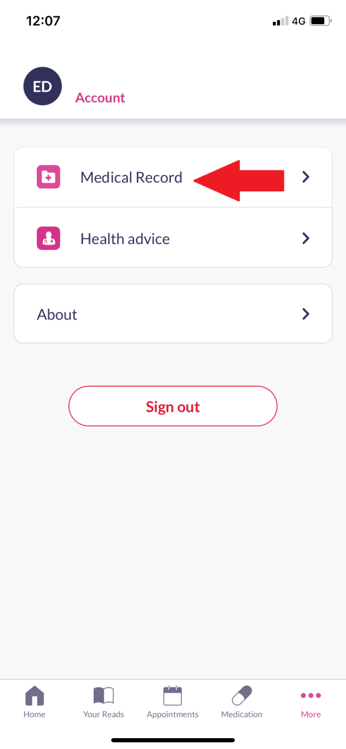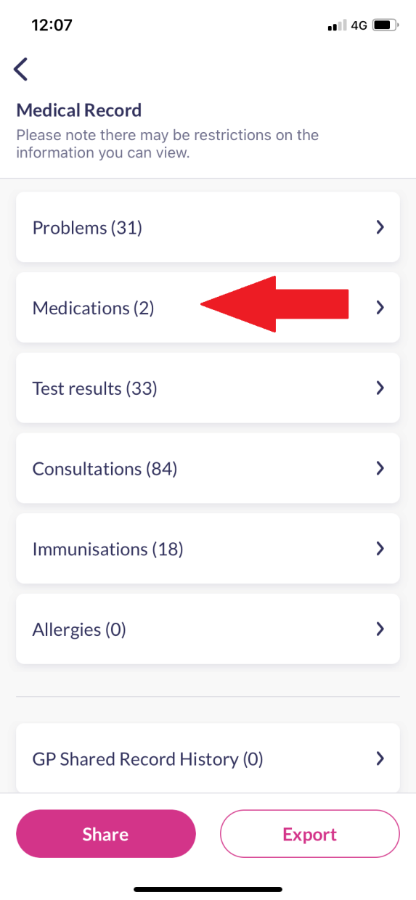

Then click on ‘Medications’ where you will be able to see your covid vaccinations

Then click on ‘Medical Record’

Once you are logged into the app, click on ‘Medication’