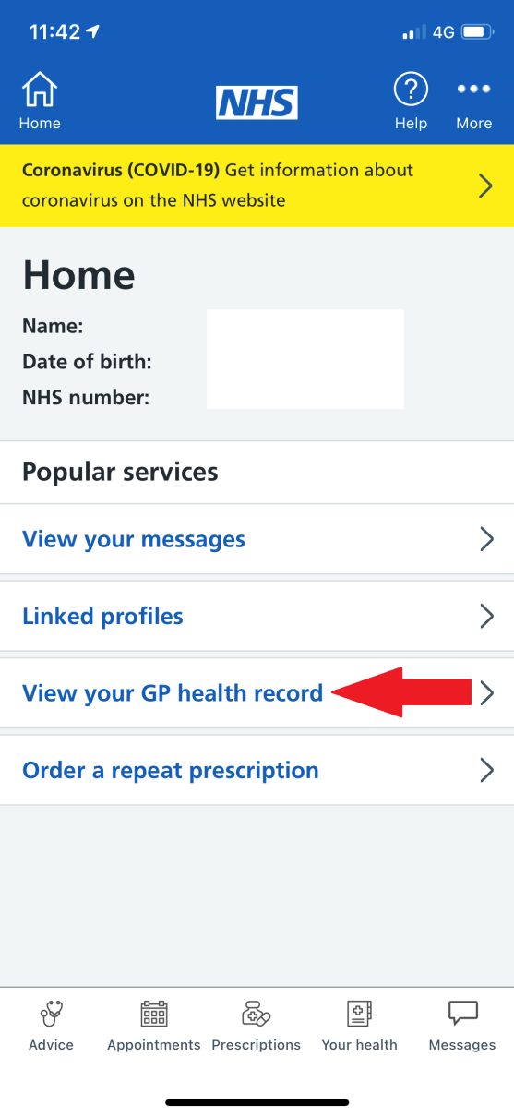 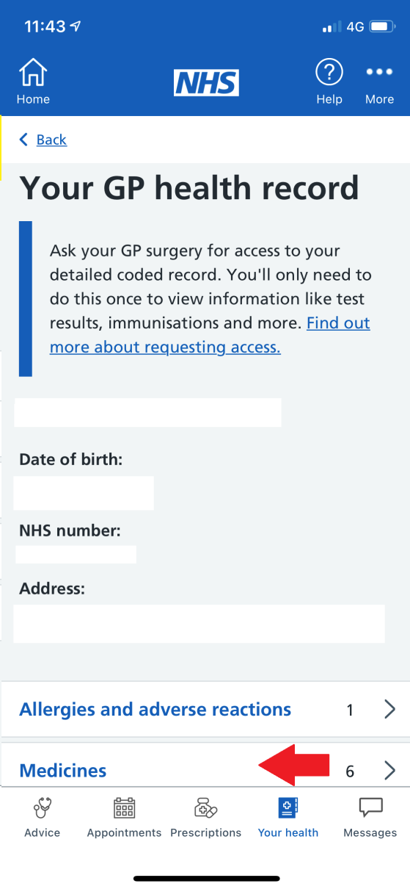 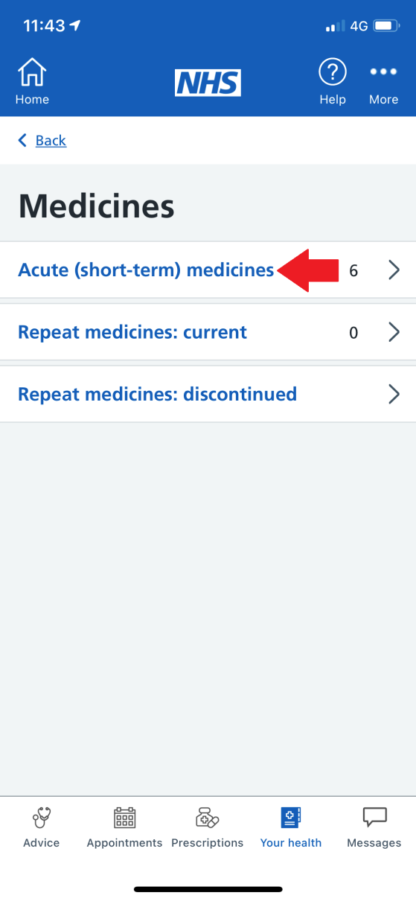

Then click on “Acute (short-term) medicines) and it will display your covid vaccinations (alongside other medicines you have been given)

Then click on “Medicines”

Click on “View your GP health record”