Apps for Children’s Health

Baby and child first aid app (Free)
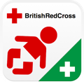
This free app provides simple, easy-to-learn skills to help a baby or child in a first aid emergency.
It is packed with useful tips, animations and video clips. You can test your knowledge using the app’s built-in first aid quizzes. There is also a handy device to record your child's medication needs and any allergies.
The information you need is all hosted on the app itself, meaning no internet connection is needed, making it fast and easy to access.
Download from Google Play or Download from Apple Store

HANDi Paediatric App (Free)

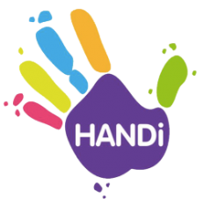
The HANDi Paediatric App is a new app that has been launched across Bristol, South Gloucestershire and North Somerset to provide advice and support to parents and carers if their children have symptoms of common childhood illnesses. The HANDi App offers simple and straightforward advice on what to do and who to contact when a child is unwell. It includes illness-specific home assessment guidelines for six common childhood illnesses:
- Diarrhoea and vomiting
- High temperature
- Chesty baby (Bronchiolitis)
- Chesty child (Wheeze and Asthma)
- Abdominal pain
- Common newborn problems
Download from Google Play or Download from Apple Store

Rafi-Tone (Free)
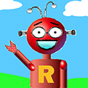
The Rafi-Tone app is designed to make using an inhaler with a spacer easier and more fun for young children with wheeze or asthma symptoms. With guidance from Rafi Robot, the app's star, your child can improve their breathing technique.

Download from Google Play or Download from Apple Store

