Fleetwood embraces mental health care services for children

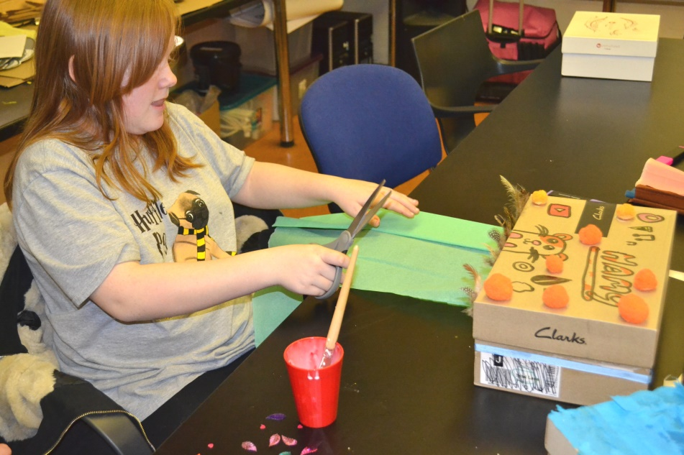

Fleetwood children have access to mental health support in their local community thanks to a dedicated group of professionals.
The Casher team from Blackpool Victoria Hospital is made up of mental health nurses, CAMHS practitioners, safeguarding nurses, paediatric nurses, health visitors and school nurses, who specialise in supporting people between the ages of 11 to 25, but prioritises those under 16.
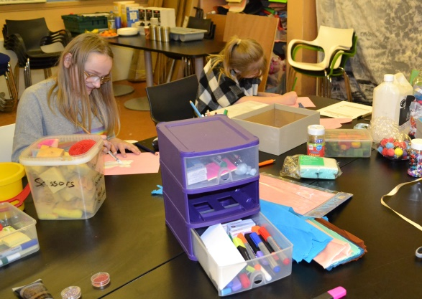
The team have recently set up a weekly group at ‘The Zone’ at Milton Street, Fleetwood, to provide young people with the opportunity to talk to a mental health care professional and to take part in group activities.
The ‘Reach Out Group’ is a drop in session for people aged 10-16, allowing young people and their parents the flexibility to turn up from any time between 6.30-8.30pm each Wednesday.
This is an opportunity for young people to take part in group work looking at mental health coping strategies and they can also speak to a professional about their mental health to gain advice.
John Stainton, Casher Team Leader, explained: “We have set up this group to give young people an opportunity to talk to professionals about their mental health wellbeing in a safe environment away from the hospital.
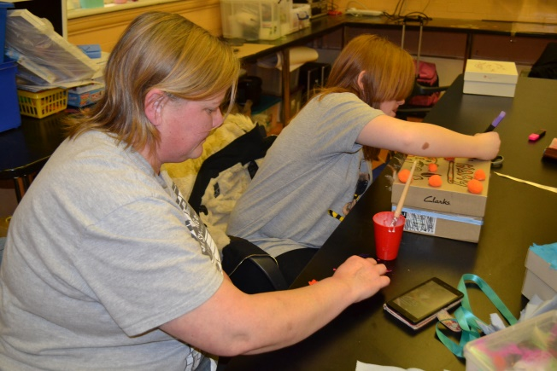
“We offer a non-judgemental service and a chance for young people to gain advice, support and guidance. We are also able to refer people to the relevant services for them to have counselling support from CAHMS or YoutherapY.
“We want young people and their parents to know they have access to support if they know of a young person feeling low, anxious, angry, wanting to talk to someone- and in some cases- if they are thinking of self-harming or have suicidal thoughts.
“Aside from the 1:1 sessions, we also encourage young people to engage with the group activities to discuss coping strategies and feelings for them to build on self-esteem.
“We are in the early stages of the group so far, but the feedback has been really positive and our young people are benefitting from having this drop in service.”

The Reach out Group is every Wednesday at ‘The Zone’, Milton Street, Fleetwood.
For more information, please contact John Stainton in the team. John.Stainton@nhs.net

