Welcome to our newsletter
PPG - Patient Participation Group: PPG is a NHS initiative which aims to:
- Improve communications between the Practice & Patients.
- Feedback suggestions for improvement to services
- Promote health education
- Develop a better understanding of the systems used in the Practice

Covid-19 is a highly infectious virus and the pandemic continues to afflict members of the community, across all age groups, especially people with underlying health issues. As a result the GPs provide telephone and video consultations, when appropriate. Patients are advised to call before coming to the Practice and are expected to wear their masks whenever they enter the building.

CORONAVIRUS (COVID-19): The main symptoms are a high temperature, a new, continuous cough and a loss or change to sense of smell or taste.

Key recommendations to stop the spread of coronavirus (COVID-19) spreading:

HANDS: Wash your hands regularly for at least 20 seconds. Use hand sanitiser gel if soap and water are not available. Wash your hands as soon as you get home;
FACE Mask: wear a mask or something that covers your nose and mouth, when it is hard to stay away from people, such as in shops or on public transport; Cover your face in enclosed spaces, especially where social distancing may be difficult and where you will come into contact with people you do not normally meet.
Space - Stay at least 2 metres (3 steps) away from anyone you do not live with or anyone not in your support bubble.
Cover your mouth and nose with a tissue or your sleeve (not your hands) when you cough or sneeze;
Put used tissues in the bin immediately and wash your hands afterwards;
Do not touch your eyes, nose or mouth if your hands are not clean.
Mask Exception:
If for any reason you do not want to wear masks, please go to the government website (www.gov.uk) to print an exemption letter. Patients do not need a GP to provide them an exemption letter for not wearing a mask.
Grove Road Surgery will be sending All medications to your nominated pharmacy. If your medicines are about to finish, call your pharmacists to order or send us an email on ikwueke.grovesurgery@nhs.net
Grove Road Surgery’s Social Prescriber, Gerald, will be calling vulnerable patients to check on their wellbeing and provide appropriate needed support.
.

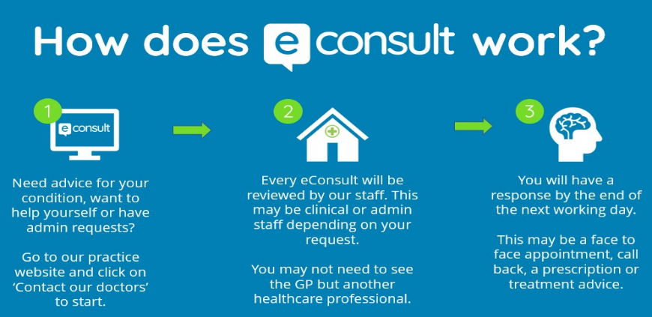

NEW INNOVATIONS:

Clinical Pharmacist: Two Pharmacists now works in the Surgery to provide extra help to patients in managing their medications. If you need advice about your medication please phone to book an appointment.

Social Prescriber: Do you need advice on matters that affect your well-being e.g. Mental health, loneliness…? Book an appointment to speak to Gerald, who is here on Tuesdays, to give advice and support on a variety of issues.

