Welcome to our first newsletter
PPG - Patient Participation Group: PPG is a NHS initiative which aims to:
- Improve communications between the Practice & Patients.
- Feedback suggestions for improvement to services
- Promote health education
- Develop a better understanding of the systems used in the Practice
Our next meeting is on Saturday 13th June at 10:00am. Come and join us!

CORONAVIRUS (COVID-19): The Public Health Department of the NHS advises that if you have flu-like symptoms:
- Do not go to the Surgery
- Stay indoors and keep the windows closed
- Phone 111 for advice
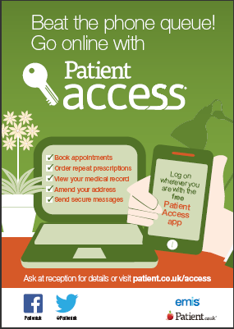
DNA (Did Not Attend): Missed appointments deprive other very ill patients getting the attention they need. It is very important to inform the surgery if you cannot keep an appointment.
PLEASE HELP US BY CANCELLING APPOINTMENTS AS SOON AS YOU KNOW YOU ARE UNABLE TO ATTEND.
NEW INNOVATIONS:
Clinical Pharmacist: A Pharmacist now works in the Surgery to provide extra help to patients in managing their medications. If you need advice about your medication please phone to book an appointment.

Social Prescriber: Do you need advice on matters that affect your well-being e.g. Mental health, loneliness…? Book an appointment to speak to Gerald, who is here on Tuesdays, to give advice and support on a variety of issues.

