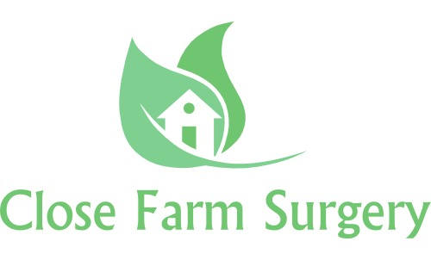

**How do I access my records?**

Remember we told you about the GDPR? Well, if you want to see what is written about you, you have a right to access the information we hold about you, but you will need to complete a Subject Access Request (SAR). Your parents or adults with parental responsibility will do this on your behalf if you’re under 16. But if you are over 12, you may be classed as being competent and you may be able to do this yourself.



**What do I do if I have a question?**

If you have any questions, ask a member of the surgery team or your parents or adults with parental responsibility. You can:

1. Contact the practice’s data controller via email at close.farm@nhs.net. GP practices are data controllers for the data they hold about their patients
2. Write to the data controller at our address on the front of this leaflet
3. Ask to speak to the Practice Manager, Robyn Jackson, or the data protection officer, Jennifer Lumsden

**What to do if you’re not happy about how we manage your information**

We really want to make sure you’re happy, but we understand that sometimes things can go wrong. If you or your parents or adults with parental responsibility are unhappy with any part of our data-processing methods, you can complain. For more information, visit ico.org.uk and select ‘Raising a concern’.

We always make sure the information we give you is up to date. Any updates will be published on our website, in our newsletter and leaflets, and on our posters. This policy will be reviewed regularly.

**Privacy Information Leaflet for Children and Young People**

**Close Farm Surgery**

**47 Victoria Road, North Common, Bristol, BS30 5JZ**

**0117 9322 108**

**www.closefarmsurgery.co.uk**

Another great question! Your data is collected for the purpose of providing direct patient care; however, we can disclose this information if it is required by law, if you give consent or if it is justified in the public interest. The practice may be requested to support research; however, we will always gain your consent before sharing your information with medical research databases such as the Clinical Practice Research Datalink and QResearch or others when the law allows. We hold your Patient data under a duty of confidence. We generally operate on the basis of *implied consent* to use patient data for the purposes of **direct care**. This does not change under the new GDPR Regulations. We may also have to share your information, subject to strict agreements on how it will be used, with other relevant organisations. Further information on who we share with is available in our Practice Privacy Notice (available on request).

**How do we keep your information private?**

Well, your doctor’s surgery knows that it is very important to protect the information we have about you. We make sure we follow the rules that are written in the GDPR and other important rule books.

**What if I’ve got a long-term medical problem?**

If you have a long-term medical problem then we know it is important to make sure your information is shared with other healthcare workers to help them help you, making sure you get the care you need when you need it!

**Don’t want to share?**

All of our patients, no matter what their age, can say that they don’t want to share their information. If you’re under 16 this is something which your parents or adults with parental responsibility will have to decide. They can get more information from a member of staff at the surgery, who can also explain what this means to you.

**How do we use your information?**

**What is a privacy notice?**

A privacy notice helps your doctor’s surgery tell you how it uses information it has about you, like your name, address, date of birth and all of the notes the doctor or nurse makes about you in your healthcare record.

**Why do we need one?**

Your doctor’s surgery needs a privacy notice to make sure it meets the legal requirements which are written in a new document called the General Data Protection Regulations (or GDPR for short).

**What is the GDPR?**

What a great question! The GDPR is a new document that helps your doctor’s surgery keep the information about you secure. It’s new and will be introduced on the 25th May 2018, making sure that your doctor, nurse and any other staff at the practice follow the rules and keep your information safe.

**How do you know about our privacy notice?**

At your surgery, we have leaflets to give to children and adults and we also have lots of information about privacy on our website, telling you how we use the information we have about you.

**What information do we collect about you?**

Don’t worry; we only collect the information we need to help us keep you healthy – such as your name, address, information about your parents or guardians, records of appointments, visits, telephone calls, your health record, treatment and medicines, test results, X-rays and any other information to enable us to care for you.