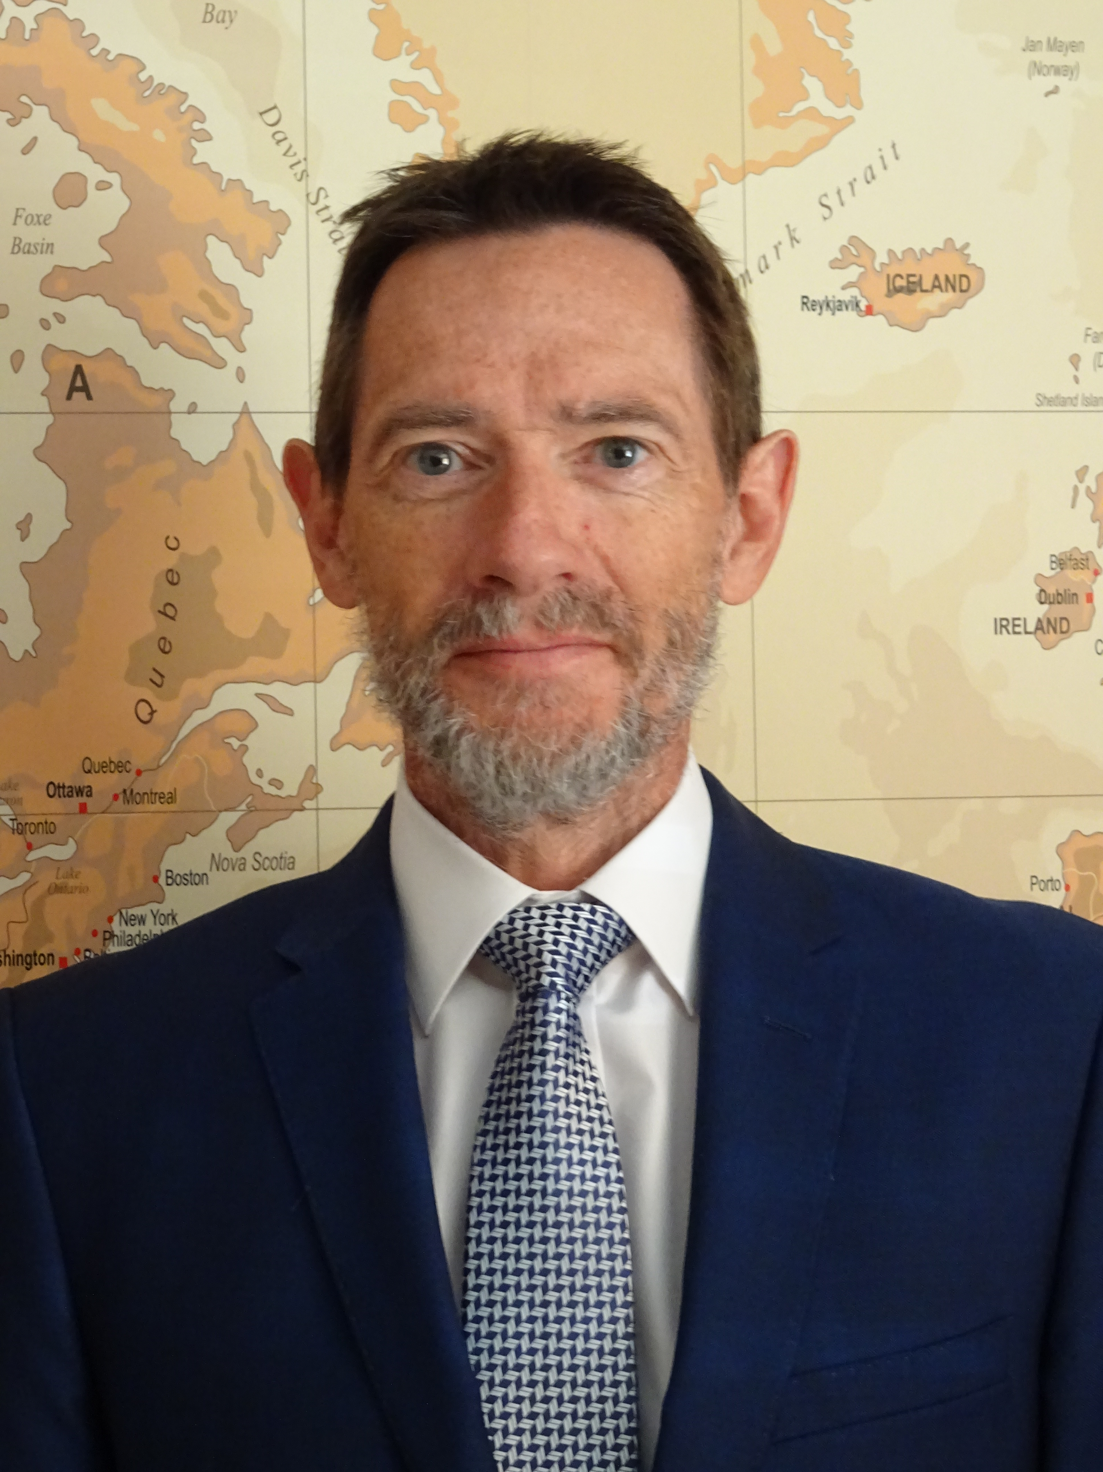
A New Course … A Change of Tack

Several months ago, in my last Newsletter to patients, I commented that it was urgently necessary to address the work-related stress, particularly around lone-working, if we were not to see doctors leaving or becoming ill. Since then, the closure of routine GP clinics at Forton Medical Centre has allowed us to spread the available GPs across three surgery sites instead of four and freed up space for the expansion of chronic disease clinics at Forton.

As some of you are aware, I have been off work since early April. The recent changes at Forton came too late for me, and I became overwhelmed by stress due to the steadily increasing workload and pressure of work, which I have tried to meet by working longer and longer hours, to the detriment of myself and my family’s lives.

I am returning to work on 30th July, with a phased return, aiming to return to full time working, four days a week.

While away, I have been giving my future a great deal of thought. I have come to the conclusion that the time has come for me to step aside from regular GP work, and to make a fresh start, doing something completely different. For several years, I have dreamed of doing a course at the International Boatbuilding Training College (based in Portsmouth’s Historic Dockyard) after I retired. In the last year or two, I have thought more and more about this, and I have now decided to take the plunge, and start a full-time one-year course at the IBTC in March next year. Readers of my previous newsletters will recall their nautical metaphors and appreciate their relevance now!

It has not been easy to make this decision, and I am not doing so lightly. I still feel a strong loyalty to you, my patients, to the Practice, and to all those with whom I have enjoyed working. However, I have come to recognise the importance of being able to have a healthy, happy work-life balance, which has been lacking in recent years. This move gives me the opportunity to do something I have long wanted to do and to enjoy more time with my wife, our children, and our rascal of a grandson.

The decision to retire earlier than planned is more of a positive life choice, an investment in my future and that of my family, rather than just an escape from the pressures of General Practice. I am hugely grateful for all the support I have received from all of my colleagues in the Practice and, indeed, from Southern Health NHS Foundation Trust, who have stepped in and supported General Practice in Gosport when it was at risk of collapse.

As I said in my Newsletter two years ago, ‘Primary Care Teams feel a huge sense of responsibility and loyalty to their patients and the local population.’ In the Willow Group, we continue to strive to maintain and develop the services you receive. A lot has been achieved, and we are really determined to make the necessary changes required to improve the services we provide. I am proud of the team that I work with – they are hugely committed to you and each other.

I am extremely grateful for all the support that you have given to me and my colleagues over the years, especially in the more difficult recent years. Thank you in particular for all the kind messages that I have received while away from the Practice in the last few months.

Very best wishes,

Stuart Morgan

Dr. SRE Morgan
Lead GP
The Willow Group

