OHP EASY READ PRIVACY NOTICE

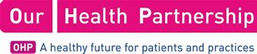 | Who are OHP?
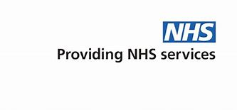 | Our Health Partnership is a super partnership of GP’s providing NHS primary care services and this Practice is also a part of the organisation.
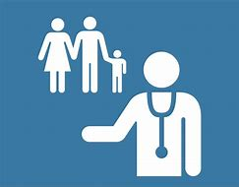 | We help people with their health and social care.
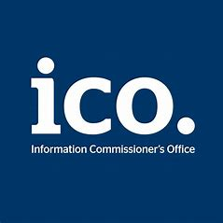 | We are registered with the Information Commissioner’s Office (ICO) to use information about the people we work with under the UK Data Protection Act 2018 and our registration number is Z9977843
Read more about OHP here:

https://ourhealthpartnership.com

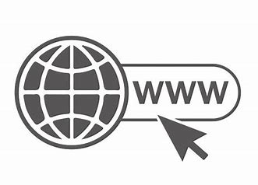 | For information on all our services please visit our website. Here is the link: https://www.ourhealthpartnership.com  www.bordesleygreensurgery.com
 | Why do we collect personal information about you?
 | Personal Information is information about you or other people
 | We need to keep information about your health, treatment and care.
 | This is so we can give you good treatment and care.
 | Read about the ways we keep personal information:
 | On paper and in a file
 | In an electronic patient record system
 | We process personal information for the provision of “health and Social care treatment to include the management of health and social care systems and services”. This is a “Public Task” as set down in UK Law.
 | You can read more about the UK Data Protection Act 2018 by clicking this link http://www.legislation.gov.uk/
 | What personal information do we need to collect about you?
 | We need some information to make you a health and social care record
 | Read more about what information we need
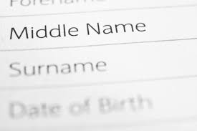 | Your name
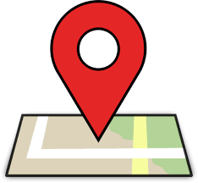 | Your address
 | Your telephone number
 | Your date of birth
 | Your ethnic origin
 | Contact details of your family and carers
 | We might also keep information about:
 | If you are married
 | Your job
 | Your religion
 | Your email address if you have one
 | Where you were born
 | If you are using the NHS as an overseas visitor
 | What you would like to be called
 | We might also keep information about you which is sensitive. For example:
 | Notes about your health, treatment and care.
 | you have a protection order that affects your health, wellbeing and human rights (safeguarding status)
 | It is important for us to have lots of information about you so that we can help you in the best way.
 | Where do we get information about you?
 | From you
 | From your previous GP (if you have one)
 | From hospital
 | How do we use your personal information?
 | We use it to make sure all the people involved in your care know what treatment you are getting.
 | We won’t tell people your name unless we really have to.
 | Read about how we might also use your information.
 | We give your information to other people who are treating you.
 | To remind you about your appointments
 | To review our service to make it better
 | To share your information with the people who are paying for your care. These people are called commissioners.
 | To send reports to organisations such as the Department of Health
 | To train healthcare staff
 | If there is a complaint
 | If the law says we need to report something that has happened.
 | Who do we share information with and why?
 | We need to tell you how personal information will be used. We need to have a legal reason for using your information without asking you first.
 | We might need to give your information to other organisations.
 | Read about why this is.
 | We might share personal information with other NHS Organisations to help them give you healthcare. This would be NHS England, Public Health England and other NHS Trusts, General Practitioners (GPs), Ambulance Services, Primary Care Agencies. This may also include those other organisations that help the NHS to look after your health.
 | We might share personal information with organisations like Social Services or private care homes to help them give you support.
 | Sometimes special permission will be given to use information that uses your name without your consent. This may be for medical research or checking quality of care. This permission is given by the Secretary of State for Health on advice from the National Information Governance Board for Health and Social Care under strict conditions.
 | Sometimes, we might need to share your information because it is the law. We will tell you when we do this.
 | Read about why this is.
 | To find out if fraud is happening.
 | If there is a court order.
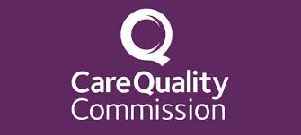 | If the Care Quality Commission need it for an inspection.
 | If the Police need to investigate a crime.
 | How do we keep personal information that is part of a health or social care record?
 | Personal information is kept in paper and electronic format. (This is in line with the NHS Records Management Code of Practice for Health and Social Care 2016 and National Archives Requirements)
 | The law tells us how to keep your information. These laws include the Data Protection Act 2018, the GDPR 2016, and the Common Law Duty of Confidentiality.
 | We keep information about you for as long as we need to do make your health better
 | You can find out more using this link (NHS Record Management code of practice) https://digital.nhs.uk/article/1202/Records-Management-Code-of-Practice-for-Healthand-Social-Care-2016
 | Read more about this.
We have to:
Maintain full and accurate records of the care we give you.

Keep records about you confidential and secure.
We will make sure we keep your information safe, using computer passwords for electronic information, and locks for paper information.
 | Give you information in a format that is accessible to you.
 | What are your rights?
 | You can ask to see the information we have about you
 | You can ask us to change any information that is wrong
 | You can tell us not to share your personal information (unless we need to because of the law)
 | You can ask us to give the records we have about you to another organisation.
 | For more information you can contact the Practice Manager or Data Protection officer: [INSERT DETAILS]
If you are not happy with how we use your personal information you can contact the
Information Commissioner’s Office.
https://ico.org.uk .

Information Commissioner’s Office, Wycliffe House, Water Lane, Wilmslow, Cheshire, SK9 5AF
Tel: 0303 123 1113 (local rate) or 01625 545 745 if you prefer to use a national rate number

Fax: 01625 524 510
Email: casework@ico.org.uk

