BORDESLEY GREEN SURGERY

143-145, BORDESLEY GREEN
BIRMINGHAM
B9 5EG

TELEPHONE: (0121) 766-1335

WELCOME
Bordesley Green Surgery is a long-established, family friendly practice. Our aim is to provide the highest standard of care that is comprehensive, holistic and responsive to you as an individual, in a convenient local setting.

Our dedicated small team are here to help in all phases of your life offering health promotion and disease prevention clinics as well as treating your illnesses, providing management for long term conditions and keeping you well. We aim to do this with honesty and integrity, involving you in decisions about your care in an environment conducive to wellbeing for both you and staff alike. We provide a full range of NHS health services to the community.

The doctors work in partnership as a practice. Therefore, you do not necessarily have to consult the doctor with whom you are registered. You may wish to see different doctors for different illnesses, but generally it is better for you to follow one problem through with one doctor. Being a small team avoids the problem of ‘always seeing a different doctor.’

We are part of Birmingham Cross City Commissioning Group and work closely with all of the other practices in the group to ensure equity of services across the area.

We are pleased to announce that as of May 2017, we became part of Our Health Partnership.
The premises have been extensively refurbished 2017 greatly improving the facilities to our patients.
Our Practice team consists of two GPs, a Nurse Prescriber, an Assistant Practitioner as well as our Practice Manager, Reception and Administration staff.

THE DOCTORS
DR RM SHAH
MBChB(2005), MRCGP(2010)

DR AS INGUVA
MBBS(2000), MRCGP(2008), DFFP, DRCOG

SURGERY OPENING TIMES
Bordesley Green reception is open Monday to Friday excluding Bank Holidays and occasional staff training days. Patients can telephone (0121) 766-1335 and speak to a receptionist. The surgery operates an extended hours service on Monday.
Monday 9.00am - 7.30pm
Tuesday 9.00am - 6.30pm
Wednesday 9.00am - 6.30pm
Thursday 9.00am - 6.30pm
Friday 9.00am - 6.30pm

APPOINTMENTS
For all same day appointments patients are advised to ring the surgery between 9:00am-10:30am. Outside of this time, only calls for emergency or routine appointments will be taken. Routine appointments may be made in advance (maximum one month).
Urgent cases
We will always see urgent cases on the same day. However, it may not always be possible for this to be with the doctor of your choice or at time of your choice. Please indicate to the receptionist if you require appointment on that day.
Online Appointment Booking System
You can now book GP & Nurse appointments online. You will need to register for online services. You can book future or on the day appointments.
Home Visits
We prefer our patients to come to the surgery. Home visits are generally reserved for patients who are housebound or terminally ill. All visits will be at doctor’s discretion.
In the time taken for the doctor to do one home visit they could see four patients at the surgery. For this reason it is in the doctor’s and the patient’s best interests that, whenever possible, an effort is made to get down to the surgery, where the optimal lighting, environment, equipment and on-site support is available.
We would normally ask children to be brought to the surgery to be examined.
If you need a home visit please telephone before 10:30am, unless a genuine emergency arises. Please tell our receptionist if you need a visit urgently. They will tell the doctor, who will assess the degree of urgency of your call.
When requesting a home visit you will be asked to give your full name, address, date of birth and telephone number along with a few details as to why you are requesting a visit. It is very important to inform the receptionist if you are not staying at your home.
Please note: In all cases the GP will telephone you first to discuss your home visit request and from the information provided, decide what action to take next.
Home visits are NOT available on the grounds of:
- lack of transport or funds to get to the surgery
- not having someone to accompany a patient to the surgery
- needing to wait at home for other deliveries or visitors

Disabled Access
Please advise the receptionists of any problems you might have so that we can be prepared to welcome you and facilitate your consultation.

OUT OF HOURS EMERGENCIES
Please telephone (0121) 766-1335, where a recorded message will inform and direct you to our out-of-hours emergency telephone number.
LOCAL URGENT CARE CENTRE:
Washwood Heath Urgent Care Centre
Clodeshall Road
Washwood Heath
Birmingham
West Midlands
B8 3SN
Tel: 0121 322 4310

TEST RESULTS
Please telephone after 10:30 am when possible as the lines are less busy at that time. The reception staff are trained to pass on test results confidentially after they have been seen by doctor.
REPEAT PRESCRIPTIONS
Patients who are on regular medication do not need to see a doctor to obtain a repeat prescription most of the time. Repeat prescriptions cannot be taken over the telephone for medico-legal reasons, as errors can occur.
Please note Pharmacy cannot order on behalf of you unless agreed in exceptional circumstances by the GP. (This is across Birmingham to reduce medicine wastage - Effect from July 2017)
Please give us 48hours’ notice. We need to know the name, strength, dose and quantity of the drug or drugs you require. You can order prescriptions online.
The surgery has Electronic Prescription Service (EPS). This means if you nominate a local pharmacy who are also signed up for the service, your prescription will be sent electronically straight to the pharmacist without you having a paper prescription.
HOW TO REGISTER
Please bring your medical card to the surgery if possible and proof of ID and an address. If you cannot find it we will give you a form to fill in, but your records will take longer to reach us without your original medical card. All newly registered patients over 18 years of age will be required to see one of the practice nurses for an NHS health check which is a simple medical examination including blood tests, blood pressure, urine testing and height and weight. If you are on regular medication you will need to see a doctor before we can issue a prescription. Please book this appointment before you run low on medication.
CHANGE OF PERSONAL DETAILS
If you change your name, address or telephone number, please let our receptionists know.
PATIENT PARTICIPATION GROUP
We aim to develop an active PPG. This is a group of patients working with the practice to contribute to the continuous improvement of services, help patients take more responsibility of their health, provide practical support and help to implement change. The PPG meet every 3-4 months on a regular basis.
Information can be found on the PPG Noticeboard in the waiting room. Please ask reception how to join the PPG.

PRACTICE SERVICES
Mother and Baby clinics

Child health surveillance development checks at 6-8 weeks are carried out by Dr RM Shah. Childhood Immunisations are administered by the Practice Nurse. Please do not bring unwell children to these clinics.

Antenatal advice & Postnatal checks can be carried out by either Doctor.

Family Planning & Sexual Health services

Comprehensive confidential advice is available for all patients irrespective of age. We offer oral contraceptives, injectable contraception, implants, coils and caps. Dr Inguva fits coils and implants by appointment.
Emergency contraception is prescribed when appropriate. You need to seek advice within 72 hours.
Women’s Health Clinics
Cervical Smears
Our policy is to test every woman aged 25-49 years every three years, and every woman aged 50-64 years every five years, as advised in national guidelines (there are exceptions where the smear will need repeating more often). Cervical smears are mainly done by practice nurses.
Well Woman
The education & health promotion of physical, mental and psychological wellbeing of women. Preconception, pregnancy & menopause care.
Flu and Pneumonia Vaccinations
A nasal flu vaccination is available for children of certain ages and certain risk categories. We recommend a flu & Pneumonia vaccination for all at risk patients in accordance to Department of Health guidelines. Please check with reception to see if you are eligible. Carers are also eligible for flu vaccinations.
Asthma & COPD Clinic
This is run by Practice Nurses. All asthmatics need annual reviews. Patients can self-refer.

Diabetic Clinic & Prediabetes Education Clinic

These are run by Practice Nurses & health professionals in partnership with National Diabetes Prevention Programme.

Coronary Heart Clinic

An opportunity to check blood pressure, arrange blood tests if indicated and discuss lifestyle. If necessary, we do in house ECG for initial assessment of certain type of heart conditions.

Weight Management Clinic

Our nurses are specially trained in weight management and offer individualised personal nutrition & diet advice.

Minor surgery/ Joint injections

Doctors carry out minor surgical procedures i.e. joint injections (some joints only), injections for plantar fasciitis by appointment. Please seek review with doctor.

Patients Over 16 Years of Age

If you have not been seen in the previous three years, you may request a medical check-up with one of our practice nurses.

Over 75 Check
You can book an appointment to see a nurse for an annual check-up at the surgery. If you are housebound, this can be carried out in your home.
NHS New Patient Check
The NHS Health Check is a free check-up of your overall health. It can tell you whether you're at higher risk of getting certain health problems, such as: heart disease, diabetes, kidney disease and stroke, If you're aged 40-74 and you haven't had a stroke, or you don't already have heart disease, diabetes or kidney disease, you should have an NHS Health Check every five years. Patients may ring and book an appointment with the nurse or HCA for this health check. A member of the team may contact you to invite you to attend for this health check if you are aged 40-74 years old and not had in the last 5 years.
We offer all new patient free NHS health check as routine new patient check at time of joining the practice

Travel Immunisations/Vaccinations
Please book an appointment with a Practice Nurse at least six weeks in advance of your holiday.
A charge is applicable for certain immunisations and vaccinations which are not covered by the NHS. A list of these charges is held at reception.
NON-NHS SERVICES
A list of non-NHS medical services and the applicable fees (BMA rates) is available at Reception. Should you require a special examination or report for insurance/driving/ employment purposes/some foreign travel services or for any other reason, this can be arranged through the Reception Team.
SICKNESS CERTIFICATES
You should not require a Doctor’s Certificate for any illness lasting 7 days or less. Your employer may request that you complete a Self- Certificate Form (SC1) and this is available from your employer, the Post Office, the Department of Work and Pensions or the Surgery.
For any illness lasting longer than 7 days you may have to see the Doctor to obtain a Statement of Fitness to Work and sometimes for subsequent renewals.
Should your employer require a Doctor’s statement for a work absence of less than seven calendar days, the Doctors may agree to issue a Private Medical Certificate i.e. a fee will be charged.
CONFIDENTIALITY
The practice makes every effort to safeguard patient confidentiality. Data concerning you, held on computer, is covered by the Data Protection Act. When giving results over the telephone receptionists need to ensure the person on the telephone is the patient concerned. Please help the receptionist to help you. Young people are often concerned that information they give to a doctor may not remain confidential. We would like to reiterate that we keep all information confidential.
ZERO TOLERENCE

We strongly support the NHS policy on zero tolerance. Anyone attending the surgery who abuses the GPs, staff or other patients be it verbally, physically or in any threatening manner whatsoever, will risk removal from the practice list. In extreme cases, we may summon the police to remove offenders from the practice premises.

COMPLAINTS AND SUGGESTIONS
While we constantly strive to provide a good, friendly and efficient service, we realise that occasionally things do not go as smoothly as we would like. If you think that this has happened to you, please contact the assistant practice manager so we can help sort out the problem. You have the right to have assistance with your complaint from an independent advocacy service. You have the choice to complain either directly to the surgery or to NHS England:
NHS England PO Box 16738 Redditch Worcester B98 9PT Tel: 0300 311 2233 Email: england.contactus@nhs.net

You also have the right to ask the Parliamentary Health Service Ombudsman to carry out an independent investigation of your complaint. If you feel you have suffered because you have received poor service or treatment or were not treated properly or fairly, the Parliamentary Health Service Ombudsman may be able to help. Their contact details are: The Parliamentary Health Service Ombudsman Millbank Tower Millbank London SW1P 4QP Helpline: 0345 015 4033 Website: www.ombudsman.org.uk Email: phso.enquiries@ombudsman.org.uk

Suggestions are always welcome either by talking to the assistant practice manager, writing to the surgery or emailing the assistant practice manager at Bg.Surgery@nhs.net.
RESPONSIBILITIES OF THE PATIENT
Please do not be late for an appointment. This may result in Clinician not being able to see you. If you are unable to keep an appointment or delayed, we request that you advise us of this as soon as possible.
If any patient persistently fails to attend booked appointments both with us and secondary care referrals we will contact you, to remind you of your responsibility.
Please be responsible for your and your children’s health by maintaining healthy lifestyles for overall wellbeing and being aware of when medications or tests are due.
Please use the walk in centre, Out of Hours GP or NHS 111 for non-life threatening medical problems. This will reduce the inappropriate use of emergency services like A&E or the Ambulance.
There is an increasing demand for prescriptions for medication that can be bought over the counter at relatively low cost, often for self-limiting or minor conditions. Some have no clear health benefit for patients. These medicines or treatments that are readily available ‘over the counter’ in pharmacies or on the shelves in shops and supermarkets are known as Self Care medicines. They include:
- Treatments for minor ailments, including medicines like paracetamol, ibuprofen, head lice lotion and indigestion tablets.
- Treatments where there is little evidence that they have a real clinical benefit, including cough syrups, nasal congestion sprays, sore throat products and vitamin supplements.
We encourage patients to buy such medications as it is more convenient to get treatment for minor ailments from a local pharmacy or shop, and will also free up valuable GP appointments.
The NHS is for all of us. Protect it.
WAITING TIME

You will be given a time at which the clinician hopes to be able to see you. Reception team will inform you if your wait is more than 30 minutes.

Please do not ask doctors or Nurses to advise on medical issues relating to siblings/ relatives during consultations originally booked for you.

Appointment times for the doctors are normally 10 minutes and Nurses/ HCA are 15-minute appointment slot. If you require more time or wish to consult about more than one problem, then please help us by booking a ‘double appointment’.

MEDICATION REVIEWS

Patients on repeat medication will be asked to see a doctor or practice nurse at least once a year to review these regular medications and notification should appear on your repeat slip. Please ensure that you book an appropriate appointment to avoid unnecessary delays to further prescriptions.
ACCESS TO PATIENT INFORMATION
We respect your right to privacy and keep all your health records confidential and secure.
It is important that the NHS keeps accurate and up-to-date records about your health and treatment so that those treating you can give you the best possible care and advice. This information is only available to those involved in your care and you should never be asked for personal medical information by anybody not involved in your care.
All our records are kept on computer and your rights are also protected by the Data Protection Act 1998. Patients may request access to their medical records under this Act. If you would like to see your medical records, please contact the Practice Manager to make an appointment.
If you require copies from your medical records, the appropriate fee will be payable.
CHAPERONE SERVICE
It is the policy of the practice to respect the privacy, dignity, religious and cultural belies of our patients.
If you feel you would like a chaperone to be present during a physical examination by a doctor or any other health professional, or if you would prefer to be examined by a doctor or health professional of the same sex as yourself, please let us know and we will do our best to comply with your wishes.

INTERPRETER / TRANSLATION SERVICES
The Practice will always try to book an interpreter from a local Interpreting Service for booked appointments with the Doctor or Nurse for patients who do not have sufficient understanding of English to ensure a successful consultation. Please make it clear to the receptionist if you are booking an appointment for someone who will need an interpreter.
CARER
We know that carers are often hidden looking after a family member or helping a friend or neighbour with day-to-day tasks and may not see themselves as a carer. Caring for someone is an important and valuable role in the community, which is often a 24-hour job that can be very demanding and isolating for the carer. Carers should receive appropriate support by way of access to accurate information on a range of topics such as entitlement to benefits and respite care and not least, a listening ear when things get too much.
As a Carer, you are also entitled to have your needs assessed by Adult Care Services. A Carer Assessment is a chance to talk about your needs as a carer and the possible ways help could be given. It also looks at the needs of the person you care for.
There is no charge for an assessment.
Also please ensure that you let us know that you are a carer.

PRACTICE STAFF

Nurse Prescriber: Mrs Z Khatoon
Assistant Practitioner: Mrs S Miah

Our nursing team manage reviews for long term conditions like asthma, COPD, Diabetes whilst also undertake investigations like phlebotomy, spirometry, ECG, ABPM. They are specially trained to offer you weight management & foreign travel advice. Please make appointments through reception.

Practice Manager: Mrs N Sajjad
Role: In charge of the administration of the practice. If you encounter any problems in accessing our services, please contact her.

Secretary & Reception Manager: Ms A. Beard

Role: Any queries on referral letters, hospital appointments or correspondence letters please approach her. She is also in charge of smooth running of the reception. Any issues relating to reception please do not hesitate to contact her.

Receptionists: Mrs T Naseem, Ms K Bi and Ms S Parveen

Community Staff

Community support is through District nurses, health care assistants, social services, health visitors, midwives, community matrons and non-clinical case managers, who work in close liaison with us. From time to time they may access your medical records for safe continuation of care.

USEFUL CONTACTS

Safeguarding Children 0121 303 1888
Other safeguarding agencies
Police - if you think a child is in immediate danger, call 999
NSPCC .3- call the helpline on 0808 800 5000, text 88858 or email help@nspcc.org.uk
STOP IT NOW - call the helpline on 0808 1000 900 or email help@stopitnow.org.uk
Safeguarding Adults 0121 303 1234
Out of hours 0121 766 2100
Child Health Centre 0121 334 0100
Walk in Centre 0121 322 4310
Birmingham Heartlands Hospital 0121 424 2000
Citizen Advice Bureau 03444 77 1010
Age concern 0121 236 2197
Alcohol Anonymous 0845 769 7555
Child Line 0800 1111
Saheli Group 0121 446 6137
The Lateef Project 0121 301-5392 or
(Islamic Counselling) 0121 301-5393
Emergency accommodation 0121 303 2296
National Drugs Helpline 0800 77 6600
Ring and Ride 0121 326 7860
Samaritans 0121 666 6644
Medical Termination 0333 004 6666
Midlands Police 0845 113 5000
Transport - WMAS 01384215555

PRACTICE CATCHMENT AREA

We are open to patients mainly living around 2miles radius from B9 5EG. We mainly cover Washwood Heath, Saltley, Alum Rock, Small Heath, Bordesley Green, Ward End, Yardley, Sparkhill and all adjacent areas.

Map Of Practice

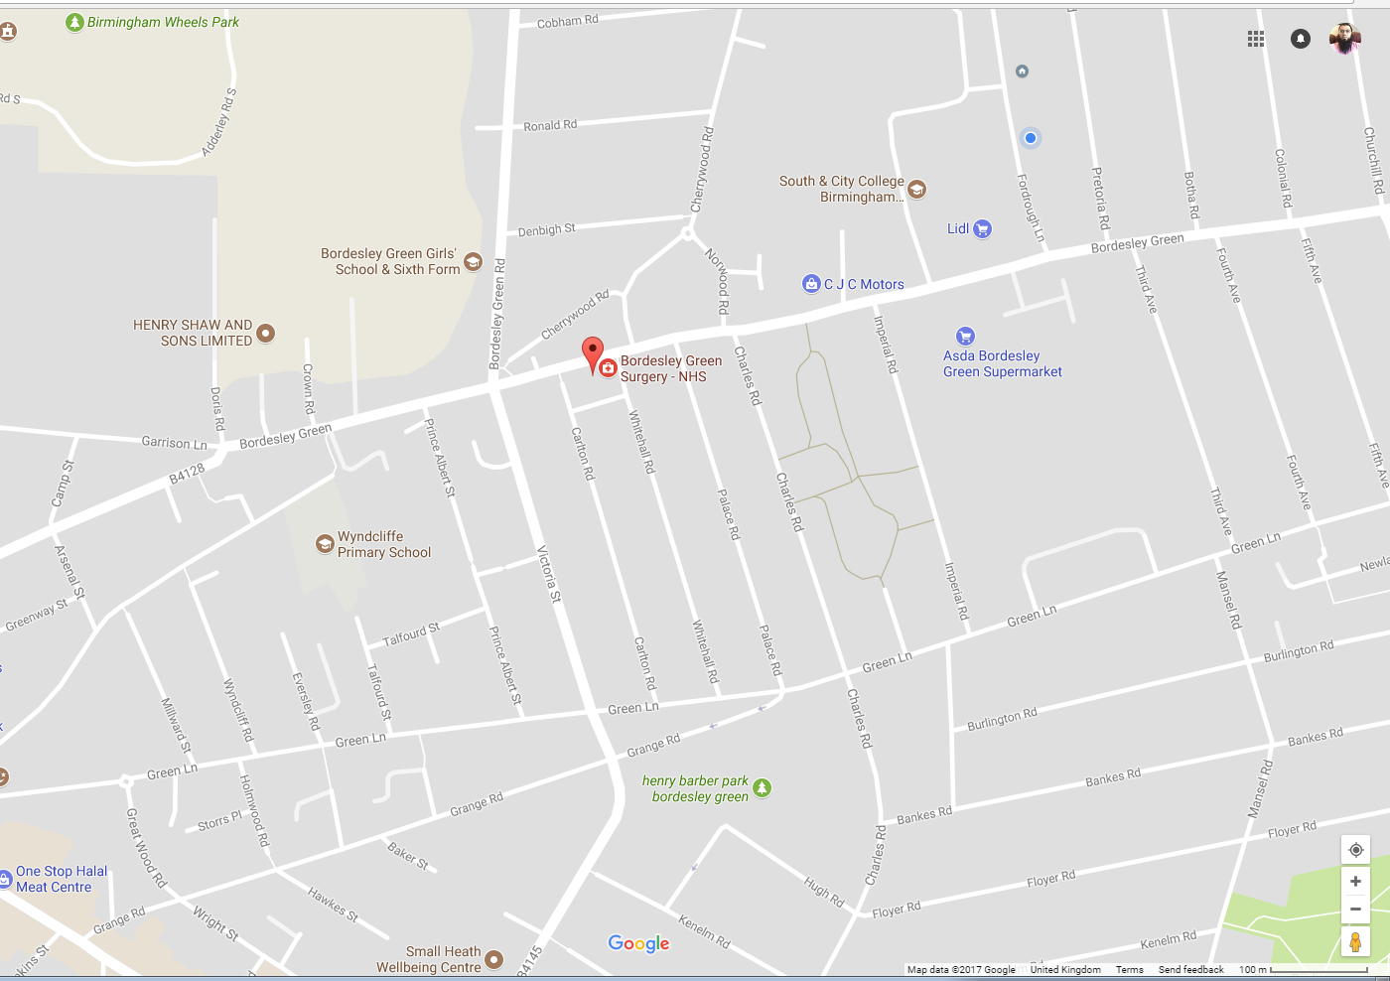

Self-Treatment of Common Illnesses
Back Pain
Back pain causes 13 million lost working days in Britain each year. Usually too much or Inappropriate lifting or gardening is the cause. Be sensible; take things easy, prevention is better than cure. Rest and painkillers will relieve most cases within a few days. Your doctor will not mind if you approach a qualified physiotherapist, chiropractor or osteopath directly.
Burns And Scalds
Apply large quantities of cold water to the burn as soon as possible and maintain this for several minutes. A loose dressing is suitable for unbroken or mildly blistered skin. Larger burns and burns in children should be seen by a nurse or doctor.
Coughs, Colds And Sore Throats
No magic cure has been found for these common ailments. Viruses cannot be treated with antibiotics. Aspirin or paracetamol, soothing drinks and other remedies help relieve the symptoms until they pass naturally in a few days or so.
Diarrhoea And Vomiting
Again normally caused by viruses. Even holiday diarrhoea can be treated with small amounts of clear fluids, not milk, taken frequently to rest the stomach and prevent dehydration. In children, mixtures of glucose and salts (Rehidrat/Dioralyte) can be used. If the patient appears very ill, or in babies who can become dehydrated more quickly, consult the doctor if symptoms persist.
Earache
Usually earache accompanies coughs and colds. Paracetamol will relieve the pain. If symptoms persist, and with children, consult the doctor at the next surgery session.
Head Lice
Very common in children, head lice prefer clean hair and are not a sign of poor hygiene. Lotions are available from the chemist for all the family.
Threadworms
All children will get these at some stage. An itching bottom, especially at night, is the most common complaint. Threadworms resemble small pieces of white cotton. Your chemist can advise you about treatment, again for all of the family.
Head Injuries/Concussion
Most bumps on the head cause no damage. A slight headache can be helped with paracetamol. If the patient is knocked out for more than a few seconds, consult your doctor. He may advise that the patient is taken to hospital if a more serious injury is suspected even though the patient can at first appear well.
Spots
Most childhood spotty illnesses are minor and often cause little upset. Measles is more serious, but is rare now that all children are immunised. Your doctor will not mind you attending the surgery with a spotty child to confirm diagnosis. All of these illnesses are contagious before the spots appear.
Insect Bites/Stings
Antihistamine tablets from the chemist relieve itches as can calamine lotion. Antihistamine creams are not recommended.
Nosebleeds
Pinch the nose between thumb and forefinger gently for five to ten minutes below the nasal bone. Persistent bleeding or a clot of blood down the throat may need further medical intervention. If heavy bleeding continues for more than 20 minutes you should go to A & E.
Sprains
R.I.C.E. - Rest, ice, compression, elevation. A cold compress with ice (a bag of frozen peas) applied over the strain for 30 minutes reduces and prevents swelling. A crepe bandage can be used and elevation continued until all swelling subsides. Gradual resumption of movements and exercise over a few days is recommended.
Sunburn
Treat as other burns. Calamine lotion and paracetamol will help. Avoidance, especially in children is most important. High factor sunblock and hats etc are advisable in all but the mildest of exposure to the harmful effects of the sun.

