THE PRACTICE
North Ridge Surgery is situated in the centre of Hawkhurst, opposite the Colonnade, in a traditional white weatherboard building. Free parking for up to two hours is available in the Waitrose supermarket car park nearby. We are a partnership of three Doctors with dispensing facilities. Surgery Reception is open from 8.30 am to 1.00 pm and from 1.30 pm to 6 pm Monday to Friday. For urgent matters between 8.00am and 8.30am; 1.00pm and 1.30 pm and 6pm to 6.30pm you can call 01580 755411.

THE AREA COVERED BY THE PRACTICE
We are happy to register patients in the villages of Hawkhurst, Sandhurst, Newenden, Benenden, Cranbrook, Hartley, Flimwell, Ticehurst, Hurst Green, Etchingham, Bodiam, Ewhurst, Staplecross and parts of Northiam, Rolvenden and Robertsbridge.

We encourage patients to have a ‘usual doctor’. Each Doctor prefers to see his or her own patients to provide personal continuity of service. If your Doctor is not available, however, one of the other Doctors will be happy to see you.

HOW TO SEE YOUR DOCTOR
We are open from 8.30am to 6pm Mon, Weds, Thurs and Fri. On Tuesday we are open from 7.30am to 7.30pm. We are closed for routine services between 1pm to 1.30pm each day.
Please see table overleaf for appointment/Doctor availability.

Contact reception to make an appointment and to find out other ways of booking appointments i.e. via online services.

If you are requested to bring in a urine sample, please drop it off at reception by 10.30 am, Monday to Friday, as samples are sent to the laboratory at 11.00 am each weekday. If you have a blood or urine test you will be asked to telephone for the result (between 10 am and 1 pm), as we do not normally contact the patient routinely.

OUT OF HOURS/URGENT MEDICAL CONDITIONS
NHS England is now responsible for medical care between 6.30pm to 8am Monday to Friday and at weekends. The Doctors help to provide this by working in the local out of hour’s centres. For urgent medical attention when the surgery is closed please call NHS 111. Do NOT EMAIL the surgery in case of medical emergencies.

For MEDICAL EMERGENCIES such as chest pain, severe shortness of breath, suspected stroke and major accidents you should call 999

If you require general medical advice please try the NHS Direct Symptom Checker via the NHS Direct website www.nhsdirect.nhs.uk

TELEPHONE APPOINTMENTS
If you wish to discuss something with your doctor please ask for a telephone appointment.
If it is convenient the receptionists will give you a telephone appointment and your doctor will phone you back. If the situation becomes urgent please phone back.

PRACTICE NURSE AND HEALTH CARE ASSISTANTS
We have two part-time Practice nurses and two Health Care Assistants who assist with practical procedures such as taking bloods, ECGs and Medication Reviews under the direction of the doctors. When booking please check with reception for appointment times and who is the best person to see.

HOME VISITS
If you are too ill to come to the surgery a home visit may be arranged by telephoning the surgery preferably BEFORE 12.00 noon. Please be prepared to give details to the Receptionists as this will help the Doctor to see the most urgent cases first.

CLINICS
Patients wishing to attend a Medication Review, Asthma clinic or Diabetic clinic should inform Reception staff who will refer you to the Practice Nurse or Health Care Assistant as appropriate.

COMMUNITY SERVICES
Our Community Nurses are based at Jockey Lane Clinic in Cranbrook and can be contacted on (01580) 713 032. Our Health Visitors are also based at Jockey Lane and their telephone number is (01580) 714935.

MATERNITY SERVICES
Our named midwife, Ella, can be contacted at the main office at Hawkhurst Cottage Hospital on 01580 755 559

DISPENSARY
The Dispensary is open
Monday to Friday at the following times: - 8.45-12.30 3.00 pm -6.00 pm
Saturday 8.45-10.15

Patients of this Practice, who live more than one mile from a chemist or, through disability, experience difficulty in using the chemist, may have their prescriptions dispensed at the surgery.

REPEAT DESCRIPTIONS
These may be obtained by ticking the boxes on the repeat request counterfoil of your prescription and delivering it to the surgery by hand, post, or fax (if possible). We do not take prescription requests over the phone. All repeat prescriptions are regularly reviewed by your Doctor. You may be asked to attend for review of the medications with an HCA or Nurse in preparation for seeing your doctor. If the results of the tests are normal however your doctor may update the review date without the need of a further appointment. Our fax number is (01580) 754 452.

Please check the signs in the surgery for lead times to get your prescriptions. Please do not wait until you have run out of medication before requesting a repeat.

The Practice delivers authorised prescriptions to Wards of Benenden, Sandhurst Post Office, Hurst Green General Store and Post Office, Etchingham Post Office and Flimwell Post Office on Thursday afternoons.

FAMILY PLANNING
We can advise on all forms of contraception. We can fit IUCDs, Mirena IUS, Nexplanon Implants and Contraceptive Diaphragm’s. Please discuss with your Doctor or the Nurse.

CHILD VACCINATION & IMMUNISATION
Clinics are held at North Ridge and a Doctor is always present. Please contact Reception for an appointment. Most patients will be sent an immunisation & vaccination reminder for their child. If no reminder is received or you have recently arrived in the area, please contact the Receptionist on (01580) 753 935.

HOLIDAY/ROUTINE VACCINATIONS
Patients going abroad or needing booster doses of tetanus, polio, etc. please pick up and complete holiday form from reception. We are a Registered Yellow Fever Centre.

NEW PATIENT HEALTH CHECKS
We like all patients who register to complete a health questionnaire and to attend to have their height, weight, blood pressure and a sample of urine checked even if recently done elsewhere. This will help us to provide subsequent medical care

MEDICAL EXAMINATIONS (Non-NHS)
The receptionist can arrange these.

HAWKHURST COTTAGE HOSPITAL
This is situated one mile west of the centre of Hawkhurst on the Flimwell Road. The hospital has excellent Physiotherapy and Occupational Therapy departments. There are visiting Consultant outpatient clinics.

COMPLAINTS
Should you have a complaint or if you feel there is any way in which we might improve, please address your comments and suggestions to your Doctor or the Practice Manager. We do have a separate ‘Complaints Procedure’ leaflet, which can be obtained from Reception.

EMAIL
We are pleased to accept emails however please do not use email for urgent matters or to book appointments that require action on the same day. Always telephone for urgent issues.

GENERAL SURGERY HOURS

 | MORNING SURGERY  Appts. 8.35-10.35am THEN  Same day appointments  Between 10.55-11.55am |  |  | EVENING SURGERY  By appointment  4.20 to 6.00 pm |  | Tuesdays  Open 7.30am until 7.30pm
MONDAY | Dr A Wood  Dr R. J. Blundell  Dr Strange |  |  | Dr A Wood (school holidays)  Dr R. J. Blundell  Dr D Strange
TUESDAY | Dr A Wood  Dr R. J. Blundell  Dr D Strange |  |  | Dr D Strange (until 7.30pm)  Dr A Wood |  | 7.30am - Drs Wood & Blundell and Nursing/HCA staff
WEDNESDAY | Dr A Wood (school holidays)  Dr R. J. Blundell  Dr J Christophers  (School term time) |  |  | Dr R. J. Blundell  Dr A Wood
THURSDAY | Bernie Strange  Dr D Strange |  |  | Bernie Strange  Dr D Strange
FRIDAY | Dr R. J. Blundell  Dr D Strange  BLUNDELL |  |  | Dr R. J. Blundell  Dr D Strange

NORTH RIDGE MEDICAL PRACTICE

NORTH RIDGE, RYE ROAD, HAWKHURST. TN18 4EX

Practice Website: www.north-ridge-surgery.co.uk
Practice Email Address:north.ridge@nhs.net
Telephone: 01580 753935 Fax: 01580 754452

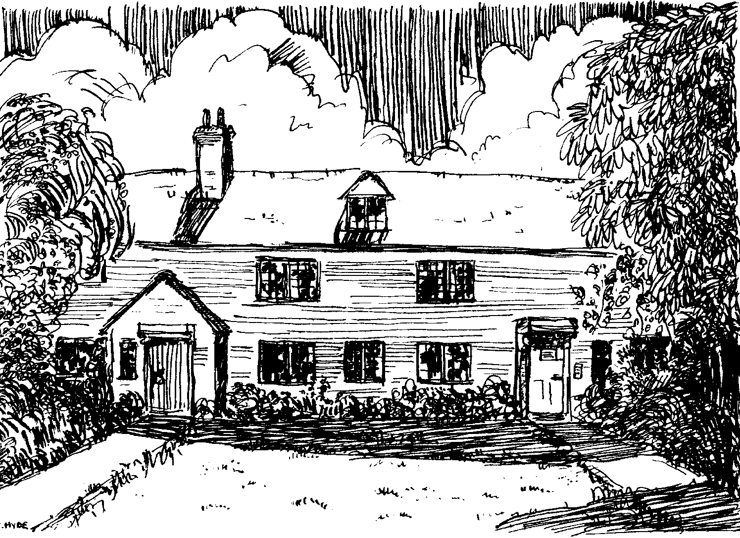

Dr A WOOD MB, ChB, MRC Psych, F .Cert Dip Hom.
Dr R. J. BLUNDELL MB, BS (Lond), DRCOG, DFFP
Dr D STRANGE MB, BS BSC, DRCOG, MRCGP

Practice Team Members
Mrs Shantal Venter Business Manager
Mrs Ali Wilson Practice Manager
Mrs. Karen Wall Medical Secretary
Mrs Clare Boutell Coder/Medical Notes
Mrs. Marianne Hay Administration
Mrs Serena Castello-Cortes Administration
Mrs. Jane Growns Senior Dispenser
Mrs Jo Hollis Dispenser
Ms Kara Coomber Dispenser
Miss Lorelei Mullen Dispenser
Mrs. Charlie Abley Lead Receptionist
Mrs Anne Davies Receptionist
Mrs Tracey Parnell Receptionist
Mrs Christine Mencner Receptionist
Mrs Bernie Strange Advanced Nurse Practitioner
Mrs Natalie Stevens Practice Nurse
Mrs Tracy Knight Practice Nurse
Mrs Christine Coleman Health Care Assistant
Mrs Sue Berks Health Care Assistant

