Ash Tree House



Dr Brown, Dr Franklin, Dr Chavali, Dr Zengeni, Dr Azam, Dr A Lake, Dr E Lake

A note from Doctor Azam

Hi my name is Dr Azam, I joined Ash Tree house in February 2017. I work Tuesday,Wednesday,Thursday full days and Friday morning. I have worked in various hospital placements prior to becoming a GP. I became a GP in December 2016 and I love this job. My special interests are Mental health and Paediatrics. I have young children and I understand the needs of people with children.

I like the continuity of care that we provide to patients.I believe in getting to know my patients and their families well.I would love to give each of my patients the best quality time if I had it, but I’m afraid we are working under time pressures.I tend to explain everything to patients so they can make an informed choice and take an active part in their own management.I strongly beleive if patients agree on a medication they will surely use it rather than a doctor pushing something on them.

A happier doctor can help you better hence I educate my patients to come in with one issue at a time or to make a double appointment so I can deal with the problem efficiently.

I look forward to continue to help my patients and ensuring each one of you works in cooperation with myself.

Dr Azam

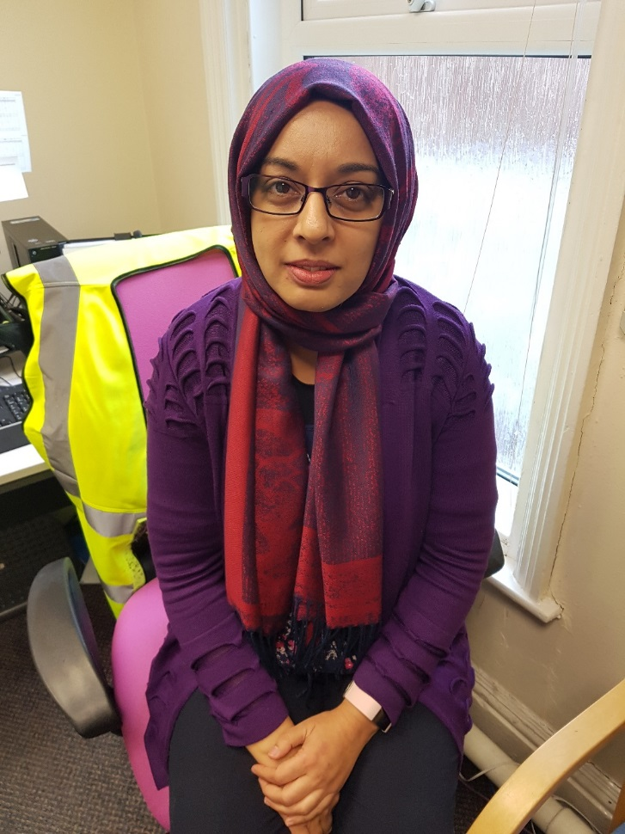

Welcome to our Ash Tree House Newsletter. We will be publishing the Newsletter on our website and Facebook page for you to download and find out lots of relevant information about the surgery and other initiatives and schemes from the NHS.

**Stoptober 1st-31st Oct**

##### October is stop smoking month, having

the right support makes a big difference when you're trying to quit smoking. If you would

Give **Quit Squad** a call on

**0800 328 6297**

**Invitation for Seasonal Flu Immunisation**

We would like to invite all eligible patients to come in to the surgery to receive a vaccination against the Flu this winter. This year **Ash Tree House** is able to offer a Flu vaccine on a dedicated morning clinic we will be opening on **Saturday 13th October** specifically for Flu vaccinations only.

Give Reception a call to book an appointment.

**01772 686688 Option 1**

This year there are 3 different types of flu vaccine:

* A live quadrivalent vaccine (which protects against 4 strains of flu), given as a [nasal spray](https://www.nhs.uk/conditions/vaccinations/child-flu-vaccine/).
* This is for children and young people aged 2 to 17 years eligible for the flu vaccine
* A quadrivalent injected vaccine this is for adults aged 18 and over but below the age of 65 who are at increased risk from flu because of a long-term health condition and for children 6 months and above in an eligible group who cannot receive the live vaccine
* An [adjuvanted](https://www.nhs.uk/conditions/vaccinations/vaccine-ingredients/) trivalent injected vaccine. This is for people aged 65 and over as it has been shown to be more effective in this age group

If your child is aged between 6 months and 2 years old and is in a high-risk group for flu, they will be offered an injected flu vaccine as the nasal spray is not licensed for children under 2.

Talk to a GP, Practice Nurse or Pharmacist for more information about these vaccines.

**01772 686688 Option 1**