Drs Cunningham, Shroff, Barrett & Smith

How we use your medical records
Important information for patients

- This practice handles medical records in-line with laws on data protection and confidentiality.

- We share medical records with those who are involved in providing you with care and treatment.

- In some circumstances we will also share medical records for medical research, for example to find out more about why people get ill.

- We share information when the law requires us to do so, for example, to prevent infectious diseases from spreading or to check the care being provided to you is safe.

- You have the right to be given a copy of your medical record.

- You have the right to object to your medical records being shared with those who provide you with care.

- You have the right to object to your information being used for medical research and to plan health services.

- You have the right to have any mistakes corrected and to complain to the Information Commissioner’s Office. Please see the practice privacy notice on the website or speak to a member of staff for more information about your rights.

- For more information and to view our Practice privacy notices, please visit our website www.thevallancecentre.co.uk

Scan this code with your mobile for more on GDPR
Scan this code with your mobile for more on GDPR
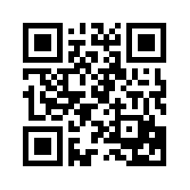
Scan this code with your mobile for more on GDPR

