Clitheroe Health Centre User Group Newsletter

Practice News
The Clitheroe Health Centre User Group (CHUG)
A meeting was recently held between members of the CHUG, practice representatives, Councillors, NHS Property Services and Nigel Evans, MP. The aim of this meeting was for the members of the CHUG to express their increasing concerns about the growth of housing within Clitheroe and surrounding areas and the impact this growth will have upon services within the Health Centre. The meeting was well attended and minutes can be found on the practice website.

Dispensary – Prescriptions over Christmas
The Health Centre will be closed on the 25th and 26th December 2018 and again on the 1st January 2019. If your repeat prescription date falls on one of these dates, please remember to order a few days early.
Below are just a few details of pharmacies open on the bank holidays. More information can be found on the practices’ Facebook pages.
Christmas Day – 25th December 2018
Peter Buckley Ltd | 34 King Street, Clitheroe, BB7 2EU | 9am – 12pm
Accrington Late Night Pharmacy | 188 Blackburn Road, Accrington, BB5 0AQ | 10am – 8pm
Oswaldtwistle Pharmacy | 300 Union Road, Oswaldtwistle, Accrington, BB5 3JD | 11am – 7pm
Boxing Day – 26th December 2018
Accrington Late Night Pharmacy | 188 Blackburn Road, Accrington, BB5 0AQ | 10am – 8pm
Asda Pharmacy | Princess Way, Burnley, BB12 0EB | 9am – 6pm
Lloyds Pharmacy | Windy Bank, Colne, BB8 9HY | 9am – 5pm
New Year’s Day – 1st January 2019
Accrington Late Night Pharmacy | 188 Blackburn Road, Accrington, BB5 0AQ | 10am – 8pm
Asda Pharmacy | Princess Way, Burnley, BB12 0EB | 10am – 5pm
Lloyds Pharmacy | Windy Bank, Colne, BB8 9HY | 9am – 5pm

Flu Vaccinations
It’s not too late to protect yourself from flu. If you are aged 65 and over, you are automatically entitled to an NHS flu vaccine. If you are under 65 years of age but suffer from a chronic disease, you may be entitled to an NHS flu vaccine.
Call your practice’s reception for more information.

Dry January 2019
Save money, lose weight and sleep better this New Year by giving up alcohol for the month of January. Dry January is a 31 day challenge starting January 1st to give up booze and get the conversation started on the damaging effects of drinking.

For more information about the campaign, visit: https://alcoholchange.org.uk/

Lancashire Adult Learning (LAL)
Lancashire Adult Learning is the second largest adult community learning provider in the country and provides exceptional learning opportunities across Lancashire. The aim of LAL is to deliver a wide range of high quality ‘targeted’ programmes, which focus on the needs of disadvantaged people and those least likely to participate in learning.

There are a range of FREE Health and Wellbeing courses available to suit you. Examples include ‘7 Minute Exercises That Can Change Your Life’, Cancer Screening Champion, Eat Well on a Budget and Relax & De-stress. More information can be found online at www.lal.ac.uk or by phoning 0333 003 1717.
LAL also hold language classes as well as online courses such as ‘Essential Digital Skills’ and ‘Make the Most of your Tablet’.

Your Locality (Ribblesdale)

Ribblesdale Integrated Neighbourhood Team
The Ribblesdale Integrated Neighbourhood Team continues to develop and the co-ordinator now hot desks at various venues across the locality which so far has reduced the level of inappropriate referrals.

Work also continues on frailty and a clinical tool has been developed and further work is underway in looking at the impact of loneliness and also falls provision for patients.

Primary Care Network
The Network is continuing to establish and meetings are taking place on a regular basis and some of the plans are around Heart Failure and Health Checks which is part of the prevention agenda.

Ribblesdale Community Partnership
Has worked closely with the CVS regarding social prescribing monies and has used the remaining grant monies on the Family Thrive Centre that has just opened in the old Physiotherapy building near the market.

Community Connector service
The Community Connector service is available to sign post and connect individuals who may require non-medical needs. GP practices can refer patients to the connectors or patients can contact directly on connector@hrv-cvs.org.uk or call 01254 888614.

Your CCG (East Lancashire)

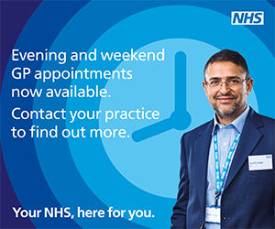
Extended GP Access

The extended GP access scheme means that patients can make an appointment to see a GP or nurse practitioner, from 6:30 pm to 8:30 pm on week days and from 10:00 am to 4:00 pm on a Saturday and Sunday. The system has been set up by local GPs working collectively to improve access to GP and practice nurse services. The appointments available in these extra weekday and weekend hours are in addition to the usual GP surgery opening hours from 8:00 am to 6:30 pm.
The appointments will be available at GP access hubs across East Lancashire (these may not be your own GP practice). To book an appointment call your GP practice or speak to your practice receptionists.

General Practice and the Power of Community Event Success
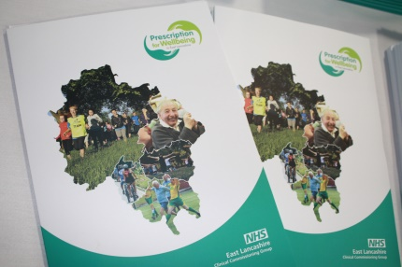
On Wednesday 31st October we held the very successful “General Practice and the Power of Community” event at Turf Moor. Approximately 250 delegates attended to learn more about social prescribing and the incredible impact it has made in our communities.

Delegates were able to view 30 exhibition stands from recipients of social prescribing grants and these displayed useful information about their activities and work, and showed examples of how the CCG grant scheme, which was managed by Burnley, Pendle and Rossendale, and Hyndburn and Ribble Valley CVS has helped their communities thrive.

Help to Keep Your Family Vaccinated Against Flu This Winter

Did you know that if your child is between 2 and 9 years of age they are eligible for a free NHS flu vaccine. Flu can affect anyone but if you’re pregnant the effects can be risky for you and your baby, pregnant women are also eligible for a free vaccine. Book yours at your local GP / Pharmacist now.
The signs of flu include a blocked up nose, painful ear, sore throat, high temperature, difficulty breathing, dry cough, tiredness and aches.
Implementation of Revised and Updated Clinical Policy on Assisted Conception Services (including IVF)

This clinical policy explains the criteria that must be met in order for assisted conception services such as IVF (in vitro fertilisation) to be given on the NHS in this area.
GPs, hospital doctors and consultants are required to follow these policies when considering your treatment. Please talk to your GP or consultant if you wish to know more about whether you are eligible for these services under the revised policy.
To read the Assisted Conception Services Policy, visit the CCG website.

