Clitheroe Health Centre User Group Newsletter

Practice News
The Clitheroe Health Centre User Group (CHUG)
The CHUG is our Patient Participation Group (PPG), which meets quarterly and consists of patient representatives, Practice Managers, GP representatives, nursing representation and the Health Centre Manager.

No training is required to become a member of our CHUG and we always welcome new members. If you would be interested in getting involved then please contact your practice for more information.

General Data Protection Regulation (GDPR)
We respect your right to privacy and keep all your health information confidential and secure. It is important that the NHS keeps accurate and up to date records about your health and treatment so that those treating you can give you the best possible advice and care. This information is only available to those involved in your care and you should never be asked for personal medical information by anyone not involved in your care.
From 25th May 2018 the law is changing with the addition of the General Data Protection Regulation (GDPR). This regulation will have an impact on how we handle your data. Further information is available on the individual practice’s websites in the Patient Privacy Notice.
Facebook
You can now find both Pendleside Medical Practice and The Castle Medical Group on Facebook. Like their pages to receive updates on practice services, new health campaigns and general health and wellbeing information.

Dispensary – Ordering Prescriptions
The Dispensary phone lines are now only open between the hours of 10am – 3pm. Prescriptions can still be requested via the repeat prescription slip or alternatively sign up to patient access to manage your medications on line.

Patient Access
Patient Access is a smart way to help you make use of your GP services online. You can access the programme via the internet or as an app on your smartphone. You can book an appointment, manage your repeat medication, view your medical record or ask your practice a question. There have also been some exciting new features added, making it easier for you to use.

To sign up for Patient Access either visit your practice’s website and sign up online or call in and ask at Reception (you will need to provide photographic identification).

Bowel Cancer Screening Programme
Bowel cancer is a common type of cancer in both men and women. About 1 in 20 people will get it during their lifetime.

Screening can help detect bowel cancer at an early stage, when it's easier to treat. It can also be used to help check for and remove small growths in the bowel called polyps, which can turn into cancer over time.

All men and women aged 60-74 are invited to carry out a faecal occult blood (FOB) test as part of the national bowel screening programme. If you have not participated yet and would like to, please get in touch with the practice and we can organise for a new kit to be sent directly to you.

Your Locality (Ribblesdale)
Social prescribing Budget 2018/19
The Social prescribing allocation for Ribblesdale is £24,210 which will be split 50/50 between small grants (handled by the CVS) and the other half will go to the Ribblesdale Community Partnership for project work.

Ribblesdale Community Partnership
The Ribblesdale Community Partnership was set up for health and care organisations to work together to transform services and the way people use and access them, to make people in the area healthier and enhance care quality. This new model of care will see the joint planning, joint development, and joint implementation of a health and care model for Ribblesdale.

The Partnership are working on a number of priorities and have an action plan that is being progressed. They are currently looking at the issues and challenges facing CYP living in the locality and a needs analysis has been commissioned. This demonstrated the main issues for CYP and also the challenges faced by organisations when trying to deliver and support these people. It was evident there was a need for a more efficient and smarter way to support CYP and families in the rural Ribble Valley and we are currently working towards a ‘family hub’. This will be a single point of access and referral pathway with access to services and activities that will ensure early help is available to support and prevent crisis. The ‘family hub’ will be a one stop shop and referrals will be allocated to the most appropriate service. A business case is in development and will then progress through the CCG governance channels. The Partnership are also looking at the whole nursing provision in Ribblesdale and a workshop took place in April to progress how they can be used more productively regardless of employer. Actions are now being progressed.

Primary Care Networks (PCNs)
Primary Care Networks across East Lancashire were established during 2017, whereby GP Practices, plus other local Healthcare providers, caring for between 30k to 50k patients (neighbourhoods), came together in order to work collaboratively. Ribblesdale have one PCN and an initial £1 per head funding has been made available by the CCG, with the aim of providing backfill to staff from GP Practices to come together and develop plans. The priorities in Ribblesdale are:

- Frailty – This pilot is to improve the quality of care provided for frail patients within Ribblesdale. The main objective is to develop an identification and care pathway for professionals to use to assist an integrated approach in the care management of patients identified as being frail. Practices have developed a register of patients and a frailty workshop has been undertaken. The project group are pursuing a clinical tool that will direct professionals to consider different care planning and the INT Co-ordinator will support with education and training for practice nurses on falls and balance testing. The main outcome will be increased collaborative working and increased management of patients with frailty in primary care leading to a reduction in activity in hospital.

- The other priority is developing an evidence based integrated heart failure pathway for the diagnosis and management of patients with chronic heart failure. A mapping exercise was undertaken in January 18 to produce flow charts of pathways. The project group continue to implement their plans and the next step is to address the issues around coding of heart failure diagnoses and echo reporting, and to design a gold-standard primary care heart failure review (and template). A workshop is scheduled for June to progress tis further.

CCG excellence Awards
A number of teams and individuals have been nominated for the awards ceremony that takes place on 28th June 2018.

Your CCG (East Lancashire)

Cancer G.P. and 25 year old patient encourage young women to have a smear
Dr Neil Smith, local GP and Cancer Lead for Blackburn with Darwen and East Lancashire Clinical Commissioning Groups is promoting a campaign called “25 its time” to encourage 25 year olds to attend their cervical screening.
Women aged 25-30 are less likely to accept an invitation for screening than those in older age groups. Practices across Pennine Lancashire are working together to improve uptake. Each practice has a nominated cancer champion who attended a recent training course on how to support more 25 year olds to have a smear.
Dr Smith said:
“The simple message of our campaign is “25 its time” for your first smear. Over 3000 women are diagnosed with cervical cancer each year. Many people are not aware that it is more common in younger women with half of the cases diagnosed in women under the age of 45.
“Cervical screening is a way of preventing cancer by finding and treating abnormal cells in the cervix. These changes could lead to cancer if left untreated. Cervical screening prevents 75% of cervical cancers from developing.
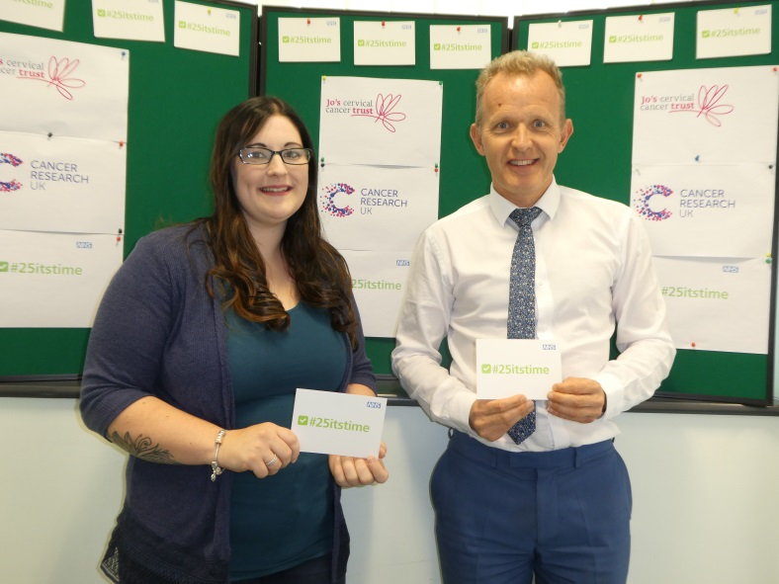
“Our work has shown that only about 1/3 of 25 year olds invited for their first smear actually attend. The G.P. practices in Pennine Lancashire are working to improve this by contacting young women with cards, text and telephone calls reminding them and booking an appointment for a smear test. We want to make it easier for everyone to take up their smear test invitation.”
The aim of the campaign is to raise awareness of the importance to attend screening and to use the hashtag #25itstime on social media to help promote these messages to young women. It has been organised in partnership with Cancer Research UK and Jo’s Trust.
Victoria Gunston is a 25 year old who supports the campaign and wants to encourage more young women to attend for their first smear. She said:
“I was dreading going for my first smear but it was nowhere near as bad as I thought. It didn’t hurt one bit. I can understand why someone may not want to go but I would certainly recommend having a smear.”
For information and support on cervical cancer, contact Jo’s Trust; a charity dedicated to women affected by cervical cancer and cervical abnormalities. Visit www.jostrust.org.uk or call 0808 802 8000 or Cancer Research UK http://www.cancerresearchuk.org/about-cancer/cervical-cancer/getting-diagnosed/screening
GP practices receive funding boost for improved primary care
GP practices in East Lancashire received a boost, when NHS East Lancashire Clinical Commissioning Group (CCG) published its plan to support primary care in the area.
The plan sets out how the CCG, will support the 54 GP practices in East Lancashire to provide improved GP care and access to services to the 381,000 people who use GP services.
Along with the plan, GP practices have signed up to a quality framework which means that GP practices will receive funding where they can show that they have improved the quality of care for people with conditions such as diabetes, dementia, COPD, cancer, cardiovascular disease, and the care of the over 75s.
Read the full news story on the East Lancashire CCG website:
https://eastlancsccg.nhs.uk/news

Patients across Pennine Lancashire are benefitting from a more efficient referral system
As a result of the introduction of an electronic referral system, patients across East Lancashire and Blackburn with Darwen are starting to benefit from a more efficient process when their GP refers them for a hospital appointment.
From the 31st July 2018 all consultant-led first appointments will be made electronically rather than by other, more traditional methods; for example letter, fax or email. This is a key element in the move to being a paperless NHS.
The move will provide a range of benefits including greater choice of appointment date and time for patients. It is estimated that there will also be a reduction in missed appointments which will reduce waiting times.
MyCOPD Web Tool
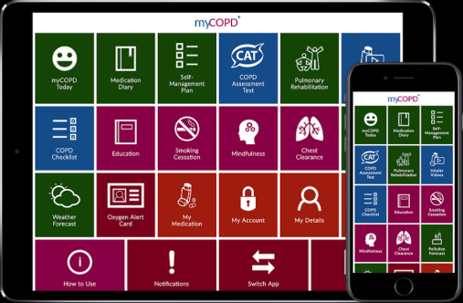
MyCOPD is an online self-management tool to enable patients to manage their COPD (Chronic Obstructive Pulmonary Disease) better. It has useful techniques such as inhaler videos as well as a wide range of other educational material. It specifically includes a video based Pulmonary Rehabilitation course, as well as some advice about how to manage breathlessness and anxiety. The tool is accessible on all devices; PC, laptop, tablet or smartphone.
Several practices across Pennine Lancashire have already signed up to trial this with their patients. If this is something you may be interested in, speak to your clinician or GP practice to find out more or visit https://www.mymhealth.com/mycopd

