REGISTRATION FORM (GMS1)
Office use only
Emis number

July 2017
www.donningtonhealthcentre.nhs.uk
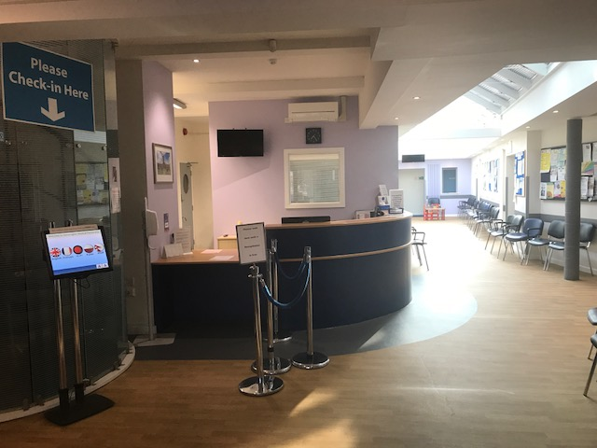

Have you ever registered with this GP practice before Yes/No
Adult | Child over 5 | Child under 5

The NHS in England has introduced the Summary Care Record (SCR), which will be used in emergency care and only by authorised healthcare professionals. It is a separate record to the one held by held Practice and you will be asked permission to access it. It is intended for use by organisations such as out of hours, hospitals and emergency services.
If you do not want an SCR creating please tick this box

All parts of this form are important. Please complete it fully using block capitals letters and in legible writing.
You will need to provide proof of ID (passport, driving licence, birth certificate) and proof that you live within our practice area. (bank statement, utility bill, council tax etc)
For a child, you will need to show the child’s red book
ID checked | Appt made? | Partner off/  Married too? | Child of? | Carer code entered | Other codes  Key safe ? | Child Imms  Other health conditions | Warning for interpreter etc

Are you? Male/Female Title? Mr/Mrs/Ms/Miss/Other……………….
Please state your Family Name (Surname)……………………………………………………………………
Please state your First name……………………………………………………………………………………
What is your Address…………………………………………………………………………………………….
Do you have any middle names………………………………………………………………………………..
Please state your Date of Birth. Day………….. Month....……….. Year………………
NHS Number……………………………………. (You can ask your previous surgery for this)
Contact Telephone Number…………………………. Mobile Number…………………………………….
Please state your email address………………………………………………………………………………
Are you interested in joining our Patient Participation Group Yes/No
If Yes, we will pass your email address and contact details to the PPG who will contact you.
Are returning from the British Armed Forces? Yes/No
If yes, please state your address prior to enlisting.
………………………………………………………………………………….
.
Patients born IN THE UK only
Which Town were you born?................................................................

What is the name of the GP/GP Practice you are currently registered with?
…………………………………………………………………………………………………..

What is your Previous address?..............................................................................
………………………………………………………………………………………………….
………………………………………………………………………………………………….
Patients born OUTSIDE THE UK only

- Which country were you born in?…………………………………………

What date did you enter the UK for this stay?............................................

Have you lived at any other addresses than the one you have given on page one since you arrived on this date? Yes/No

If Yes please give the most recent address prior to moving to the address on page one
…………………………………………………………………………………………..

- Have you ever lived in the UK before the date given above? Yes/No

If yes, what date did you arrive in the UK for your previous stay?

……………………………………………………………………………………….

Please state your previous address on that occasion

……………………………………………………………………………………….

- Have you ever registered with a GP before in the UK? Yes/No

If Yes, please state the name of the GP or the Practice name

…………………………………………………………………………………………..

Please state what you consider your Ethnicity to be?
White British/Mixed British Irish Other White Background Indian/British Indian
Pakistani/British Pakistani Bangladeshi/British Bangladeshi Other Asian Background Black/ African
Caribbean Other I prefer not to say Main Language……………………………………………….
Do you need help to access services in regard to your health? (ie interpreter, Sign Language, legal or citizen advocate) Yes No
If Yes, What help do you need?...................................................................................................................................

Do you have a Carer? Yes No If Yes, Please give name and telephone number……………………………………………………………………………………………………………

Does someone rely on your help or support?
Do you look after a friend, relative or neighbour who is ill, frail or in need of emotional support, but you receive no payment? You may be a Carer and we can offer you support and information. Please ask at reception if you would like a carers pack. I am a carer Yes/No

If you are registering a child under the age of FIVE years old, please provide details from the Red Book of the child’s immunisation status
I wish the child named on this form to be registered for Child Health Surveillance Yes/No
Please tick if your child has been immunised against the following and give dates if known
 | Given? | Date given
BCG (if relevant)
First: Diptheria/Pertussis/Tetanus/Polio/HIB
First: Pneumococcal (PCV)
First: Meningitis B and Rotarix
Second: Diptheria/Pertussis/Tetanus/Polio/HIB/Rotarix
Second: Pneumococcal (PCV)
Second: Meningitis B
Third: Diptheria/Pertussis/Tetanus/Polio/HIB/Pneumococcal
Booster: HIB and Meningitis B
First: Measles/Mumps/Rubella
Pre-School Booster: Diptheria/Pertussis/Tetanus/Polio/HIB
Second: Measles/Mumps/Rubella
Hepatitis B:

Medical Emergency Contact details

Name………………………………………………………Relationship to you……………………………..

Telephone number………………………………………………………KeySafe Number……………….
NHS Organ/Tissue Donor Register
I want to register my details on the NHS organ Donation register as someone whose organs/tissue may be used for transplantation after my death

Any of my organs

Kidneys Heart Liver Corneas Lungs Pancreas Any Part of my Body

Signature confirming my agreement to NHS organ/Tissue donation

……………………………………………………………………………… Date……………………………………….
NHS Blood Donor register
I would like to join the NHS Blood Donor register as someone who may be contacted and would be prepared to donate blood.

Tick here if you have given blood in the last 3 years

Signature confirming my agreement to NHS Blood Donation

…………………………………………………………………….. Date…………………………………………
I am already on the donor register

Please answer the following questions which are asked to enable the practice to ensure that the correct review, support and care is offered to patients
What are your smoking habits?
Never smoked Ex Smoker
Current Smoker If Current or ex-smoker, how many cigarettes do you/did you smoke in a day?
Have you been prescribed medication for the treatment of ASTHMA in the past 12 months?
Yes No Prefer not to say
Have you been diagnosed with CANCER in the last 18 months?
Yes No Prefer not to say
Do you suffer from any of the following medical conditions , for which you are taking prescribed Medication? Tick all that apply
Coronary Heart disease Stroke and/or TIA Learning Disabilities Cardiovascular disease
Diabetes type I Diabetes type II Hypertension Schizophrenia
Bi-Polar Affective Disorder Other Psychosis COPD Heart Failure
Anaphalaxis Epilepsy None of these conditions

Females Only – Please indicate which method of birth control you have used in the past 12 months. Tick all that apply
I have not used any contraception in the past 12 months

Oral Contraceptive pill Implanon (Implant) Condoms Vaginal Ring

Injection Method Coil Emergency Contraception Contraception Patch

What is your Height?......................................... What is your Weight?.....................................................
(cm/feet/inches) please delete as appropriate (kgs/stones/lbs) please delete as appropriate

Have you been vaccinated against the following diseases?
Anyone under the age of 25 without these vaccinations will be offered them free of charge at the Health Centre. This age group is considered to be at high risk of contracting these diseases.

Menigitis C: Yes No Unsure Measles, Mumps and Rubella: Yes No Unsure

If Yes, How many injections of MMR have you received? One Two

Alcohol | 0 | 1 | 2 | 3 | 4 | score
 | Never | Monthly or less | 2-4 times a month | 2-3 times a week | 4+ times a week
How often do you have a drink that contains alcohol?
How many standard alcoholic drinks do you have on a typical day when drinking?
How often do you have 6 or more standard drinks on one occasion?

I have read, understood & completed this form in good faith & to the best of my knowledge.

Signed……………………………………………. Dated…………………………………………… Signed on behalf of patient

