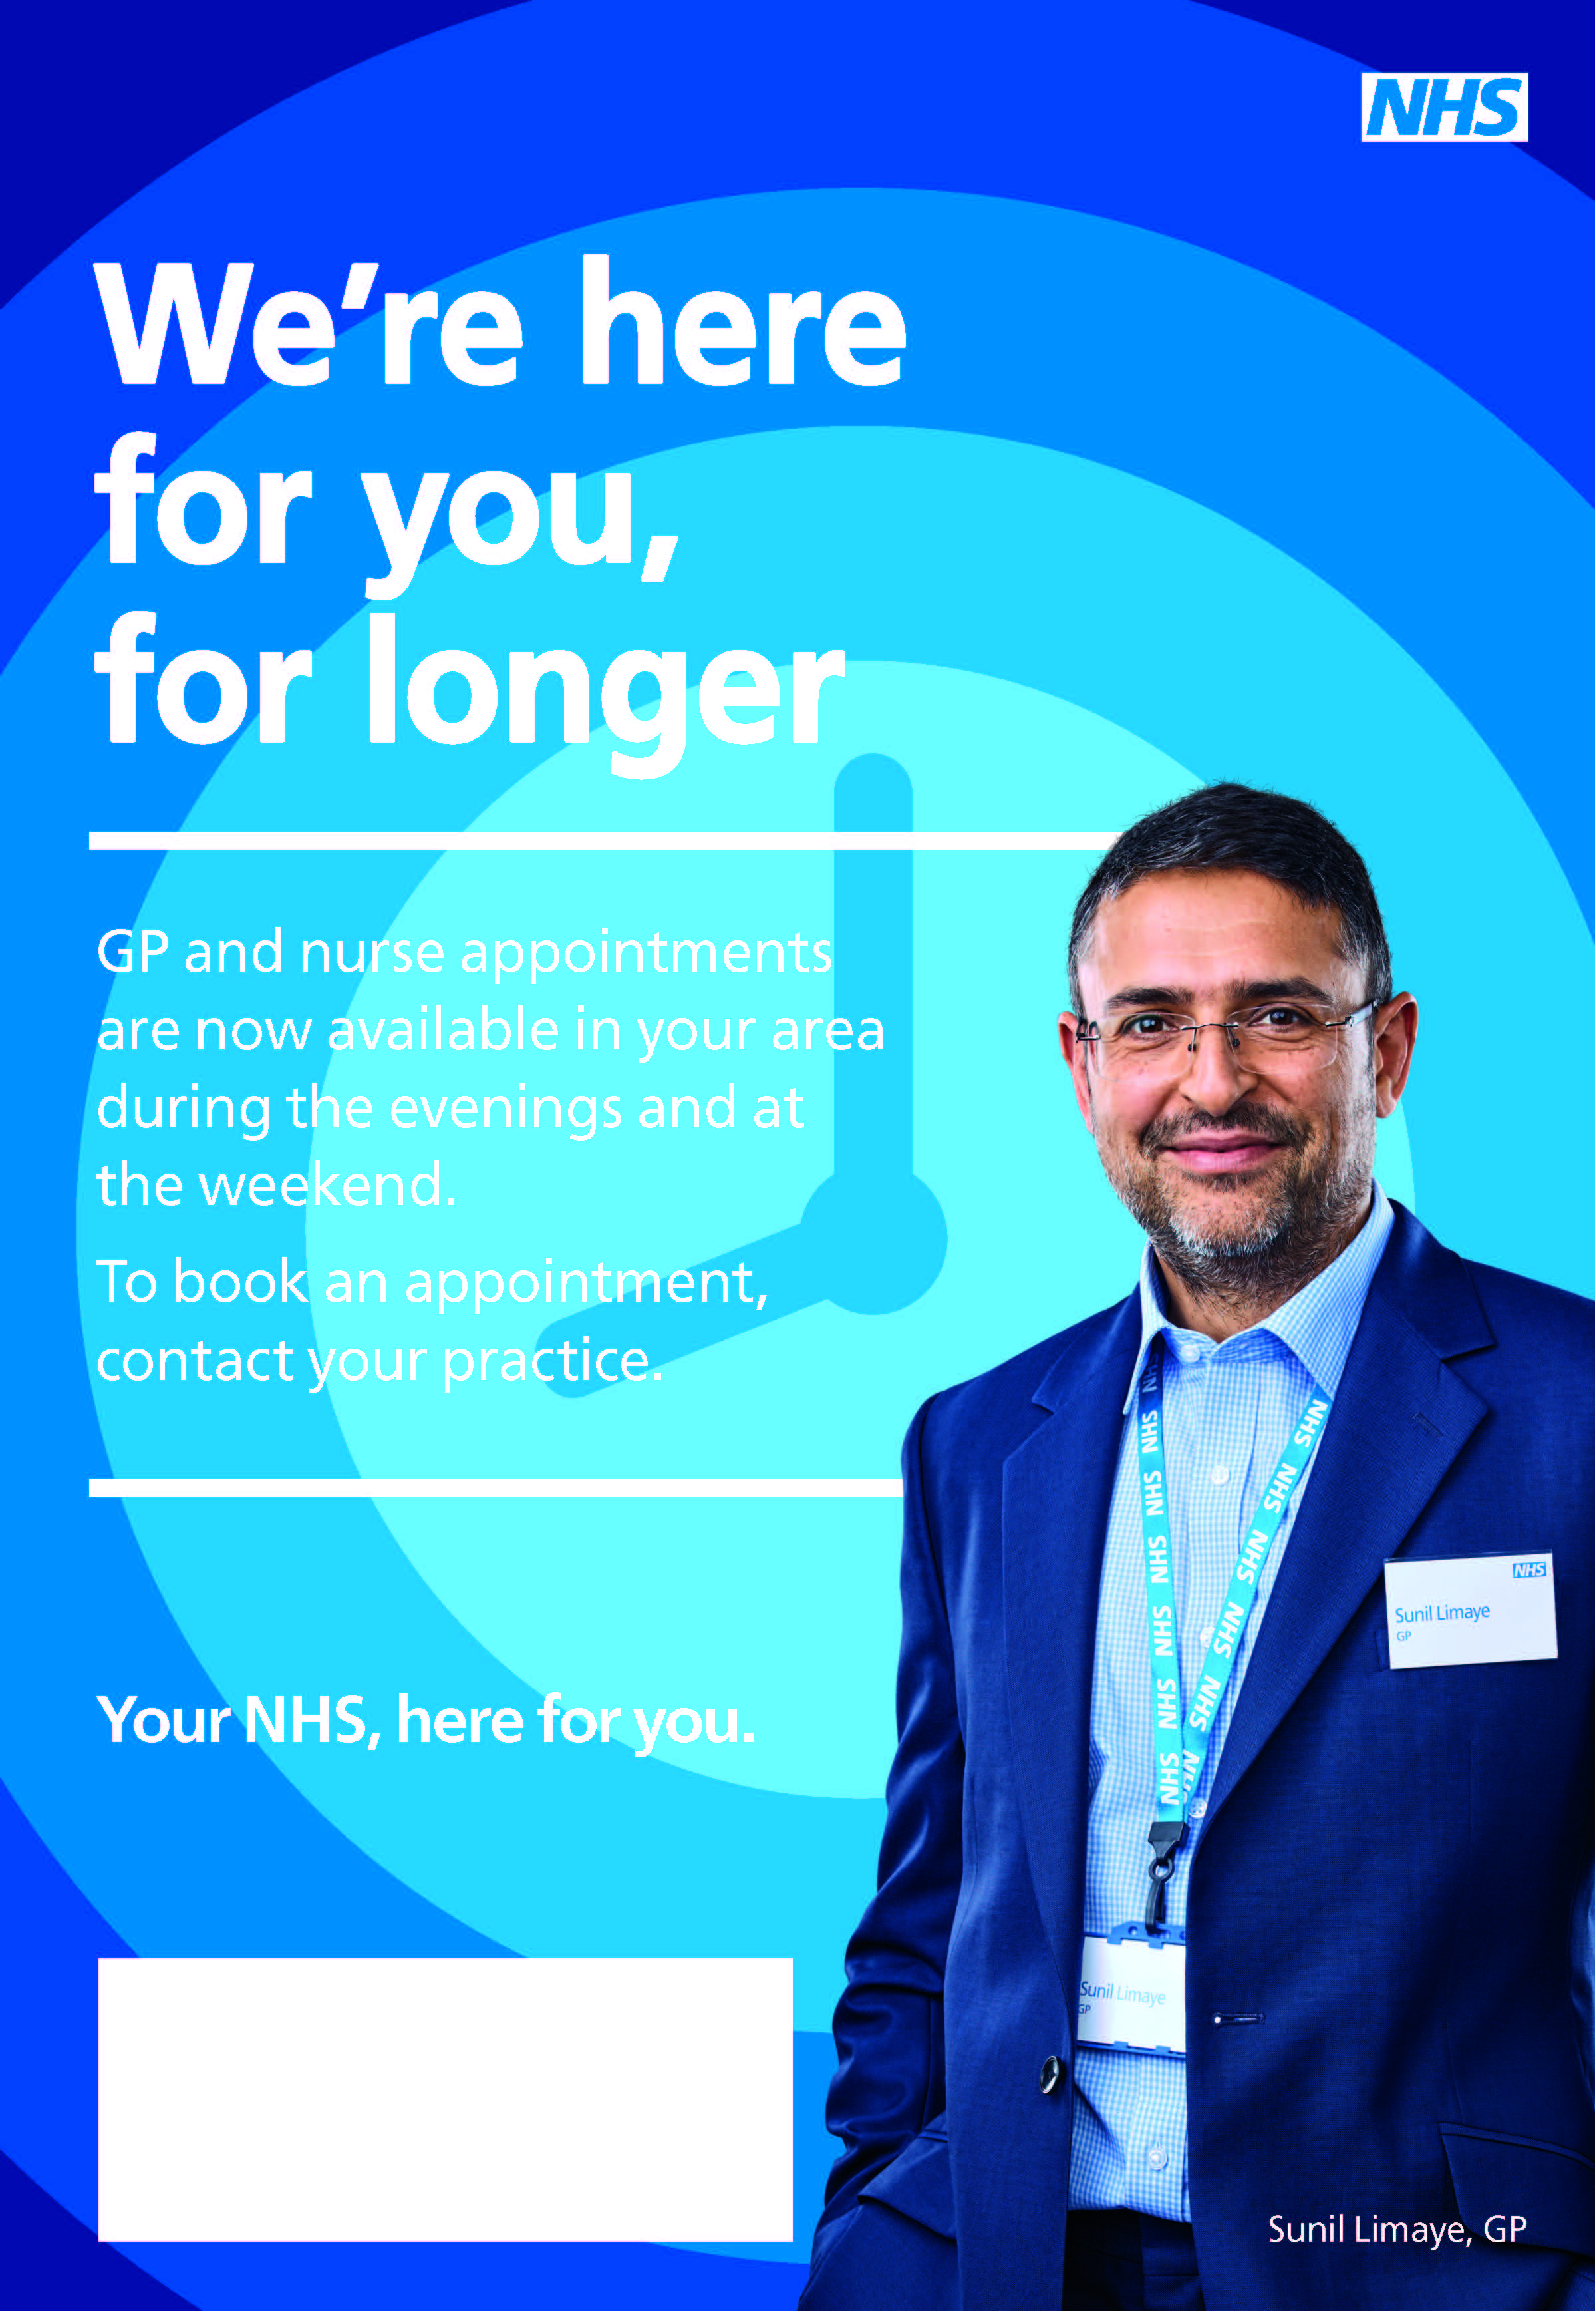

Dalston Medical Group

Townhead Road

Dalston, Carlisle

CA5 7PZ

Tel 01228 710451