The Crouch Hall Road Surgery

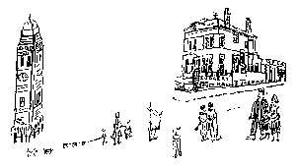
48 Crouch Hall Road Email: crouchhallroadsurgery@nhs.net
London N8 8HJ Web: www.crouchhallroadsurgery.nhs.uk
Tel: 020 8340 5952
Fax: 020 8340 3384

Zero Tolerance Policy
The Crouch Hall Road Surgery fully supports the NHS Zero Tolerance Policy. The aim of this policy is to tackle the increasing problem of violence against staff working in the NHS and ensure that all staff have a right to care for others without fear of being attacked or abused.
We understand that ill patients do not always act in a reasonable manner and will take this into consideration when trying to deal with a misunderstanding or complaint. We ask you to treat all staff courteously.
Aggressive behaviour (physical violence or verbally abusive behaviour), will not be tolerated and may result in you being removed from the practice list. The police will be contacted if an incident is taking place and the patient is posing a threat to staff or other patients.

Removal from the practice list
Removal of patients from our list is a rare event and is a last resort. When trust has irretrievably broken down, it is in the patient’s interest, just as much as that of the practice, that they should find a new GP. Immediate removal will take place on the grounds of violence or abusive behaviour.

Reviewed and updated April 2019

