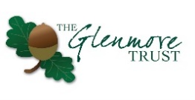
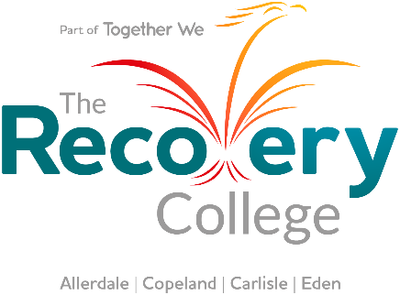
Recovery College Timetable
In partnership with

To sign up for a course click on the link to take you to the registration page.
For more information about each course see below the timetable.

 | Monday | Tuesday | Wednesday | Thursday | Friday | Saturday
Morning |  | Managing Stress  10.00 – 11.00  Jean-Ann & Emily | Assertiveness  9.00 – 10.00  Janine & Emily | How stress enters and leaves the body  10.00 – 11.00  Venetia & TBC | Draw & Talk  10.00 – 11.00  Janine &  Jean-Ann
Afternoon | WRAP  1.30 – 2.30  Janine &  Jean-Ann |  | Chair Exercise  2.30 – 3.00  Sam & Chloe | Dungeons & Dragons Introduction  2.00 – 4.00  Matt & Emily
Evening |  | Emotional Resilience  6.45 – 7.30  Janine & Emily

Wellness Recovery Action Planning
Written and evidenced by Mary Ellen Copeland this 6 session course provides you with tools to keep yourself well, notice triggers, identify early warning signs and plan for crisis' in an engaging and fun way.
It is a great course for anyone who would like to manage their health better.
Delivered by Janine, Emma, Johnny and Jean-Ann
Number of sessions: 6
Resources required: Discussed in the first session but a scrap book would work well or paper.
For more information: Email janine@ncrecoverycollege.org

Managing Stress
This course will benefit you if you have trouble managing stress and anxiety; following resources provided by Marie Chellingsworth from The CBT Resource, you will be guided through explanations and strategies to help understand and manage stress and worry.
Delivered by Jean-Ann and Emily
Number of sessions: 6
Resources required: Pen and paper to make notes.
For more information: Email jean-ann@ncrecoverycollege.org or emily@ncrecoverycollege.org

Emotional Resilience
Six sessions covering managing wellbeing, making changes/problem solving, eating well, sleeping well, relaxation and being mindful and moving forward. The sessions will help you to understand and manage your own resilience and increase understanding about the resilience of others, how wellbeing is affected and the positive changes that we can make to improve wellbeing.
Delivered by Janine and Emily
Number of sessions: 6
Resources required: Pen and paper to make notes.
For more information: Email janine@ncrecoverycollege.org or emily@ncrecoverycollege.org

Assertiveness
Would you like to be more assertive? Attend this course to find out what assertiveness is and isn’t, we will explore the different elements of assertive behaviours.
This course is beneficial to those who wish to improve their confidence in their everyday life.
Delivered by Janine and Emily
Number of sessions: 6
Resources required: Pen and paper to make notes.
For more information: Email janine@ncrecoverycollege.org or emily@ncrecoverycollege.org

Chair Exercise
A fun session based in a chair. Low impact exercise using a standard chair without arm rests. Improving your physical well being in your own home.
Safety notice: If you have any injuries or illnesses that may affect your ability to exercise please check with your GP.
Delivered by Sam
Number of sessions: 6
Resources required: Chair without sides or arms.
For more information: Email hello@ncrecoverycollege.org

How stress enters and leaves the body

Delivered by Venetia and TBC
Number of sessions: 6
Resources required:
For more information: Email hello@ncrecoverycollege.org

Dungeons and Dragons Introduction
The Dungeons and Dragons (also known as D&D) introduction will introduce people to the game and teach individuals how to run and play it themselves using online resources. The hope is this will help individuals struggling with loneliness and isolation establish a hobby to help establish a regular peer group and also be a jumping off platform into other self-taught per-led hobbies and interests as D&D tends to draw in a wide a varied group of individuals that have multiple interests, such artists, digital map makers and creative writing enthusiasts.
Dungeons and Dragons is a cooperative roleplaying game that is usually played by a group of 4-6 players and a Dungeon Master or “DM” that referees and runs the game.
“The Dungeons & Dragons role playing game is about storytelling in worlds of swords and sorcery. Like games of make-believe, D&D is driven by imagination. It’s about picturing a crumbling castle in a darkening forest and imagining how a fantasy adventurer (s) might react to the challenges that scene presents.” -From the official website look here for more information: https://dnd.wizards.com/
Delivered by Matt (The Glenmore Trust) and Emily
Number of sessions: 6
Resources required: A computer/laptop, stable internet connection, and a microphone/video camera (Many online D&D games choose to use audio only but it’s down to group preference) and an email account to log onto the main website that is used to play the game called Roll20. It does require a basic level of maths (adding and subtraction mainly) but nothing to complicated. Creative imagination is a key part of the game.
For more information: Email hello@ncrecoverycollege.org

Draw and Talk
Sessions based on the drawing and talking experiential training company.
Delivering 6 sessions of experiential drawing, where you draw whatever you feel. It can help process some of our underlying feelings and thoughts and is mindful in its delivery.
Anyone can join this session- expand your creativity and enjoy putting pen to paper.
Delivered by Janine and Jean-Ann
Number of sessions: 6
Resources required: Plain white paper, sharp pencil and a folder with your name on it
For more information: Email janine@togetherwe.uk or jean-ann@ncrecoverycollege.org

