HEATHERLANDS MEDICAL CENTRE
SUMMER NEWSLETTER
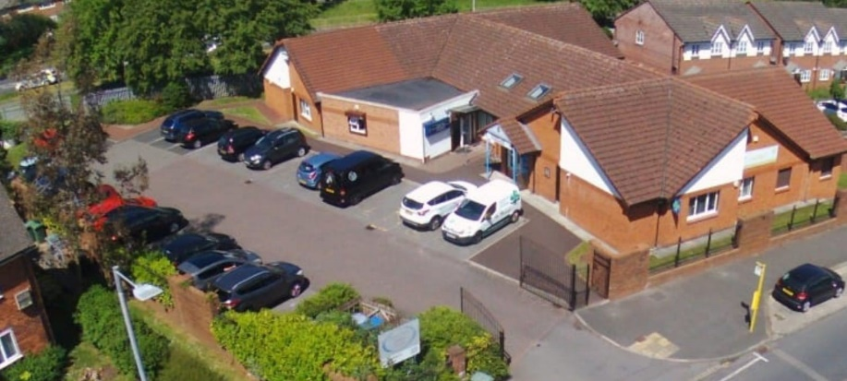

We are pleased to welcome new reception members to our team:-
Laura, Amanda and Lauri who have all joined us since April this year
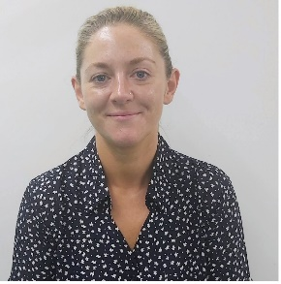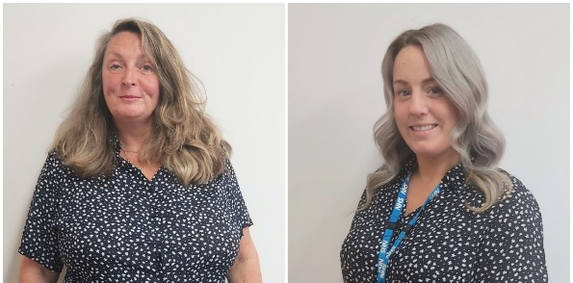
Staff News/Practice News
All our staff have recently completed their Basic Life Support Skills (BLS) Training.
Heatherlands has recently been the filming set for a new pilot sitcom. Head over to our website www.heatherlands.net to see photo’s of the film crew in action!
Our Healthcare Assistant Kelly Knight now has a dual role in the Practice and has become Deputy Manager/HCA, supporting the Practice Manager, Karen Jones.
In the news
There has been a recent out break of Polio in the UK
We urge parents to contact us at the surgery if they are unsure if their child has been vaccinated or if they know they have not been vaccinated for this and any other childhood vaccinations they have missed. This is the first outbreak in 40 years due to the NHS childhood vaccination programme but recently the uptake for vaccinations has reduced and further outbreaks of preventable childhood diseases will happen. The polio symptoms are flu like they course high tempters, fatigue, headaches, vomiting, stiff neck, muscle pain and in severe cases permanent paralysis.
Vaccinations should be given at 8,12 and 16 weeks old. Booster dose at pre school imms and age 14 in school imms. Please contact the surgery if you have any questions about the vaccinations.

Symptoms of monkeypox
If you get infected with monkeypox, it usually takes between 5 and 21 days for the first symptoms to appear.
The first symptoms of monkeypox include:
- a high temperature
- a headache
- muscle aches
- backache
- swollen glands
- shivering (chills)
- exhaustion
A rash usually appears 1 to 5 days after the first symptoms. The rash often begins on the face, then spreads to other parts of the body. This can include the genitals.
NHS AND HEALTHCHECKS 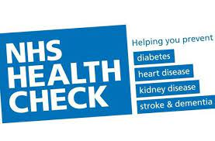
The Wirral Weight Management Service is FREE, confidential and for people with a BMI of 39.9 and over. The fully inclusive, friendly service helps people reduce their BMI and gives them access to a variety of nutrition and dietetics experts. The team delivers the service via one to one or group intervention with a multi-disciplinary approach to weight management. If you are interested, please make an appointment with the nurse.
OUR NURSES RUN HEALTH CHECK APPOINTMENTS 5 DAYS A WEEK WITH A WIDE RANGE OF APPOINTMENTS.
NHS health checks for the over 40’s
Cervical screening for all women aged 25- 64 years you will be invited by letter from the screening team when this letter arrives, please call the surgery to make an appointment with either Oriel or Lucy our Nurses. The procedure takes no longer than 5 minutes to be taken. The nursing team will be happy to answerer any worries or questions you may have around this appointment and a chaperon will be offered should you so wish.
Blood pressure checks
We now offer home loan monitors for patients to monitor their blood pressure for a week at a time please contact reception. Monitoring your blood pressure is important to a clearer idea of the risk of heart disease and stroke.
We have carried on with the chronic health conditions checks which include a yearly Asthma review and COPD review. Diabetic 6 monthly reviews, including yearly diabetic foot checks and eye screening. If you think you are due for any of these checks, please book a Nurse appointment.

JUNE
June has been the learning disability month and we as a surgery carry out yearly health reviews for all patients on the register and encourage all learning disability patients to attend this health check and support networks, we can sign post them to.
Carers
We also encourage to have yearly health checks and please inform us if you are a carer for anybody as we will code this and offer you health checks and any vaccination like the flu vacs you are entitled to.
Veterans
If you have been a service member of the armed forces, please inform staff as we will code this on your records as it may impact your health needs.
JULY TO AUGUST
Breast screening months for our surgery please be aware any lady aged 50 – 71 who is due their 3-year breast screening check will shortly receive a letter to book this. Early detection can give a better survival rate should you be diagnosed with breast cancer.
The NHS also offers bowel screening checks which are done at home for all people aged 60-74.
For men aged 65 you will be invited for a AAA screen this checks for abdominal aortic aneurysm.
Vaccinations 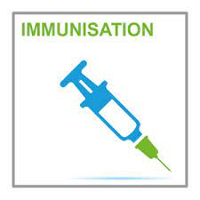
Spring covid boosters for the over 75 are still being given at the Miriam centre.
We here at the surgery offer shingle vaccinations for patients aged 70-79 years old
Pneumonia vaccinations for all people aged 65 and over or in an at-risk group.
We look forward to starting the 2022 Flu vaccination program in august people book in with our nurses if you are aged 65 and over or in an at-risk group. We also offer nasal flu vaccinations for all 2–3-year-olds.
We also hold weekly child immunisation clinics on a Thursday but are happy to make other appointments if this date does not suit.
We have a new message on our phones and ask if calling for results to call back in the afternoon after 2.30pm results will not be given before this time as it impacts on our reception team being able to take appointments calls.

Patient Participation Group members wanted
We request any patients who would be happy to volunteer some time to attend and help run a PPG group here at Heatherlands to contact karen.jones97@nhs.net or kellyknight@nhs.net.
The participation group is to help improve patient satisfaction and the services offered to the patients within our surgery. They identify areas in need of improving and help the practice meet all patient needs. We aim to hold the meetings every 2 months and attendance can be in person, via teams or with email suggestions. The practice manager Karen Jones and Deputy Manager Kelly Knight will be in attendance, and we aim to have a GP or nurse at the meeting. Please contact us if you can spare any time or would like to lead this group and meeting times can be made to suit the majority.
Finally, we thank you all for the support given during Covid times and have now fully resorted back to face-to-face appointments daily with doctors and nurses. We carry on with telephone consultations at patient request as we know it can fit in better with some patients. Sick notes request must be made on the day they are due before 10am and the doctor will the action this. All prescriptions have a 48 hour turn around please remember this when placing repeat requests.

