Phone: 01702 710131

1643 London Road

Leigh on Sea

Essex

SS9 2SQ

#### Tel 01702 710131

Sharps Disposal

For Patients

**Shoebury House**

Ness Road, Shoeburyness Essex SS3 9DL

01702 577600

**Warrior House Health Centre**

42-48 Southchurch Road Southend Essex SS1 2LZ 01702 577000

**Thorpedene Clinic**

Delaware Road Shoeburyness SS3 9NW

01702 578800

**Westcliff Clinic**

415 Westborough Road Westcliff Essex

01702 577370

**St. Lukes Health Centre**

Pantile Ave Southend Essex SS2 4BD

01702 611505

Highlands Surgery

Highlands Surgery

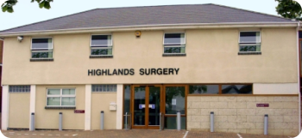

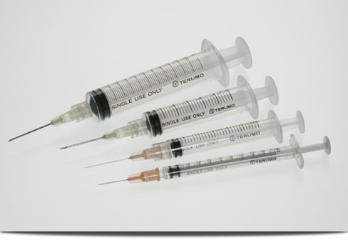

Medical waste should not be placed into kerbside recyclable bins. This waste is not recyclable and could contaminate other material causing problems at the recycling facility.

Needles could harm the staff involved and potentially spread disease.

Medical waste includes:

Sharps boxes (full or empty)

Needles/syringes

Incontinence waste/nappies

Bandages, plasters and dressings.

Needles should be disposed of into a sharps box and boxes should be either taken to your local health centre below:-

**Castle point area:-**

**Benfleet Clinic**

513 High Road, Benfleet, Essex SS8 0JA

01268 366840

**Central Canvey Primary Care Centre**

Long Road, Canvey Island Essex SS8 0JA

01268 686000

**Hadleigh Clinic**

49 London Road, Hadleigh, Essex, SS7 2QL

01702 578600

**Thundesley Clinic**

8 Kenneth Road, Thundesley, Essex SS7 3AT

01268 366820

Rochford Area

**Hockley Clinic**

53 Spa Road, Hockley, Essex, SS5 4AR

01702 578700

**Hullbridge Clinic**

130 Ferry Road, Hullbridge, Essex SS5 6EU

01702 577900

**Mapline House**

14 Bull Lane, Rayleigh, Essex SS6 8JD

01268 775650

**Raphael Clinic**

Old Ship Lane, Rochford, Essex, SS4 1DD

01702 549547

**Rayleigh Clinic**

Eastwood Road, Rayleigh, Essex SS6 7JP

01268 366600

**Southend Area**

**Kent Elms Clinic**

1 Rayleigh Road Eastwood Essex SS9 5UU

01702 577500

**Kingsley Ward Centre**

42-82 Southchurch Road Send, SS1 2LZ

01702 577110

**Leigh Primary Care Centre**

918 London Road, Leigh on Sea SS9 3NG

01702 582800