Phone: 01702 710131

1643 London Road

Leigh on Sea

Essex

SS9 2SQ

#### Tel 01702 710131

Semen Analysis

Investigation

Highlands Surgery

Highlands Surgery

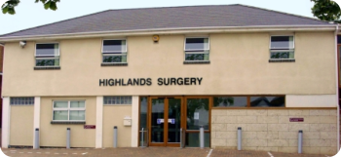

[](http://afrovibez.com/dev/wp-content/uploads/2014/02/semen.jpg)

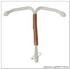

You have been asked to provide a semen sample so that your doctor can check whether it shows any problems associated with inability to conceive.

The semen sample that you provide will be analysed as follows:-

* Examined to see whether your sperm are moving.
* Examined for number of sperm present.
* Examined for appearance/structure of the sperm.

To ensure that we are able to provide an accurate result it is important that you follow the instructions below.

* **You must make an appointment for your test to be performed. Please telephone the booking line on 01702 422555 ext 7726.**
* Label the specimen container provided, with your full name, date of birth, sample date and time you produce your sample.
* You must NOT have ejaculated for three days prior to producing a specimen. However you should have ejaculated within the last seven days.

Please complete the slip below and bring to the hospital with your sample.

Full Name …………………………………

Date of Birth……………………………….

Date and time of sample

……………………………………………….

Has all the semen from this ejaculation been collected?

YES NO

I have read and followed the above instructions.

Signature ………………………………….

* Produce your specimen no longer than one hour prior to your appointment time.
* The specimen should be produced by masturbation (self-stimulation) directly into the container provided. A condom must NOT be used for collection of the specimen.
* It is important that ALL of the semen is collected into the container.
* Make sure the lid of the container is screwed on securely so it does not leak.
* Place the specimen container into the plastic bag provided.
* The specimen MUST be kept warm after collection so place in an inside pocket close to your body.
* Bring your specimen together with the specimen request form to pathology reception on the first floor of the tower block, Carlingford Wing.
* Please ensure you deliver the specimen at your appointment time and within one hour of collection.
* Your results will be sent back to the requesting doctor and will usually be available in 10 days. The laboratory cannot give you your results directly.