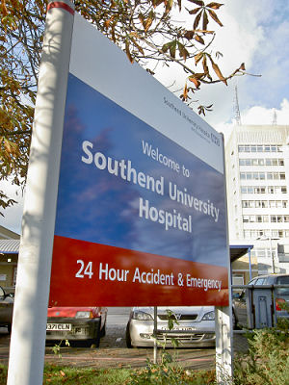

My Named GP is

My Care Coordinator is



Telephone number



Email address



Phone: 01702 710131

1643 London Road

Leigh on Sea

Essex

SS9 2SQ

#### Tel 01702 710131

Patients care review and support

Highlands Surgery

Highlands Surgery

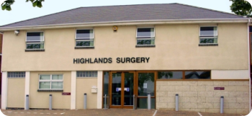

within the surgery, as you would normally do.

Your named GP and named care coordinator will work with you to develop a personal care plan and review/discuss any changes needed. We will also invite, with your agreement, other health and care professionals involved in your care to help develop and keep your personal care plan up to date.

Your care planning discussion will help us (you, your carer, your named GP and named care coordinator) to think about your health and care needs. With your agreement, your personal care plan will include information like.

* Your NHS number
* Details of your named GP and care co-ordinator
* details of any other health and care professional who are involved in your care.
* Confirmation that you have agreed to sharing your care plan with relevant health or care professionals.
* Details of your conditions and significant past medical history.
* Details of any medications that you are taking and plans for reviewing them.
* Any allergies
* The action that you are taking to manage your health.
* How you can detect any early signs that your health may be worsening and what you should do if this happens
* Who to contact if you think that you need to see a doctor or nurse urgently.

Your named GP and named care coordinator will work with you to review your health needs as often as necessary and at least every three months. They will ensure that you receive support from us and others to help you manage your health. We may also be able to help you find local community resources that you may find helpful.

We will also make sure that, whenever you have an urgent need to see or speak to a GP or nurse, as soon as possible on the same day one of our GPs or nurses will phone you back to help deal with your problem.

If you have any question, or would prefer not to receive this service, please contact us on (phone number) or at (email address)

The NHS England has introduced a new service for people who are more at risk for an unplanned hospital admissions and who would be likely to benefit from more tailored, active support from their GP surgery. We believe personal care planning could help improve the health and wellbeing of patients receiving this service, as well as to help reduce the risk of unplanned hospital admissions.

**What does this mean for you, as a patient?**

As a member of this programme, you will have a named GP from our surgery and they will have overall responsibility for the care and support that your surgery provides for you. We will also make sure that you have a named care coordinator, who may be your named GP or another health professional involved in your care and who will likely be the person from our surgery who you see the most. Your named care coordinator will be responsible for sharing information with you, (your carer) and – if you are happy for us to do so – with other health or care professionals involved in your care. These new arrangements do not prevent you making an appointment or seeing any doctor of your choosing