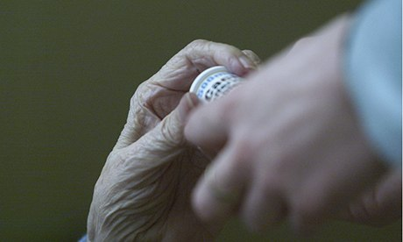

Phone: 01702 710131

1643 London Road

Leigh on Sea

Essex

SS9 2SQ

#### Tel 01702 710131

Named GP for patients aged 75

and over

Highlands Surgery

Highlands Surgery

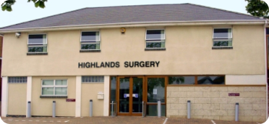

01702 710131

My Named GP is

Telephone number



**Did you know?**

**Influenza vaccinations**

Every year Highlands Surgery offer all our patients over the age of 65 and those with chronic diseases an influenza vaccination.

The surgery orders the next years flu vaccines in early December for delivery around mid to end of September. Clinics are always arranged at the end of September through to December. The surgery likes to have completed most, if not all of the vaccines by the end of the year.

Patients who are housebound should contact the surgery and put their names onto a visit list. This service is strictly for patients who are housebound and this is triaged accordingly.

**Pneumonia**

Pneumonia vaccines can be given at the same time as the flu vaccine. Unlike the flu vaccine the pneumonia injection is only necessary once in a lifetime, unless you no longer have a spleen.

**Is there anyone who shouldn't have the vaccination ?**

Most people can have the vaccine, but you should not be vaccinated if you have had a serious allergy to the vaccine in the past, or if you have a serious allergy to hens’ eggs.

If you have a fever, it is best to delay the vaccination.

**Named GP for patients aged 75 and over.**

From April 2014, all patients aged 75 and over will have a named GP who will have overall responsibility for the care and support that our surgery provides to them.

**What does this mean for our patients aged 75 and over?**

As one of our patients in this group, you will be given a named GP.

Your named GP will have overall responsibility for the care and support that our surgery provides to you. They will also work with our relevant health and care professionals, who are involved in your care, to ensure that your care package meets your individual needs.

**Any questions?**

If you have any questions, or wish to discuss this further with us, please contact us on 01702 710131.