
Phone: 01702 710131

1643 London Road
Leigh on Sea
Essex
SS9 2SQ
Highlands Surgery
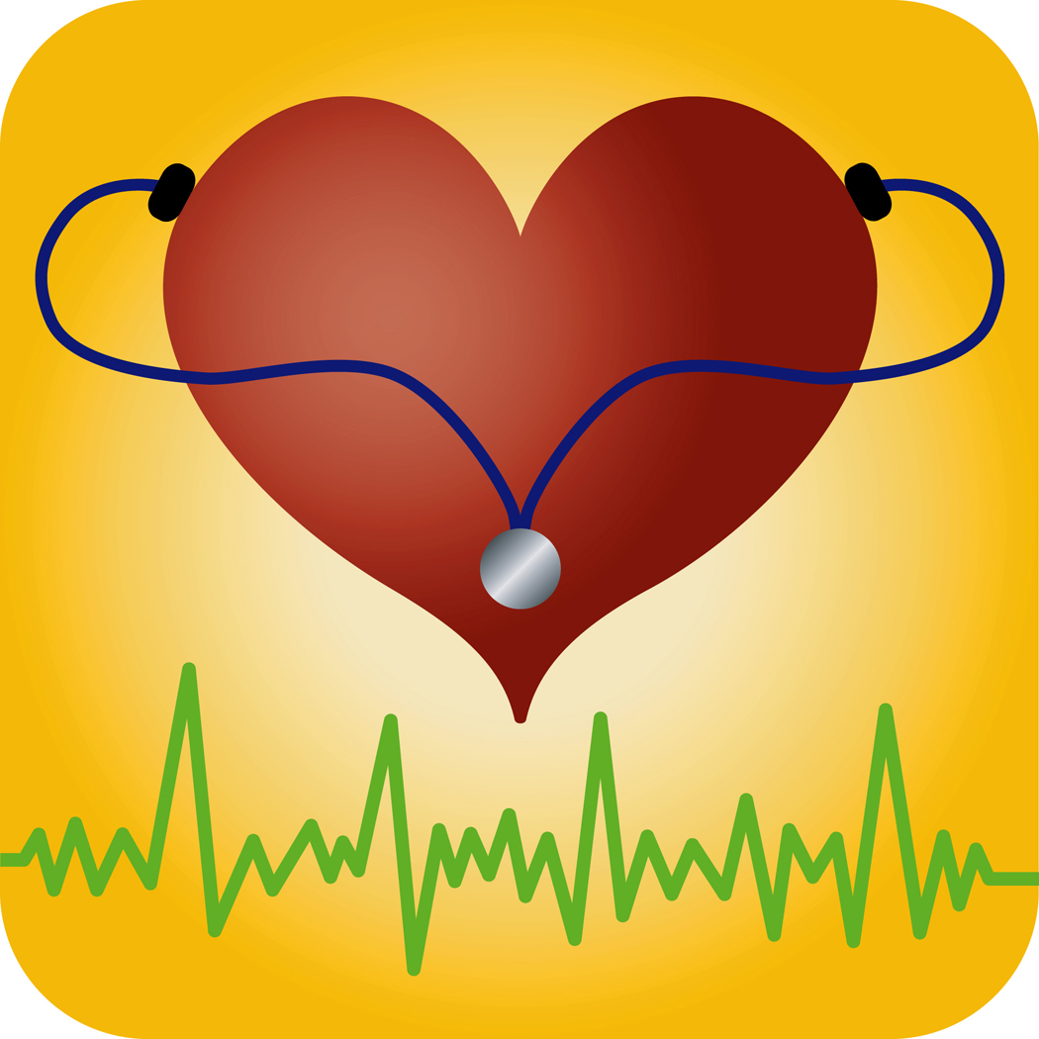

Tel 01702 710131
Cholesterol
Lowering
Diet
Do they work?
Clinical studies show that eating these functional foods 2 – 3 times a day may reduce LDL cholesterol levels.
It is important to remember that you must also follow a healthy diet and take regular exercise, if you are using these products.
Atheroma | Fatty material that can build up within the walls of the arteries.
Artherosclerosis | The build up of fatty material within the walls of the arteries
Blood cholesterol | Cholesterol in the blood.
Blood lipids | Fatty substances found in the blood
Coronary heart disease | When the walls of the arteries become narrowed by a gradual build up of atheroma.
Electrocardiogram (ECG) | A test to record the rhythm and activity of the heart.
HDL | High density lipoprotein, The protective cholesterol.
Hypertension | High blood pressure
LDL | Low density lipoprotein. The more harmful cholesterol.
Lipids | Fatty substances in the blood.
Lipoproteins | Combinations of cholesterol and proteins.
Mmol/l | Millimoles per litre. Used for measuring cholesterol and other fats in the blood.
Omega-3 fat | An oil found in certain types of fish.
Triglycerides | A type of fatty substance found in the blood

Highlands Surgery

How can healthy eating lower my cholesterol levels?
Diet plays an important role in both the prevention and treatment of coronary heart disease. It is possible to lower cholesterol levels by; cutting down on fats, and replacing some of the saturated fats with unsaturated fats. It is also important to follow a healthy diet.
You should aim to:
- Reduce total amount of fat in the diet.
- Lower the intake of saturated fat, by replacing it with polyunsaturated (PUFA) and monounsaturated (MUFA) fats. This means reducing foods such as fried foods, pastry, fatty meat products, full fat mayonnaise and salad dressings, full fat dairy products, cakes, biscuits, chocolate and creamy desserts and use small amounts of low fat spread and cooking oil.
- Choose high fibre foods such wholemeal bread, wholegrain cereals, rice, pasta, potatoes. These should be a major part of every meal. Oat-based cereals are a good choice for breakfast. Crackers, crisp breads and plain biscuits are useful snacks.
- Fruit & vegetables, at least 5 portions per day. These foods are particularly beneficial as they provide nutrients which help protect the heart.
- Milk and dairy products: 2-3 portions per day. Choose low fat dairy products e.g. low fat milk, cheeses, yoghurts and fromage frais.
- Meat, fish and alternatives: about 2 servings per day. Limit fatty meats like pies, sausages, burgers, salami and pate. Choose lean meats. fish, sardines, herrings, mackerel. Aim to have oily fish in the diet at least 2 – 3 times per week. Include pulses, beans peas lentils in the diet, these are a good source of soluble fibre, which can help to lower blood cholesterol levels.
- Take care with sweet and sugary foods.
Cholesterol is a soft, fat like substance found in all your body’s cells. Cholesterol plays a vital role in the functioning of every cell wall throughout the body. However, too much cholesterol in the blood may increase your risk of developing coronary heart disease. Cholesterol comes from two sources.
- It is made in your body, mainly in the liver.
- Dietary fats e.g. saturated fats which are found mainly in animal products.
What are lipoproteins and blood lipids?
Proteins are important for the transport of cholesterol in the blood. The combination of cholesterol and proteins are called lipoproteins.
Lipoproteins: There are two main forms of lipoproteins.
- Low density lipoproteins (LDL), “bad fats”, which carry cholesterol from the liver to the body’s cells.
- High density lipoproteins (HDL) “good fats”, which return cholesterol to the liver.
Blood Lipids: This is the name for all fatty substances in the blood, including HDL cholesterol, LDL cholesterol and triglycerides.

If you have high levels of both triglycerides and blood cholesterol, you run a greater risk of coronary heart disease. The risk is particularly high if you also have a low level of HDL cholesterol.
When does high blood cholesterol level matter?
A high level of cholesterol is one of many important risk factors towards developing coronary heart disease. The other major factors are:
- Smoking High blood pressure
- Lack of physical activity Being overweight
- Excess alcohol intake High Salt Intake
- Stress

The higher your cholesterol level is, the higher your risk is of developing heart disease.
Tips on reducing fat in the diet
Try cooking foods in ways that do not use fats:
Boiling dry roasting Casseroling
Grilling poaching Steaming microwaving
- If you need to use oil to cook e.g. stir fry, choose a suitable oil & use as little as possible.
- There is no need to add butter/margarine to vegetables or potatoes.
- Remove all visible fat on meat and skin on poultry.
- Skim fat from the surface of mince, casseroles, stews or curries.
- Try a mash potato topping instead of pastry, or just putting pastry on the top of the pie instead of top and bottom.
- Avoid adding cream to sauces or soups.
- Spread butter or margarine thinly on bread, toast and crackers.
- Avoid adding cream to sauces or soups.
- Spread butter or margarine thinly on bread, toast and crackers.
- You may not need to use spread on sandwiches.
- Use tomato based sauces on pasta or with meat/fish, instead of cream/cheese based sauces.
What are functional foods?
Functional foods e.g. Benecol, Flora proactive are clinically proven cholesterol lowering foods made from plant sterol esters. Plant sterol esters are found in small amounts in grains such as corn, rye, oats and wheat. Functional foods include spreads, cream cheese and yoghurts.

