[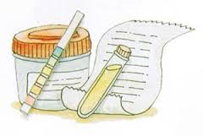](http://www.google.co.uk/imgres?sa=X&rls=com.microsoft:en-gb:IE-Address&biw=1280&bih=843&tbm=isch&tbnid=dLXJjtSogu_qfM:&imgrefurl=http://www.guioteca.com/diabetes/%C2%BFque-es-la-microalbuminuria/&docid=Kz3VC5avyQmgkM&imgurl=http://g.cdn.mersap.com/diabetes/files/2011/09/microalbuminuria.jpg&w=300&h=202&ei=DG_NUsW1OoXwhQfC3oHwBA&zoom=1&iact=rc&dur=16&page=1&tbnh=149&tbnw=209&start=0&ndsp=32&ved=1t:429,r:20,s:0,i:149&tx=105&ty=87)

Phone: 01702 710131

1643 London Road

Leigh on Sea

Essex

SS9 2SQ

#### Tel 01702 710131

Information Sheet

Micro-albuminuria

Adult Males

Store your sample in a plastic bag, in a refrigerator if possible

The sample should be taken to the surgery along with the enclosed request form.

Highlands Surgery

Highlands Surgery

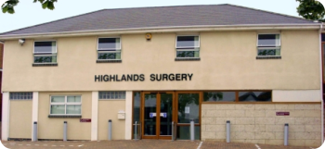

[](http://www.google.co.uk/imgres?sa=X&rls=com.microsoft:en-gb:IE-Address&biw=1280&bih=843&tbm=isch&tbnid=dLXJjtSogu_qfM:&imgrefurl=http://www.guioteca.com/diabetes/%C2%BFque-es-la-microalbuminuria/&docid=Kz3VC5avyQmgkM&imgurl=http://g.cdn.mersap.com/diabetes/files/2011/09/microalbuminuria.jpg&w=300&h=202&ei=DG_NUsW1OoXwhQfC3oHwBA&zoom=1&iact=rc&dur=16&page=1&tbnh=149&tbnw=209&start=0&ndsp=32&ved=1t:429,r:20,s:0,i:149&tx=105&ty=87)

Small amounts of protein in urine (micro-albuminuria) may indicate an increased risk of developing diabetic complications. Fortunately this may occur up to 15 years before development of complications and early treatment may be given to prevent or reduce the severity of the complications. As part of your continuing care we would like to assess if you have a small amount of protein in your urine.

Because of the significant daily variation in urinary protein output we need you to collect a mid-stream early morning urine sample as described below.

We would also ask that you refrain from vigorous sporting exercise and sexual intercourse for two days before you start to collect the urine sample.

If you have a urine infection you should wait until your infection has been successfully treated before starting the urine collection.

Please ask at reception for a white topped container if not already provided.

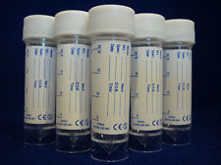

# *Collection Procedure*

No vigorous sporting exercise or sexual intercourse

After rising from your night’s sleep, collect a mid-stream urine sample as described below.

Pass some urine into the toilet

Pass some urine into the sample bottle or into a clean collecting vessel from transfer into the sample bottle.

Finish emptying your bladder into the toilet

Write your name, date of birth, date and time of urine collection on the sample bottle label