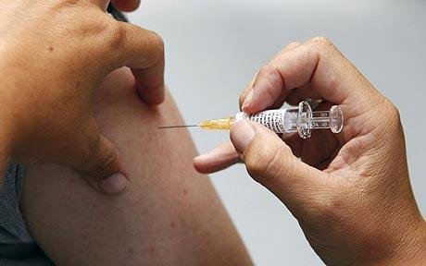

Phone: 01702 710131

1643 London Road

Leigh on Sea

Essex

SS9 2SQ

#### Tel 01702 710131

Influenza and Pneumonia vaccination

The vaccination will help your body to fight the flu virus. Your body starts making antibodies against the viruses about a week to ten days after the injection. These antibodies help to protect you for a whole year against similar seasonal flu viruses that you may come into contact with.

The seasonal flu vaccination will not protect you against:

• swine flu

• the common cold

• other winter viruses.

**A seasonal flu vaccination is**

**your best protection**

Highlands Surgery

Highlands Surgery



**Influenza**

Every year Highlands Surgery offer all our patients over the age of 65 and those with chronic diseases an influenza vaccination.

The surgery orders the next years flu vaccines in early December for delivery around mid to end of September. Clinics are always arranged at the end of September through to December. The surgery likes to have completed most, if not all of the vaccines by the end of the year.

Patients who are housebound should contact the surgery and put their names onto a visit list. This service is strictly for patients who are housebound and this is triaged accordingly.

# Highlands Surgery

# Flu and Pneumonia

**Other groups**

Vaccination is also available even if you don’t fall into one of the categories, but are a carer of someone who relies on you and could be affected if you became ill.

If you’re not sure whether you qualify, please contact the surgery.

If you are pregnant and in an at-risk group, you can still have the seasonal flu jab. There are no reported problems from giving the vaccine to pregnant women.

**Is there anyone who shouldn't**

**have the vaccination ?**

Most people can have the vaccine, but you should not be vaccinated if you have had a serious allergy to the vaccine in the past, or if you have a serious allergy to hens’ eggs.

If you have a fever, it is best to delay the vaccination.

**Pneumonia**

Pneumonia vaccines can be given at the same time as the flu vaccine. Unlike the flu vaccine the pneumonia injection is only necessary once in a lifetime, unless you no longer have a spleen.

**Do I qualify?**

The seasonal flu and one-off pneumonia* vaccination is offered free of charge to anyone over the age of six months with the following medical conditions, as they are at higher risk:-

• chronic (long-term) respiratory disease, such as severe asthma, Chronic obstructive pulmonary disease (COPD) or bronchitis

•  chronic heart disease, such as heart failure

•  chronic kidney disease

•  chronic liver disease

•  chronic neurological disease, such as Parkinson's disease or motor neurone disease

• diabetes

• a weakened immune system due to disease (such as HIV/AIDS) or treatment (such as cancer treatment)