
Phone: 01702 710131

1643 London Road
Leigh on Sea
Essex
SS9 2SQ

Seasonal flu
myth buster
Highlands Surgery
Highlands Surgery


Tel 01702 710131
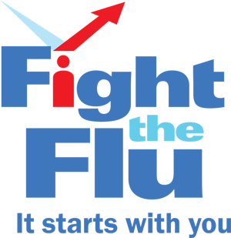

Healthy people don’t get seasonal flu?

Generally, 15-20% of the population gets flu each year – healthy people included!

Hand-washing is very important, but it won’t stop flu?

It is vital to follow universal infection prevention procedures and wash your hands, but once flu has been passed on to your family, colleagues or patients, clean hands won’t keep flu at bay.

The flu jab will give you flu?
It is impossible to get flu from having the flu jab. This is because the vaccine doesn’t contain any live viruses.

I have had the flu jab before so I don’t need it again?
People should be vaccinated against seasonal flu every year. There is no such thing as natural immunity to influenza; with new strains circulating this year, it is best to get vaccinated against flu.

The side effects of the vaccination are really bad?
For the most part, side effects of the seasonal flu vaccination are really mild or often non-existent.

I can’t have the vaccine if I’m pregnant?
The flu vaccine is safe for all pregnant women and can be given at any stage of pregnancy.
Flu vaccination could harm my unborn baby?
It is safe to give flu vaccine at any stage of pregnancy.

Flu can be treated with antibiotics?
No, it can’t. Like colds viruses cause flu and antibiotics only work against bacteria.

Anyone can have the flu jab?
No, you need to be in one of the “at risk” groups to qualify for the flu jab, information is available at reception. If you are not in one of these groups vaccinations are available from your local pharmacy.

