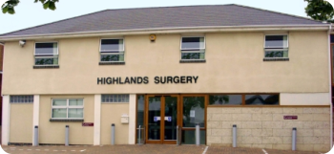

Phone: 01702 710131

1643 London Road
Leigh on Sea
Essex
SS9 2SQ

Tel 01702 710131
Long-acting reversible contraception (LARC)

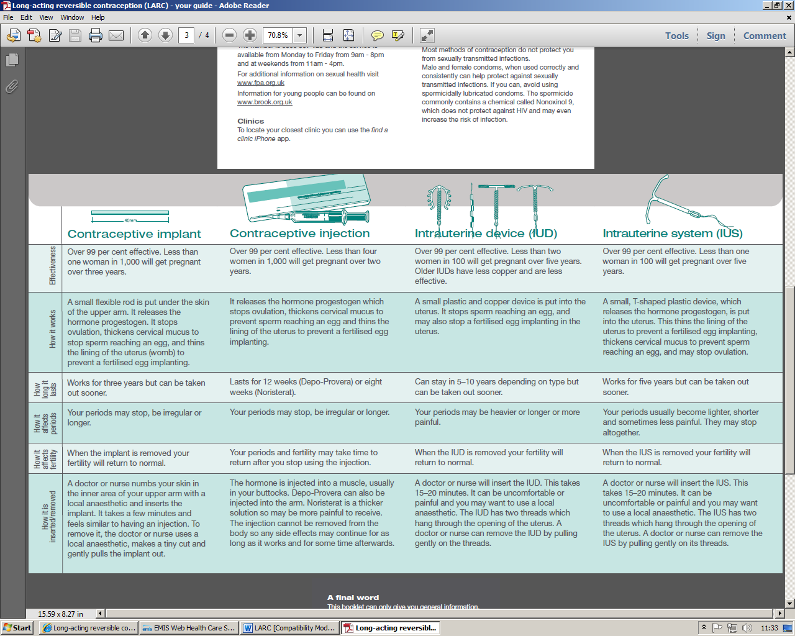

Highlands Surgery
Highlands Surgery

There are many different contraceptive methods
available in the UK and you should choose one
that suits you. This leaflet provides information
about four methods that do not depend on you
remembering to take or use them to be effective.

