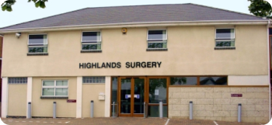
Phone: 01702 710131

1643 London Road
Leigh on Sea
Essex
SS9 2SQ
Highlands Surgery
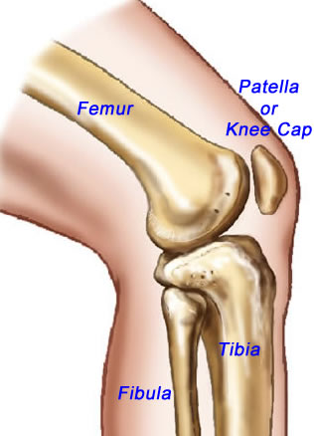

Tel 01702 710131

Knee
Exercise
- Dips. Stand with affected leg on a step or block. Slowly bend knee to between 20 – 40 degrees, then straighten fully. Ensure that unaffected leg makes no contact with the floor or the step.

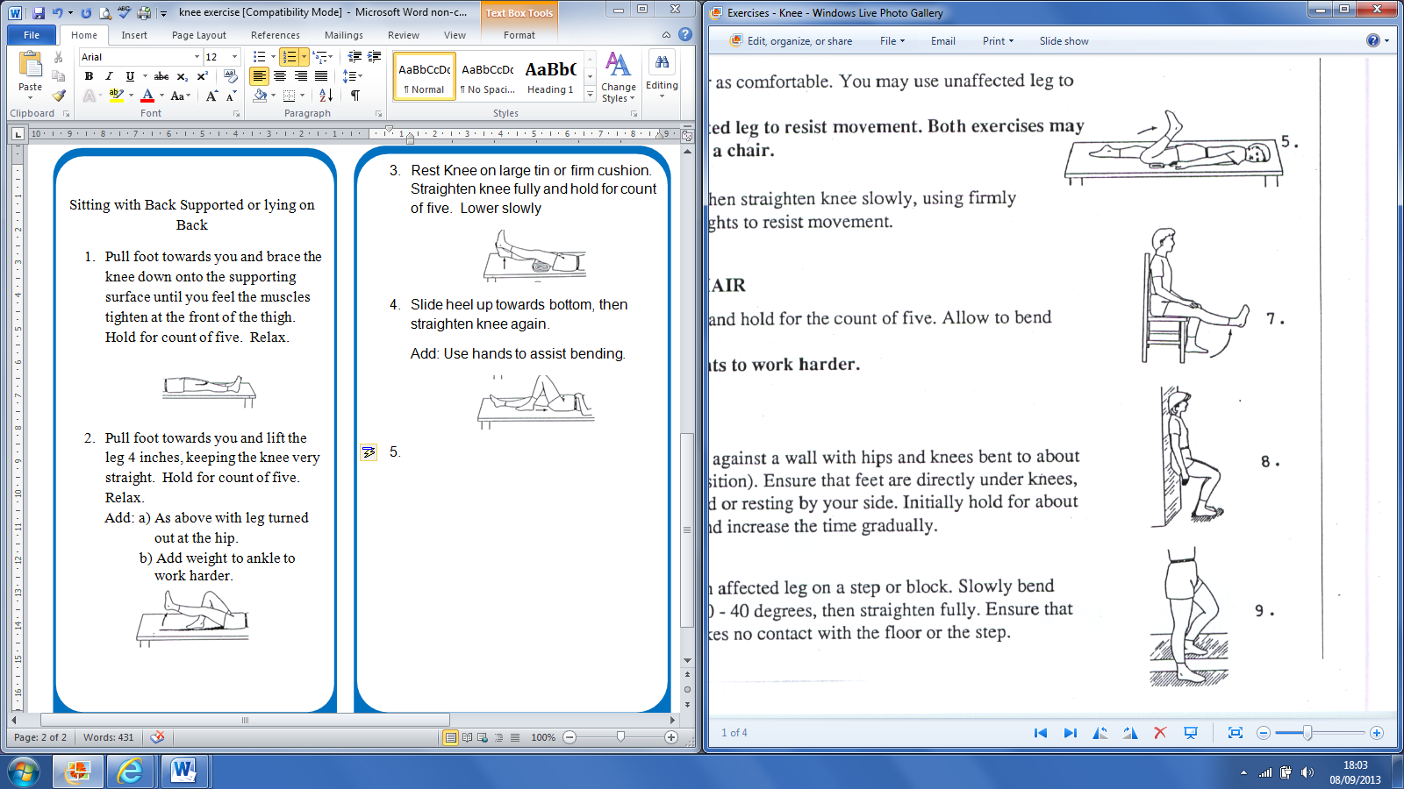
Highlands Surgery

Sitting with Back Supported or lying on Back
- Pull foot towards you and brace the knee down onto the supporting surface until you feel the muscles tighten at the front of the thigh. Hold for count of five. Relax.
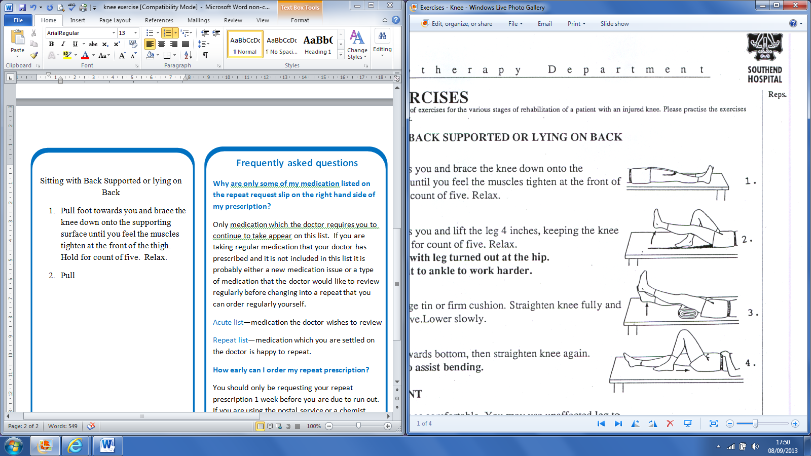
- Pull foot towards you and lift the leg 4 inches, keeping the knee very straight. Hold for count of five. Relax.
Add: a) As above with leg turned out at the hip.
b) Add weight to ankle to work harder.

- Rest Knee on large tin or firm cushion. Straighten knee fully and hold for count of five. Lower slowly
- Slide heel up towards bottom, then straighten knee again.
Add: Use hands to assist bending.
Lying on Front
- Bend knee as far as comfortable. You may use unaffected leg to assist movement.
Add: Use unaffected leg to resist movement. Both exercises may be done sitting on a chair.
- Fully bend and then straighten knee slowly, using firmly attached ankle weights to resist movement.
Sitting on Chair
Straighten knee and hold for the count of five. Allow to bend slowly, rest.
Add: Ankle weights to work harder
Standing
- Stand with back against a wall with hips and knees bent to about 75 degrees (ski position). Ensure that feet are directly under knees, and arms are folded or resting by your side. Initially hold for about 20 – 30 seconds, and increase the time gradually.

