Phone: 01702 710131

1643 London Road

Leigh on Sea

Essex

SS9 2SQ

#### Tel 01702 710131

Advice on Pelvic Floor Muscles

After a few months, you should start to notice the results. Your incontinence should improve, as well as the sensitivity you experience during sex. You should carry on doing the exercises, even when you notice them starting to work.

See our other leaflets including

Breastfeeding and thrush

Coil fitting and replacement

Cardio vascular disease prevention

Prescriptions

Highlands Surgery

Highlands Surgery

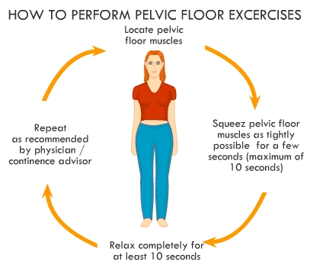

The muscles support and surround the back passage and the birth canal (vagina) They get stretched when a baby is born and need strengthening afterwards.

If the pelvic floor muscles are weak the following problems may occur.

• Lack of complete control of your bladder.

• Reduced pleasure in love-making for you and your partner.

• Lack of support for the pelvic organs leading to possible prolapse.

# 

# Pelvic Floor Muscles

***Pelvic Floor Exercises***

• Sit, stand or lie, and without tensing the muscles of your legs, buttocks or abdomen, tighten the ring of muscle around the back passage by imagining that you are trying to control passing wind. This will help you identify the back part of the pelvic floor.

• When you are passing urine, try to stop the flow, then restart it. Gradually you will become aware of the front muscles of the pelvic floor.

• Working from back to front, tighten muscles while counting to four slowly, then release them.

• Do this four times every hour for the next three months.

You can do the exercises anywhere—sitting or standing, while watching television or waiting for a bus. There is no need to interrupt your normal daily activity. After practising for 2—3 weeks you will feel the closure of the back and front passages and a drawing up of the pelvic floor in front.

**The Pelvic Floor Test**

Try this test three months after starting the exercise.

• Ensure the bladder is nearly full and stand with feet apart.

• Jump up and down on the spot three times, and cough deeply.

No leakage of urine proves that your pelvic floor is strong!

Exercise your pelvic floor as necessary to obtain and maintain this standard.