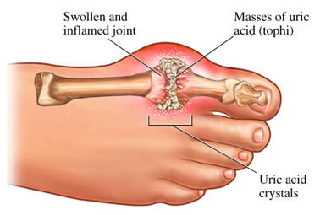

Phone: 01702 710131

1643 London Road

Leigh on Sea

Essex

SS9 2SQ

#### Tel 01702 710131

GOUT DIETARY ADVICE

Highlands Surgery

Highlands Surgery



• Keep to a healthy varied diet by eating plenty of high fibre foods and limiting your intake of foods rich in fat and sugar.

• Watch your weight. Do not over indulge in food.

• If you are already overweight aim to lose 1—2 pounds per week.

• The principal sources of purines in the diet are listed below.

***TRY TO AVOID***

***Liver***

***Heart***

***Kidney***

***Sweetbreads***

***Meat Extracts eg OXO***

***Anchovies***

***Crab***

***Fish Roes***

***Herring***

***Mackerel***

***Sardines***

***Shrimps***

***Sprats***

***Whitebait***

• Drink at least 8 cups of fluid per day

• Alcohol, if taken, should be drunk in moderation.

This means a **maximum**

per day of

3 units for men

and

2 units for women

1 Unit = 1/2 pint beer

Or

1 Glass of wine

Or

1 Pub measure of Spirit

Or

1 Small Sherry

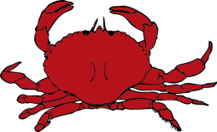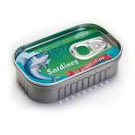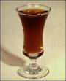

# 

# Gout Dietary Advice