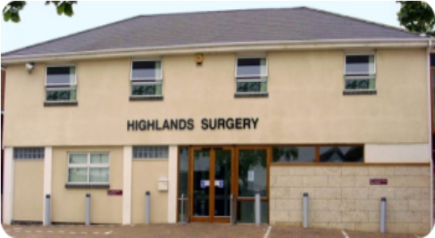
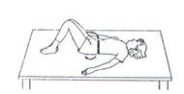
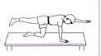
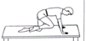
Phone: 01702 710131

1643 London Road
Leigh on Sea
Essex
SS9 2SQ
On hands and knees
12. Lift your right hand out in front, and your left leg out behind. Repeat with the left hand and right leg.

13. Bend right knee up to chest and tuck head in, rounding the back. Then stretch leg out straight behind you and look up, arching the back. Repeat with the left side.

14. Dips, stand on a block or step. Slowly bend knee to between 20-40 degrees, then straighten fully. Ensure the other foot makes no contact with the floor. Repeat with the other leg.

Highlands Surgery
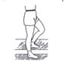

Tel 01702 710131
Back Exercises
Highlands Surgery

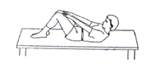
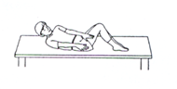
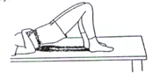
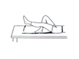
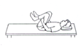
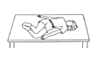
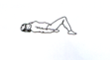
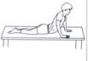
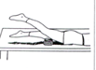
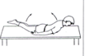
Lying on your back with knees bend, feet on the bed.
1. Draw in your tummy and press the back of your waist down into the bed. Hold this flattened position, then relax.

2. Pull tummy in, lift head and shoulders of pillow, reach forward towards your knees, relax slowly down.

3. Repeat exercise 2 but when reaching forward, take the right hand to the outside of the left knee, relax down, then repeat by reaching the left hand to the outside of the right knee.

Exercise 2 and 3 should be progressed gradually to 5—10 minutes
4. Fold arms onto chest, lift your bottom up as high as possible “making a bridge”

5. Keeping one leg bent, let the other leg rest straight. Tighten the muscles on the front of the thigh and the straight leg, and lift the leg 4 inches off the bed, keeping the knee straight. Hold for the count of five, then slowly relax. Repeat with the other leg.

6. Bend one knee at a time up to chest. If not painful, bend both knees together and lift head up. (Do NOT completely straighten legs between repetitions)

7. Keeping feet and knees together, roll knees over to one side, aiming to touch the bed with the lower knee. Return to center, and repeat on other side.

8. Bend sideways, reaching the hand down towards the ankle. Return to the center and repeat on the other side.

Lying on front
9. Place hands on the bed as if to do a press up. Ensure that the legs remain on the bed, and that all the muscles of the legs and back are relaxed. Slowly straighten the elbows, arching the back. Relax slowly down.

10. Keeping your knee straight, lift your leg up behind you. Hold for the count of 5, then relax slowly down. Repeat with other leg.

11. Lying with your arms by your side, lift your head and shoulders up, using the muscles in your back. Hold for the count of five, then relax slowly down. This can also be down by lifting your legs behind you, keeping the knees straight, or if painless, lifting both arms and legs at the same time.

