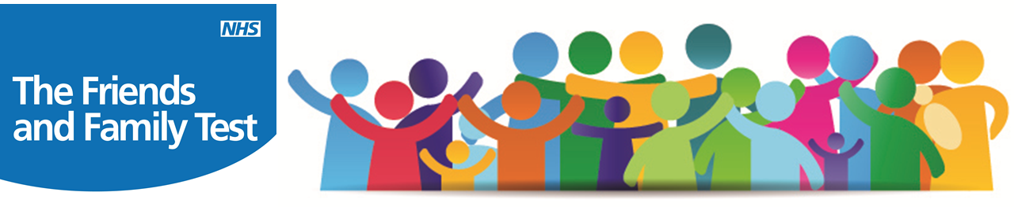

Practice Response to Comments:
I cannot get an appointment for my 3 month old daughter due to them not being released and when they are released they are no longer available.
It is Practice Policy that all children under the age of 12 can have same day access to a clinician, during our core opening hours. All Receptionists have been reminded of this policy.

I can’t get an appointment. I have had to ring a couple of times.
The Practice has recently audited how many appointments are on offer per week. The results show that on week commencing 14th December 2016, 644 appointments were available for a face to face appointment with one of our Healthcare professionals. From this 65 appointments were wasted through patients that did not attend. This is 10% of appointments that were on offer that week. Therefore it is important for patients to cancel appointments that they cannot attend.

Getting a Sick Note is impossible if you are a patient undergoing treatment in hospital.
If a patient is undergoing treatment at the hospital, it is the responsibility of the hospital to provide a Sick Note.

Thank you for your comments, they are really useful to help improve
the service we offer to our patients.

