Meal Plan suitable for people with Diabetes and those trying to lose weight
Most foods have an excellent traffic light system which makes it very easy to read the labels on the packaging. RED is high, AMBER is medium and GREEN is low in either fat, sugar, carbohydrate, salt etc. Easy to see at a glance. Don’t look at the percentages, look at the grams per 100g. (Top row).
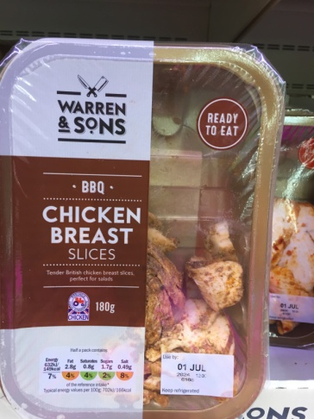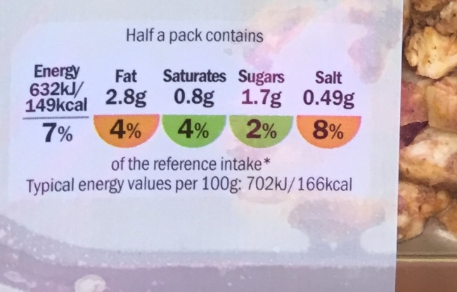
You are aiming for a FAT content which is lower than 10g (per 100g) – ideally under 3g is very good. (so this label says 2.8g which is ideal)
And a SUGAR content of less than 6g (per 100g) – ideally under 2g is the best. (this label says 1.7g which is ideal)
Once you know what you are looking for – it becomes easy to spot what is good and what is too high in fat and sugar.
Cooking from scratch is always the best option for healthy eating because you know what you put into the food yourself and you can choose the best product to put in the recipe, HOWEVER, if you are unable to cook from scratch for whatever reason the most appropriate “ready meals” which are ideal for people with Diabetes or people trying to lose weight, are “Slimming world” ready meals. They are far lower in sugars and fats than any of the other ranges. These seem to be only available in ICELAND.

Recommended BREAKFAST OPTIONS
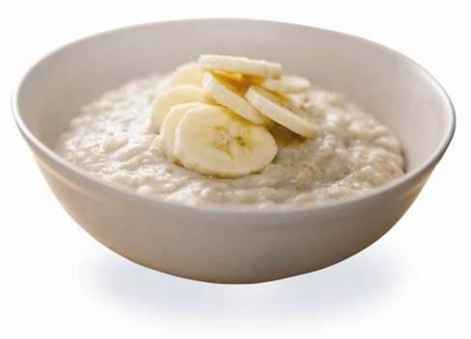  Porridge sachet with low fat milk (and banana or any fruit)  or |  | 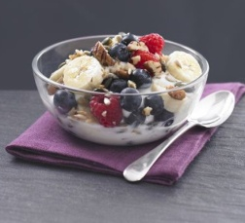  Low fat Yoghurt and cereal (shreddies, weetabix or porridge oats) mixed with fruit  or |  | 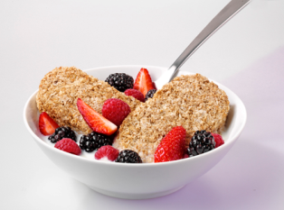  Weetabix with low fat milk (and fruit)  or |  | 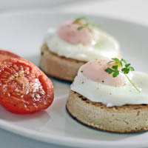  Paoched eggs on crumpets  or | 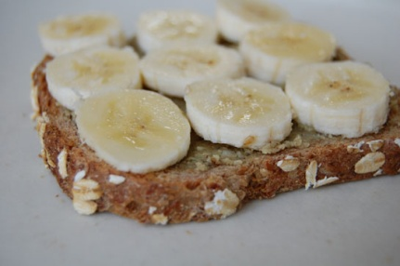  Banana on 2 slices of toast using wholemeal Bread and low fat spread  or |  | 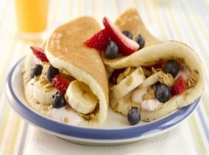  2 Ready made pancakes filled with fruit and low fat yoghurt  or |  | 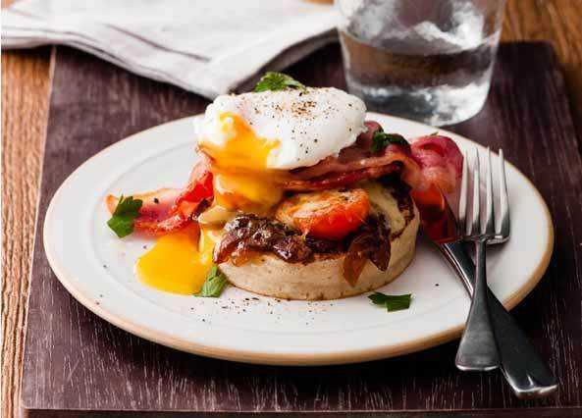  Poached egg, bacon, tomato and mushrooms on a toasted crumpet  or
MID MORNING SNACKS
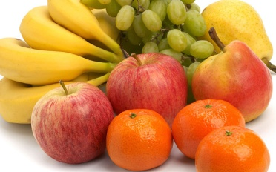 |  | All fruit is great for a snack – for Grapes , only a handful though per day.
LUNCH OPTIONS
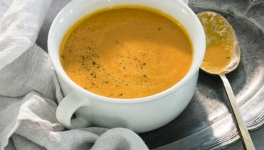 |  | 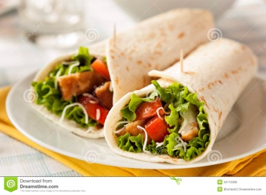 |  | 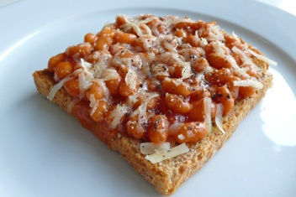 |  | 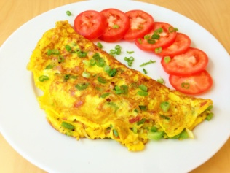 | 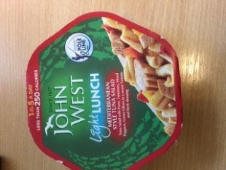 |  | 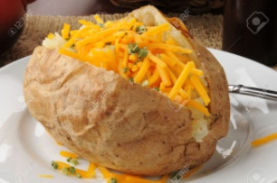 |  | 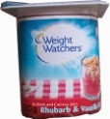
Low fat low sugar Soup, with 1 slice wholemeal bread  (recommend Slimming world soups or look at labels)  or |  | Cooked chicken or prawns in 1 Tortilla wrap with salad and light mayonnaise  or |  | Beans on Toast (with tiny sprinkle of cheese)  or |  | 2 Boiled eggs or scambled eggs or omelette on toast  or | Tuna “Light lunches” LIDL or Morrisons with salad  or |  | Ready Baked Jacket potatoes with low fat cheese  Plus…. |  | Low fat yoghurt or small bowl of tinned fruit for dessert  (fruit must be in it’s own juice not in syrup)
AFTERNOON SNACKS (not every day for those with Diabetes – just sometimes)
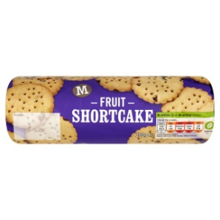 |  | 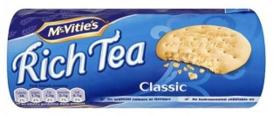 |  | 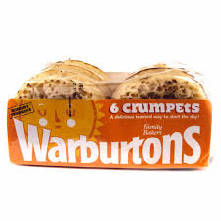 |  | 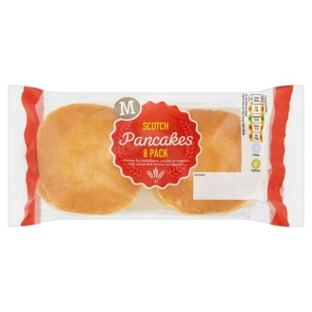 | 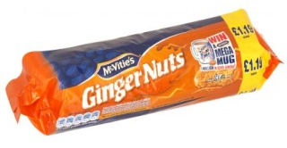 |  | 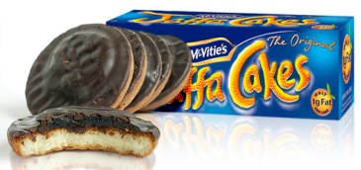 |  | 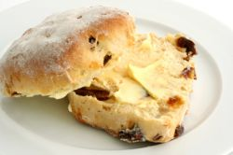
2 Fruit shortcake biscuits  (38 calories per biscuit)  or |  | 2 Rich tea biscuits  (38 calories per biscuit)  or |  | 1 crumpet  (89 calories each)  with low fat spread and a scrape of jam  or |  | 1 pancake  (70 calories each) with low fat spread and a scrape of jam  or | 2 Gingernut biscuits  (46 calories each)  or |  | 1 Jaffa cake  (45 calories each)  or |  | Once a week treat – a fruit scone  (126 calories each before low fat spread)
DINNER OPTIONS

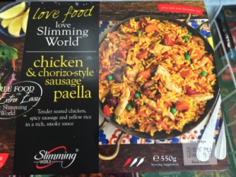 |  | 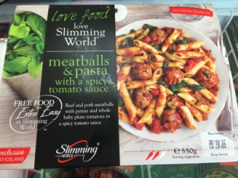 |  | 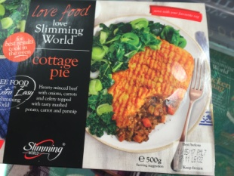 |  | 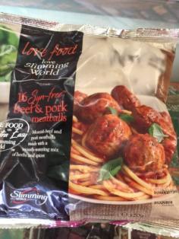 | 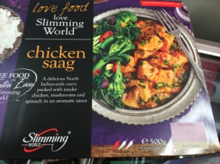 |  | 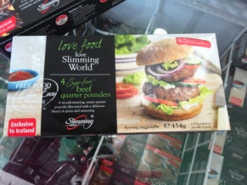 |  | 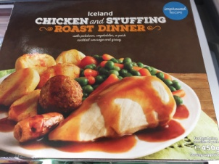
Slimming World Ready meals e.g  Chicken and Chorizo Sausage Paella  or |  | Meatballs and pasta  or |  | Cottage Pie  or |  | Beef and pork meatballs  or | Chicken Saag  or |  | Beef quarter pounders  or |  | Roast Dinner
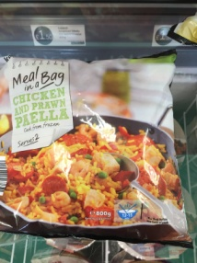 |  | 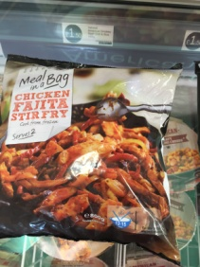 |  | 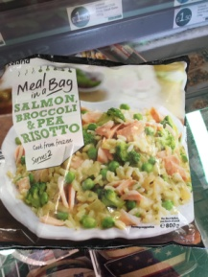
Ready meals e.g “Meals in a bag”  Chicken and prawn paella |  | Chicken fajita stir fry |  | Salmon broccoli and pea risotto
MORE DINNER OPTIONS
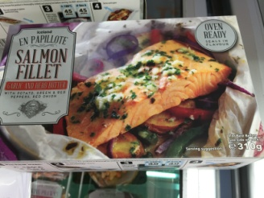 |  | 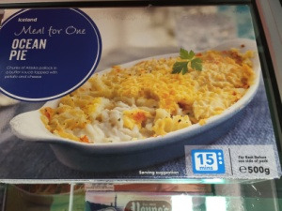 |  | 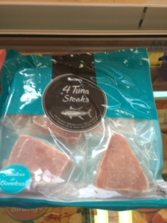 |  | 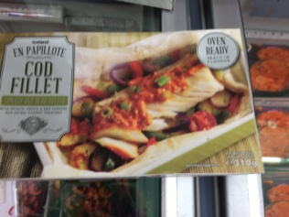 | 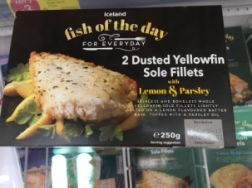 |  | 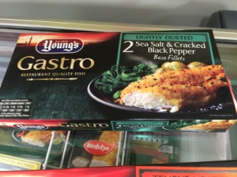 |  | 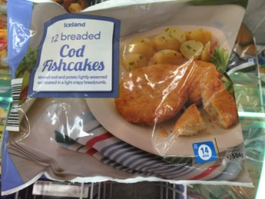
Fish e.g  Salmon Fillet with garlic and herb butter with potatoes and veg |  | Ocean Pie |  | Tuna steaks |  | Cod fillet with tomato and herb butter with potatoes and veg | Yellow-fin Sole fillets |  | Sea salt and Cracked Pepper Basa fillets |  | Cod Fishcakes
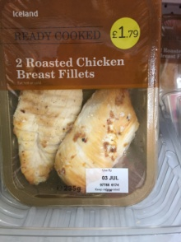 |  | 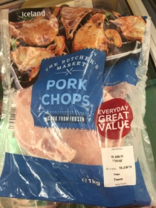 |  | 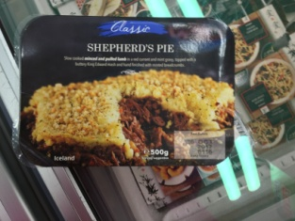 |  | 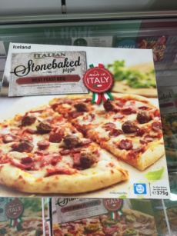 | 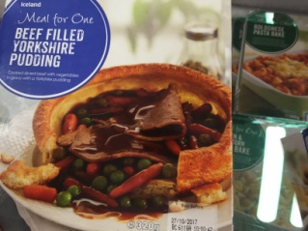 |  | 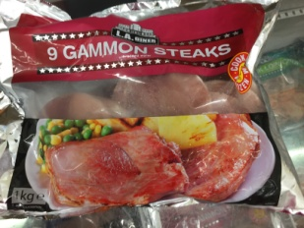 |  | 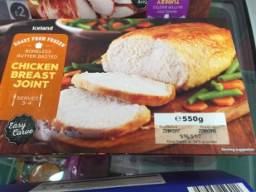
Or meat  e.g Roasted chicken  or |  | Pork Chops  or |  | Sherherd’s Pie  or |  | This type of pizza only – look at the labels -low fat, low sugar  or | Beef and Yorkshire pudding  or |  | Gammon Steaks  or |  | Roast Chicken joint
WITH A CHOICE OF CARBOHYDRATES –(small portions)
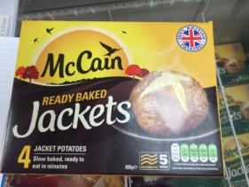 |  | 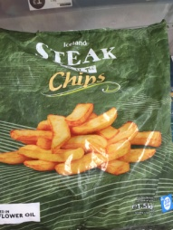 |  | 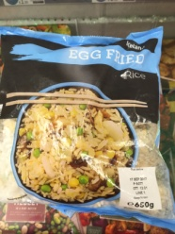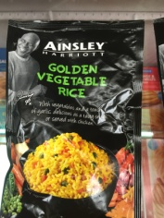 |  | 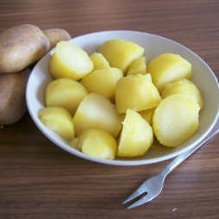 | 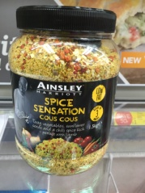 |  |  |  | 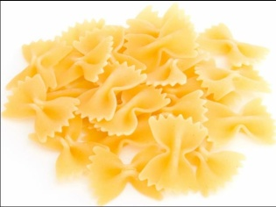
Baked Potatoes  1 potato |  | Oven chips  100g |  | Rice  Dried 60g  Already Cooked 150g |  | Boiled or mashed  Potatoes  Once cooked 150g | Couscous  Dried 60g  Already Cooked 150g |  | Noodles  Dried 40g  Already Cooked 150g |  | Pasta  Dried 40g  Already Cooked 150g
PLUS VEGETABLES– fresh or frozen (large portion)
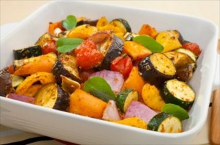 |  | 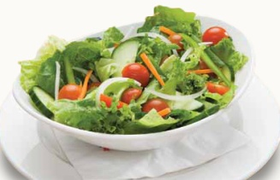 |  | 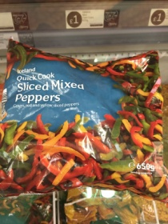 |  | 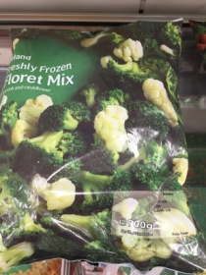 | 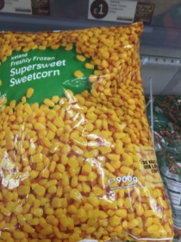 |  | 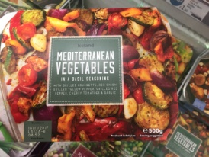 |  | 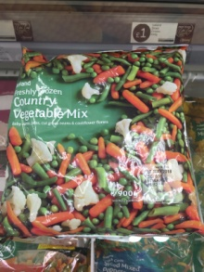
Mixed vegetables boiled or roasted |  | Salad |  | Sliced mixed peppers |  | Broccholi and cauliflower mix | Sweet corn |  | Mediterranean Vegetables |  | Country vegetable mix
DESSERT OPTIONS
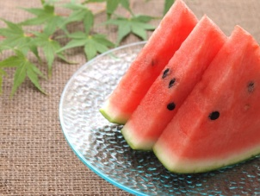 |  | 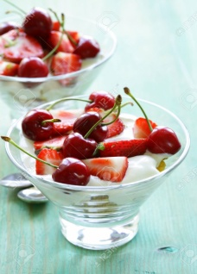 |  | 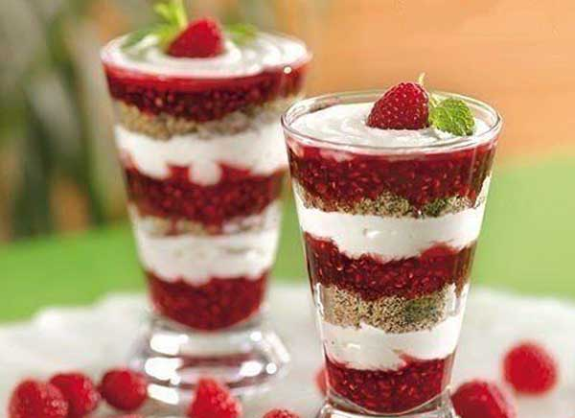 |  | 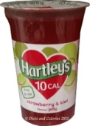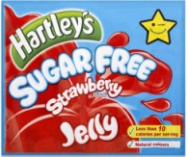 | 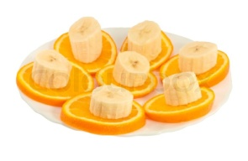 |  | 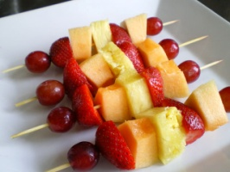 |  | 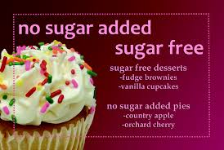
Fresh or tinned fruit |  | Strawberries and cherries (or any fruit) with low fat yoghurt/ fat free greek yoghurts |  | Raspberries (or any berries) layered with crushed ginger nuts biscuits and low fat fromage frais |  | Sugar free Jelly – either the pot or  Make up with fruit inside | Bananas and oranges – a nice combination |  | Fruit Kebabs – very tasty |  | Find sugar free dessert recipes on-line or in a book. Try out some recipes.
ONCE-A-WEEK TREATS – choose from one of the following :
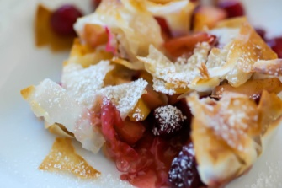 |  | 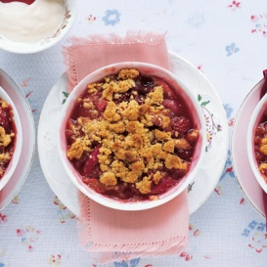 |  | 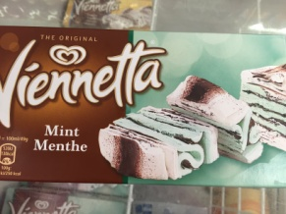 |  | 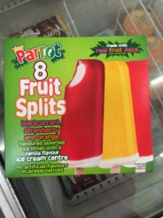
Once a week treat -Frozen apples or any fruit baked in a filo pastry parcel with sweetener and cinnamon |  | Once a week treat -  Frozen rhubarb  baked in small dish with sweetener, flour and oats mixture to top as a crumble |  | Once a week treat – 1 small slice Vienetta |  | Once a week treat – 1 ice lolly
EVENING SNACK OPTIONS
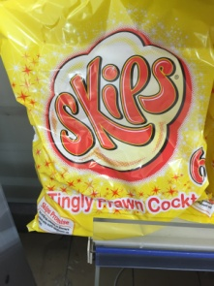 | 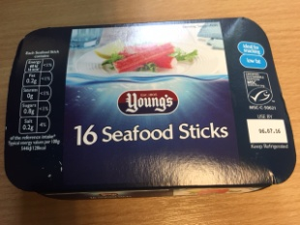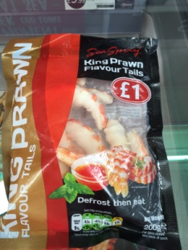 |  | 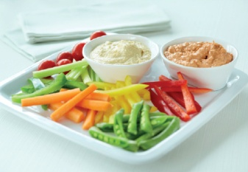 |  | 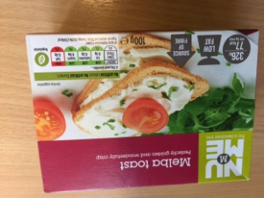 |  |  | 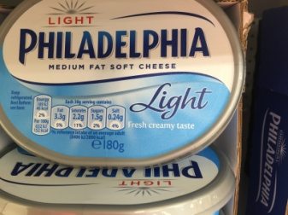 |  | 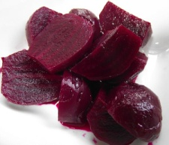
1 packet of skips  (89 calories per packet) | 4 seafood sticks or  3 Prawn flavour tails  (16 calories per seafood stick) |  | Sliced vegetables with Philadelphia lite or low fat dip  Veg doesn’t count  Only count the dips and cheese |  | 1 packet of 6 ( 77 calories for 6 toasts) with Philadelphia lite cheese and cherry tomatoes or pickles  or |  |  | Thin spreading of Philadelphia (50g = 55 calories) |  | Pickled beetroot  100g=22calories |  | Pickled onions  100g = 23calories
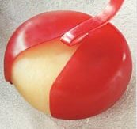 | 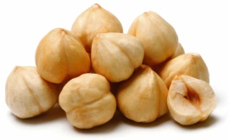 |  | 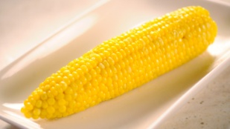 |  | 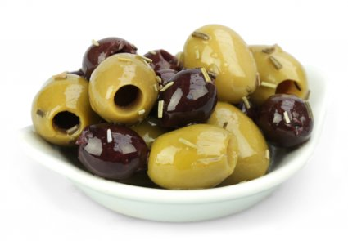 |  |  | 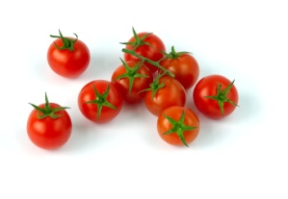 |  | 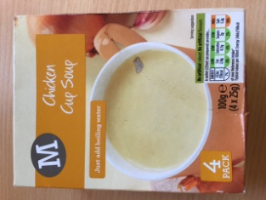 |  | 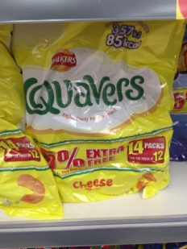
Babybel cheese = 60 cals  Babybel light = 43 | 10 Hazelnuts –  10 g = 62 calories |  | Corn-on-the-cob = 106 calories |  | Olives  50g = 55 calories |  |  | Cherry Tomatoes  100g=18 calories |  | 1 Cup –a- soup  (131 calories each)  or |  | Quavers – 1 packet (88 calories)  or

DRINKS
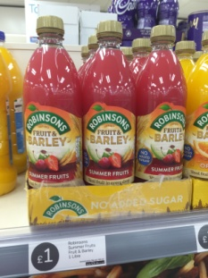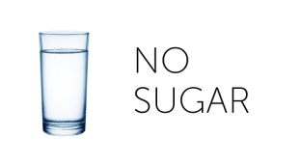 | 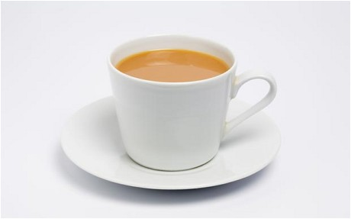 | People with Diabetes should  NEVER EVER drink Lucozade or non -diet Fizzy drinks, unless they are having a Hypo (very low in sugar - under 3 on their glucose monitor)  This usually only happens to people with Type 1 Diabetes, or people who need Insulin, VERY RARELY does it happen to those with Type 2 Diabetes. | 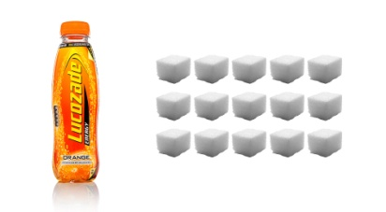  1 small bottle of Lucozade has 15 spoonfuls of sugar | 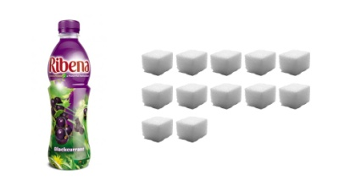  Ribena ready to drink has 12 spoonfuls of sugar
Water or No added sugar Juice or herbal tea’s with no milk and sugar or black tea or coffee,  are by far the best drinks to have. | Tea with low fat milk and sweetener if required.  Peppermint or fruit teas even better as taken without milk | Beware fresh fruit juices. Although fruit is good for people with diabetes, when it is turned into juice it has a different effect and is high in sugar | 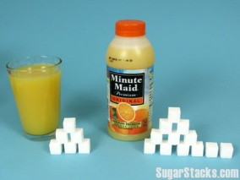  Glass of fresh orange = 5 spoonfuls of sugar, bottle =12 | 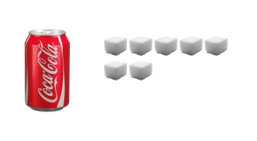  Can of non-diet Coke = 7 spoonfuls of sugar
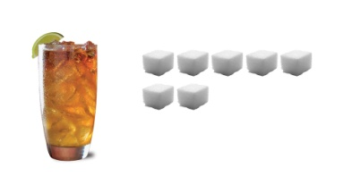  Rum and Coke = 7 | 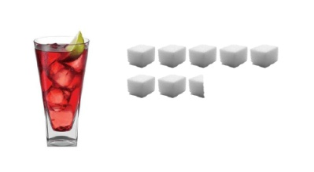  Vodka and Cranberry = 7 1/2 | 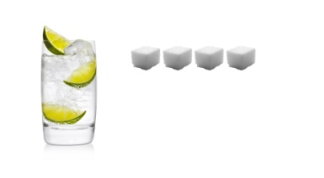  Gin and Tonic or any spirit and diet mixer = 4
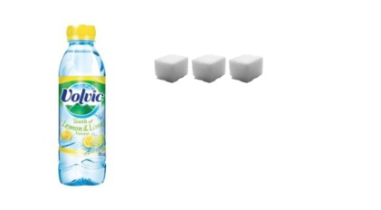
Watch out for flavoured water – this has 3 spoonfuls of sugar in it!

