

**Sharing Preferences**Patient guide to setting preferences online

When you receive care close to your home you will not usually need to give a verification (security) code but you should still be asked about what your choices are about record sharing.

This guide gives instructions on how to view the organisations locally that will not require you to provide a security code and how to add other organisations via the SystmOnline portal.

After logging in to SystmOnline click on the **‘Managing Sharing Rules’** hyperlink, this will display preferences regarding the verification process.

For the purposes of this guide ‘**verification’** refers to either approving a record sharing request on SystmOnline or providing the service with a security code sent to the patient via SMS/Email.

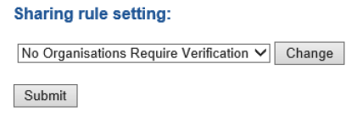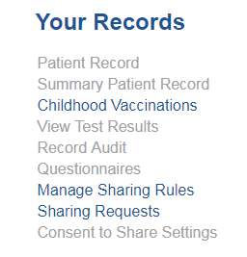

On the ‘**Sharing rule setting’** drop down there are four different options available on the drop down menu (shown left):  
  
- **Practice Default:** follows the preferences set by your GP surgery.

- **No Organisations Require Verification:** Any service requesting access will be able to view your patient record without verification.

- **All Organisations Require Consent:** Whenever an external organisation attempts to share in the patients’ record for the first time, additional verification will be required.

- **Custom a): Organisations That Do Not Require Verification (ALLOWED):** These organisations will be allowed to set a share in preference for the patient without additional verification. Typically these will be Healthcare providers throughout Leicestershire. You can add additional specific organisations as per your preference.

- **Custom b): Organisations That Cannot Access the Shared Record (PROHIBITED):** These organisations will not be able to record a share in preference for the patient and will not have access to your record. This can only be set in consultation with a GP as it could significantly impact on the ability to treat you.