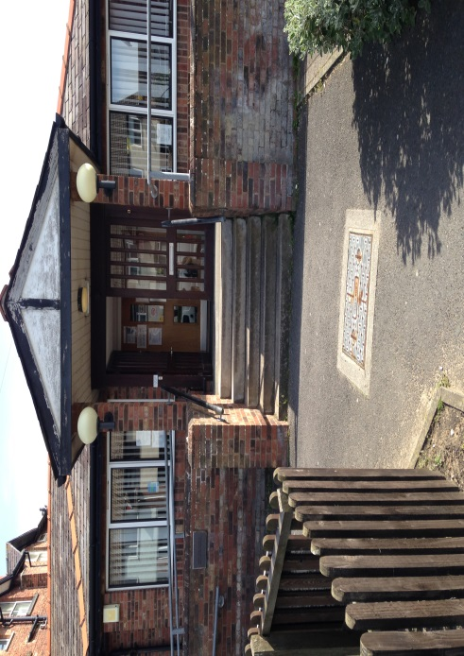

Welcome to the first of our Poplar House Medical Practice newsletters!

We are hoping to improve communications between doctors, nurses, staff and patients so we can all share our ideas and visions to create the best practice for all of us.

We will write to you in each newsletter to keep you aware of practice changes, relevant health promotions and advice updates.

*Poplar Press*

*The newsletter for Poplar House Surgery*

*Issue 1 (May 2015)*

**TRAVEL IMMUNISATIONS**

**PLAN AHEAD TO STAY SAFE ON HOLIDAY**

Holiday time is now upon us. If you are lucky enough to be travelling further afield please make sure you give yourself enough time to have any vaccinations required.

**Please Plan Ahead:**

* Many vaccinations require a course to become fully effective, taking up to 6 weeks
* It takes 3 weeks for vaccinations to become fully effective after completing the course
* Organising your vaccinations takes a few steps to ensure the correct vaccinations are given at the correct time

**How To Get Your Vaccinations:**

* As soon as you know where you are going, or have booked your holiday, make an appointment with either, Mary or Moyra, our Practice Nurses to discuss the vaccinations that are recommended for your individual travel plans.
* Once we know what vaccinations you will need, an appointment can be made with either Mary or Moyra to have the vaccinations
* Some of these vaccinations are free of charge, but some will incur a cost as they are not provided on the NHS and they will need to be specifically ordered for you. We will therefore ask you to pay for these, in cash, before your appointment to have the vaccination. Details of cost can be obtained from the surgery.

**PRACTICE MISSION STATEMENT:**

It is the aim of this practice to provide a high standard of patient care by both medical and non-medical staff. We wish to be an approachable and accessible practice which provides personal care to all our patients

**PATIENT ACCESS**

**Patient Access** is the On Line service that a number of our existing patients use to manage their appointments, order their repeat prescription and change their address and/or telephone number.

**Access to Medical Records**

We will now be extending this service and will be offering all patients the opportunity to have on-line access to information from their medical record. This will include details of current medications, allergies, adverse reactions and immunisations.

**Application Process**

All patients, including existing users of **Patient Access,** will need to complete an application form to register for access to their Medical Record. You will be required to supply proof of identity and proof of address. Documents accepted for this will be a passport, photo driving licence and a bank or building society statement.

Once we have received the application and verified the identity of the patient, we will, within 48 hours, provide new users of **Patient Access,** their unique User ID and PIN number and instructions of how to register. Existing users will receive confirmation that their access has been extended. This documentation will have to be collected from the surgery.

**STAFFING NEWS**

We will be saying goodbye to Dr Mark Dillon on Friday 29th May, Mark is returning to his native Ireland, to get married and continue his career as a GP. Mark has been an integral part of the team here at Poplar House and we will all miss his enthusiasm and good humour, as I am sure his regular patients will miss his excellent care.

Anne – Marie Potter our Nurse Practitioner, left the practice in early April, we wish her all the best in her new position. I am sure that her regular patients will miss her.

We have, however been very lucky in being able to employ an experienced Nurse Practitioner, in Andrea Barnes and we are all looking forward to making her part of the team. Andrea will be with us Tuesday to Friday (4 full days) from 2nd June, 2015

**FRIENDS AND FAMILY TEST**

From 1st December 2014, all GP practices in England have been running an anonymous and continuous survey called, The Friends and Family Test. The survey allows patients to give feedback after every interaction with the Practice. Anyone registered at Poplar House Surgery can complete the survey at any time.

The aim of the survey is to gather feedback about patients’ recent experiences of our services and how likely they are to recommend their GP practice to friends and family if they needed similar care or treatment

You can complete a Friends and Family slip and post it in the blue returns box on the reception counter in the surgery.

Monthly results are displayed in the surgery and we will also be publishing them in future Newsletters.

**MEDICAL EXCEMPTION CERTIFICATES**

We would like to make patients, who have a medical exemption certificate, aware that the NHS Business Services Authority, have been issuing fines to people who have not renewed their certificate. A rule change means that these certificates must be renewed every 5 years. Please take a moment to check your certificate and if it needs to be renewed you can collect a form from the surgery, that will need to be signed by a doctor and forwarded by the surgery to the relevant address.

**PRIVATE FEES, NON NHS CONSULTATIONS AND SERVICES**

Some services provided by the Practice are not paid for by the NHS. In these cases a fee is charged to the patient, which is payable in **cash** by the patient prior to the work being undertaken. Examples are:

* HGV, PSV, Taxi, Sports or driving medical examinations
* Sickness or accident insurance claim
* Private Healthcare forms
* Holiday Cancellation claim forms
* To Whom It May Concern letters

If you are uncertain, as to what does and does not have to be paid for, either contact the practice or speak to a member of the reception team.

As this work falls outside the NHS, the GPs have to find time to do this work outside of their allotted clinical time. We try to complete this work within 5 working days, but this may take longer, if pressure of clinical work intervenes

**SURGERY OPENING TIMES:**

Monday to Friday

08.00 to 18.00

Tel: 01253 782255 (Appt)

Tel: 01253 722121 (Enqs)

**REPEAT PRESCRIPTIONS**

We have received a number of phone calls recently from patients wishing to order repeat prescriptions over the phone. Just to remind patients, repeat prescriptions can only be ordered by:

**Patient Access,** via our website,

Via the chemist of your choice

Ticking **right hand side of prescription** and putting it in the prescription box at reception

Completing **a clerical prescription form** available from reception and putting it in the prescription box at reception

**PLESE ALLOW**

2, full working days after ordering, for repeat prescriptions to be ready for collection.

**IN HOUSE PHARMACIST**

Our In-House Pharmacist **Ross Groves,** will undertake medicine reviews and ensure that any hospital/specialist recommended medications are added to your prescription.

**PRACTICE MEDICAL STAFF:**

**Doctors:**

**Dr Shahid Samad,** (Full Time Senior Partner)

MBBS; MRCGP (UK) Graduated 1997

**Dr Saleem Akhtar** (Salaried GP)

MBBS, MRCGP (UK); FRCS (Edin), FRCS (Ireland); FCPS (Gen Surgery Pak) Graduated 1995

**Dr Saad Rehman** (Salaried GP)

MBBS Graduated 2001

**Dr Lakshmi Nagaragu** (Sessional GP)

MBBS, MRCGP Graduated 2012

**Advanced Nurse Practitioner:**

**Andrea Barnes**

Advanced Nurse Practitioner and Independent/Supplementary Nurse Prescriber.  Highly trained and experienced Nurse Practitioner qualified to deal with a number of medical conditions.

**Practice Nurses**

* Mrs Moyra Curzon
* Mrs Mary Huddleston
* Our Practice Nurses are able to give injections, travel advice/immunisations, they also take smears, give family planning advice and assist with the management of patients with hypertension, diabetes and asthma/COPD.

**Healthcare Assistant/Phlebotomists**

* Ms. Linda Barton