Adults Seasonal Flu Campaign 2018

Unbelievably, the flu campaign has come around again. This year it will be particularly difficult as NHS England have decreed that we should use two types of flu vaccination instead of just one.

- One type is what is termed a trivalent vaccine for all patients aged 65 and over. This is a new vaccine.
- The second type is a Quadrivalent vaccine for all people at risk up to and including the age of 64.
The problem with the new trivalent vaccine is that there is only one supplier in the whole UK so delivery schedules are very tight. However, we will be starting our campaign officially on 8th October and we will be having two drop in Saturday morning clinics.
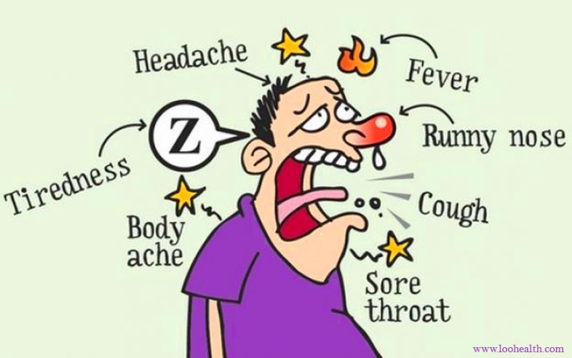
Please appreciate that these new issues are not of our making and we will, as always, endeavour to provide your vaccinations when you want them. The campaign this year will run into November.

Follow this link to find out more about the seasonal flu campaign:
https://www.nhs.uk/conditions/vaccinations/flu-influenza-vaccine/

Follow this link to find out more about flu clinic times and details at Bentham and Ingleton:
[Insert Poster link]

