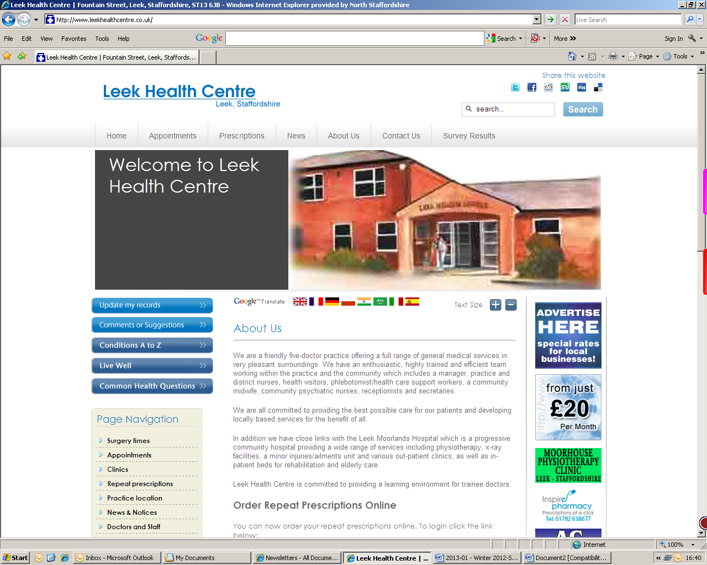

**Winter 2015**

Leek Health Centre

Telephone: 01538 381022/381072

www.leekhealthcentre.co.uk

***Opening Times***

Our core opening times are:

Monday-Friday 8.00am-6.30pm

In addition to the core opening hours above, we currently offer 4 hours of extended access per week to accommodate patients who are unable to attend the surgery within the core opening times.

These additional opening hours are:

* Tuesday, Wednesday and Friday 7.30am-8.00am for appointments with Practice Nurse or Health Care Support Worker
* Wednesday 6.30pm-7.30pm for GP appointments

Please note that the early mornings are subject to change due to annual leave, however we will continue to provide 4 hours of extended access per week.

## Practice News

The Practice would like to congratulate:

* Samantha Brown, as she has been promoted to take the role of Trainee Manager.
* We would also like to congratulate Laura Spooner, Quality & Services Manager, on the pregnancy of her second child.

We would like to welcome Jessica Goldstraw, Elizabeth Farrelly & Sue Fradley to the Reception & Admin Team.

***Useful Contacts***

**Tel ‘111’**

When it’s less urgent than 999

**Leek Moorlands Walk in Centre for Minor Injuries & Minor Ailments**

8am – 8pm 0300 123 1894

**Haywood Walk in Centre**

Mon-Fri 7am - 10pm

Sat, Sun & Bank Holiday 9am - 10pm

01782 581112

**Midway Medical Walk-In Centre**

8am – 8pm 01782 663757

**Hanley Health and Wellbeing Centre**

8am – 8pm 0300 123 6759

**NHS Choices** www.nhs.uk

**Out of Hours Service**

If you require a doctor outside of normal surgery hours, please telephone 111 and your call will be triaged by the Out of Hours service.

**Leek Health Centre**

**Page 1 of 4**

## Text Reminders

If you would like to receive a reminder for your appointment via text message, please give your information and an up-to-date mobile number at reception.

## Family & Friends Test

## Online Access

The Practice now uses Patient Access, in place of Vision Online. If you would like to order your prescriptions, make appointments online please go to the practice website (please see top of this page), click on patient access and follow the instructions or ask at reception.

**We are currently looking in to allowing access to more information.**

The Friends and Family Test (FFT) is an important feedback tool that supports the fundamental principle that people who use NHS services should have the opportunity to provide feedback on their experience.

Friends and Family test is open to all patients.

We would be very grateful if you could take the time to complete the survey with is available at Reception.

The Practice now has a portable hearing loop machine available to our patients.

If you require use of the hearing loop machine, please ask at Reception.

## Hearing Loop

## EPS

Leek Health Centre continues to offer the Electronic Prescription Service which allows you to collect your prescriptions straight from the pharmacy instead of coming into your GP surgery.

By nominating a pharmacy, your prescriptions will be electronically sent to the pharmacy of your choice.

Please contact the surgery if you are interesting in using this service.

www.leekhealthcentre.co.uk

www.leekhealthcentre.co.uk

**Page 2 of 3**

**Leek Health Centre**

Telephone: 01538 381022/381072

## Keep Warm This Winter

## The Pharmacy First Scheme is back!

**Cold homes have a significant impact on people's health. One of the best ways of keeping yourself well during winter is to stay warm.**

The Pharmacy First Scheme provides any patient who is registered at Leek Health Centre and is exempt from prescription charges, with access to medication for the treatment of minor ailments via the Pharmacy, free of charge.

The Pharmacy First Scheme is offered as a quicker alternative for patients to access healthcare for treatment of minor ailments.

Conditions which can be treated by your local Pharmacy include:

* Acute Pain/Headache/ Temperature
* Athletes foot
* Bites and stings
* Cold Sore
* Common Cold/Cough/ Flu/Nasal Congestion
* Conjunctivitis
* Constipation
* Dermatitis/Dry skin
* Diarrhoea
* Haemorrhoids
* Hay fever
* Head lice
* Heart burn/Indigestion
* Impetigo
* Infant colic
* Mouth ulcers
* Nappy rash
* Oral thrush
* Scabies
* Sore throat
* Sprains and strains
* Teething
* Threadworm
* Urine Infections
* Vaginal thrush

Keeping warm over the winter months can help prevent colds, flu or more serious health conditions such as heart attacks, strokes, pneumonia and depression.

The chances of these problems are higher if you're vulnerable to cold-related illnesses.

You can get advise from your local pharmacist. Pharmacy Christmas opening hours are available in the waiting room.



## Keep your home warm

* If you have reduced mobility, are 65 or over, or have a health condition such as heart or lung disease, you should heat your home to at least 18C. It's a good idea to keep your bedroom at this temperature all night if you can. During the day you may prefer your living room to be slightly warmer. Make sure you wear enough clothes to stay warm.
* If you're under 65 and healthy and active, you can safely have your house cooler than 18C, if you're comfortable.
* You can also use a hot water bottle or electric blanket (but not both at the same time) to keep warm while you're in bed.

If you do pay for prescriptions, the items provided by Pharmacy First are often cheaper than the usual prescription charge!

## Travel Vaccines

www.leekhealthcentre.co.uk

**Page 3 of 3**

**Leek Health Centre**

Telephone: 01538 381022/381072

**Information Sheet for patients.**

**Arthritis and Pain Management.**

**Arthritis**.

There are over 200 kinds of rheumatic diseases - the word rheumatic means ‘aches and pains in joints, bones and muscles’. Two of the most common forms of arthritis are osteoarthritis and rheumatoid arthritis.

It is not just a disease that affects older people, it can affect people of all ages, including children.

**Arthritis Care**.

A national organisation**.** Website - www.arthritiscare.org.uk

Exists to support people with arthritis**.**

**Arthritis and Musculoskeletal Alliance. (**ARMA.)

Website - www.arma.uk.net

ARMA is a national umbrella association body providing a collective voice for the arthritis and musculoskeletal community in the UK.

**There is an active patients’ group**  working at **The Haywood Hospital, Stanfields, Stoke on Trent.**  ***This hospital is a leader in arthritis treatment and care.***

Haywood Hospital website - www.haywoodrheumatology.org.uk

Osteoporosis advice line - 01782 673824

Rheumatology / arthritis advice line - 01782 673687

***The Hospital is about to open a new Patient Information and Education Centre. (P.I.E.R.) - It will be available to anyone seeking information on the subject.***

***Opens 12th October 2015.***

**Fibromyalgia**. Website - [www.ukfibromyalgia.com](http://www.ukfibromyalgia.com/)

FMS (fibromyalgia syndrome) is a widespread musculoskeletal pain and fatigue disorder for which the cause is still unknown. Fibromyalgia means pain in the fibrous tissues in the body.

Fibromyalgia Support Stafford, Stoke-on-Trent and Surrounds  
<http://fmstaffs.yolasite.com/>  
[fmstaffs@gmail.com](mailto:fmstaffs@gmail.com) (*Not verified)*

**Pain Management.**

**I.M.P.A.C.T** - is the *Interdisciplinary Musculoskeletal Pain Assessment and Community Treatment Service* . This service aims to improve quality of life and functioning for adults with longstanding widespread or localised pain. Based at The Haywood Hospital with clinics held at Leek Moorlands Hospital (and elsewhere).

*Referrals via a General Practitioner*.

**Royal Stoke University Hospital runs a Pain Management Service** which can be accessed *by referral by a General Practitioner*.

It includes an Inpatient Acute Pain Service and an Outpatient Chronic Pain Clinic

(7 clinics each week). Both encompass a variety of medical interventions.

*Prepared by Leek Health Centre’s Patient Participation Group*

## A note from your Patient Participation Group