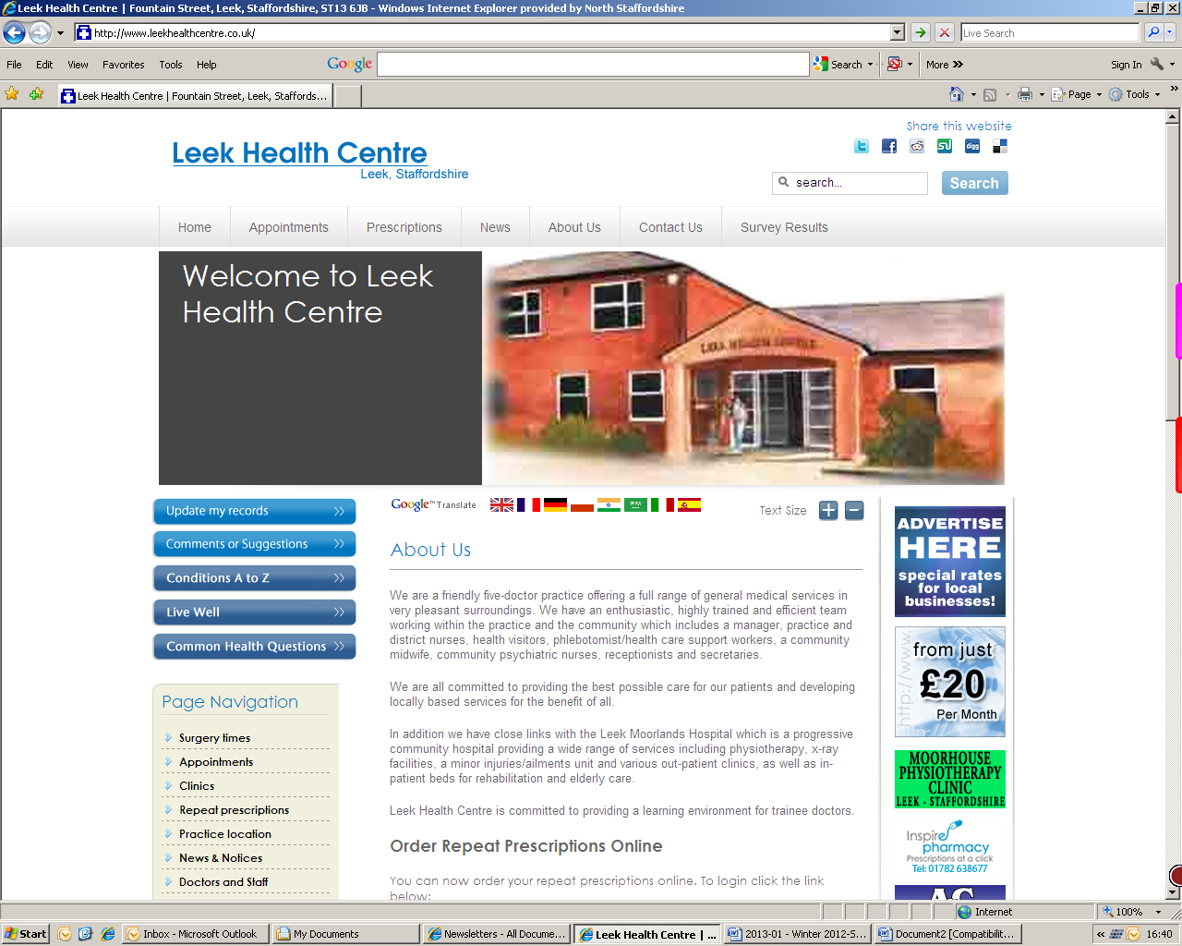

**Summer 2015**

Leek Health Centre

## Make the most of your appointment

Telephone: 01538 381022/381072

www.leekhealthcentre.co.uk

**All GP appointments are for 10 minutes only.**

Once you've got an appointment, plan ahead to make sure that you cover everything you want to discuss.

* Before you see the doctor, write a list of problems, starting with the most important. List your symptoms so that you don’t forget them. Write down when they started and what makes them better or worse during a 24-hour period. If you have a complicated problem, ask for a longer appointment when you book.
* When you see the doctor, bring a friend or relative if you're worried. Research shows that we forget half of what we're told by the doctor when we're stressed, so having a friend with you can help.
* Be honest about what you think may be causing the problem, and don’t be embarrassed. Your doctor will have seen and heard it all before.
* Be clear about what you want the doctor to do, such as refer you to a specialist or prescribe a different medication.
* Ask the doctor to repeat and explain anything you don’t understand. If there are words you don’t understand, ask what they mean or get the doctor to write them down so that you can look them up later.
* If you and your GP decide you need to be referred for specialist tests or treatment, you usually have a right to choose which hospital you go to.

Reference: <http://www.nhs.uk/choiceintheNHS/Yourchoices/GPchoice/Pages/GPappointments.aspx>

***Opening Times***

Phone line opening hours are:

Monday-Friday 8.00am-6.00pm

Our core opening times are:

Monday-Friday 8.00am-6.30pm

In addition to the core opening hours above, we currently offer 4 hours of extended access per week to accommodate patients who are unable to attend the surgery within the core opening times.

These additional opening hours are:

* Tuesday, Wednesday and Friday 7.30am-8.00am for appointments with Practice Nurse or Health Care Support Worker
* Wednesday 6.30pm-7.45pm for GP appointments

Early mornings are subject to change due to annual leave, however we will continue to provide 4 hours of extended access per week.

***Useful Contacts***

**Tel ‘111’**

When it’s less urgent than 999

**Leek Moorlands Walk in Centre for Minor Injuries & Minor Ailments**

8am – 8pm 0300 123 1894

**Haywood Walk in Centre**

Mon-Fri 7am - 10pm

Sat, Sun & Bank Holiday 9am - 10pm

01782 581112

**Midway Medical Walk-In Centre**

8am – 8pm 01782 663757

**Hanley Health and Wellbeing Centre**

8am – 8pm 0300 123 6759

**NHS Choices** www.nhs.uk

**Out of Hours Service**

If you require a doctor outside of normal surgery hours, please telephone 111 and your call will be triaged by the Out of Hours service.

Seasonal flu is a major killer of vulnerable people; people aged 65 and over and people with long-term health conditions. The best way to prevent getting flu is to have the seasonal flu vaccine. It gives good protection against flu and lasts for one year.

If you fall into one or more of the categories below, you are eligible for a vaccination:

* Aged 65 and over
* Chronic respiratory disease
  + Asthma that requires continuous or repeated use of inhaled or systemic steroids or with previous exacerbations requiring hospital admission
  + COPD
* Chronic heart disease
* Chronic kidney disease
* Chronic liver disease
* Chronic neurological disease
* Diabetes
* Immunosuppression
* Asplenia or dysfunction of the spleen
* Pregnant women
* People in long-stay residential homes
* Carer in receipt of a carer’s allowance or main carer of an elderly or disabled person

**Clinic Dates and Times**

We want this service to be accessible to as many people who are eligible as possible, please see below dates and times.

**Wednesday 7th October 2015**

**8am – 7pm**

All bookable appointments, including online appointments.

**Wednesday 14th October 2015**

**8am – 7pm**

Walk in clinic – no appointment necessary.

If you are unable to attend our flu clinics, do not worry, our receptionists will be able to advise you further.

## Flu Clinics

**Leek Health Centre**

**Page 2 of 5**

**Appointments**

Improvements have been made to the appointment system over the last 12 months and more appointments are available to book either on the day or 48 hours in advance. Last year, 59.49% of patients said they have to wait 2 or more working days to see or speak to a Doctor; this has decreased significantly this year to 40.27%.

**Opening Times**

The access at Leek Health Centre is flexible, accommodating the varying needs of patients; this is reflected in the survey as 83.67% rate the opening hours as good to excellent, compared to 81.01% last year.

**Access via phone**

A major concern expressed by patients is the ability to get through to a receptionist on the phone. The practice has invested in additional Receptionist hours to help address the issue and will continue to monitor the situation. The practice has also implemented a voicemail option on the telephone system to allow cancellation of appointments without having to wait in the queue. This has had a positive impact on phone access as it has improved since the last survey with 50.34% of patients rating phone access as good to excellent, compared to 42.02% last year.

**Receptionists**

In order to continually improve the service offered, patients were asked how they are treated by the receptionists. 91.16% of patients rate the way they are treated by the receptionists as good to excellent; a significant improvement from 83.34% last year. Our receptionists work extremely hard and receive ongoing mentorship and training to ensure they deal with patients in a polite and efficient manner.

**Would patients recommend Leek Health Centre to someone who had just moved into the area?**

A substantial increase has been seen with 91.16% of patients recommending the service, compared to 78.54% last year.

**Overall service provided**

Patients were asked to rate the overall service provided at Leek Health Centre; 90.35% rate the service as good to excellent, a dramatic change from 79.84% last year.

## Practice Survey 2015

**Page 3 of 5**

**Leek Health Centre**

## Electronic Prescription Service

## Pharmacy First Scheme

**Leek Health Centre**

**Page 4 of 5**

The Electronic Prescription Service enables you to collect your prescriptions straight from the pharmacy instead of coming into your GP surgery.

By nominating a pharmacy, your prescriptions will be electronically sent to the pharmacy of your choice.

The Pharmacy First Scheme is offered as a quicker alternative for patients to access healthcare for treatment of minor ailments.

You will need to inform the chemist that you are registered at Leek Health Centre and take the following to the pharmacy with you:

* Evidence of any entitlement to free prescriptions
* Details of any other medication you are taking

Conditions which they are able to treat:

* Acute Pain/Headache/ Temperature
* Athletes foot
* Bites and stings
* Cold Sore
* Common Cold/Cough/ Flu/Nasal Congestion
* Conjunctivitis
* Constipation
* Dermatitis/Dry skin
* Diarrhoea
* Haemorrhoids
* Hay fever
* Head lice
* Heart burn/Indigestion
* Impetigo
* Infant colic
* Mouth ulcers
* Nappy rash
* Oral thrush
* Scabies
* Sore throat
* Sprains and strains
* Teething
* Threadworm
* Urine Infections
* Vaginal thrush

If you do pay for prescriptions, the items provided by Pharmacy First are often cheaper than the usual prescription charge!

**Chemist that take part in this scheme are:**

Boots Pharmacy, Derby Street

Lloyds Pharmacy, Fountain Street & Rosebank Street

Co-op Pharmacy, Derby Street & Ball Haye Street

Millers Chemist, Cheddleton

Sainsburys Chemist

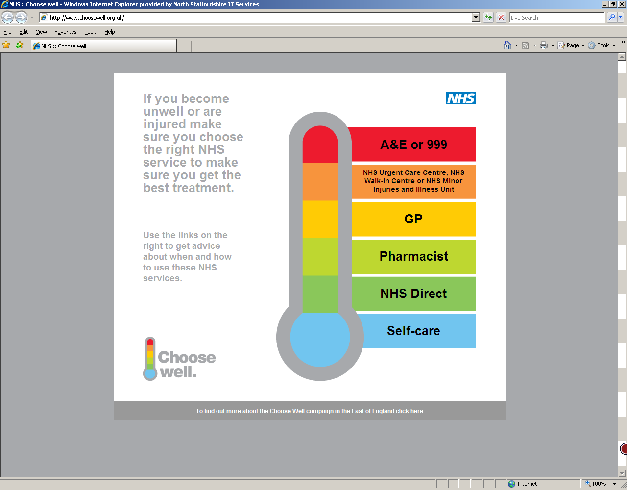

Online services allow patients to book (and cancel) appointments and order prescriptions online. Please ask the receptionist for an application form.

## Online Services

## Patient Participation Group

The Patient Particpation Group (PPG) gives patients, like you, the opportunity to get involved in local healthcare issues and to have a voice with regard to the services you and other members of the Practice receive as NHS service users.

If you are interested in becoming a member please come into the surgery and ask for more information or a form to become a either a full or virtual member.

## Family & Friends Test

The Friends and Family Test (FFT) is an important feedback tool that supports the fundamental principle that people who use NHS services should have the opportunity to provide feedback on their experience.

It asks people if they would recommend the services they have used and offers a range of responses. Friends and Family test is open to all patients and available in the surgery.

## Text Messaging Service

Would you like to receive appointment reminders and invites via text message?

If so, please let the receptionist know and provide an up-to-date mobile number.

**Self-care**

Make sure you keep your medicine cabinet stocked up with basic medicines to treat minor illnesses and ailments:

* Paracetamol or Aspirin
* Anti-diarrhoeal medicine
* Rehydration mixture
* Indigestion mixture
* Plasters
* Thermometer

**GP**

Your local doctors' surgery or GP practice provides a wide range of family health services, including:

* advice on health problems
* vaccinations
* examinations and treatment
* prescriptions for medicines
* referrals to other health/social services

**Pharmacist/Chemists**

Pharmacists/chemists are experts in medicines and how they work. They play a vital role in providing quality healthcare to patients at your local pharmacy. They dispense your prescriptions, provide a range of services related to specific health issues and can give advice on healthy living and minor ailments. See page 4 for information regarding the Pharmacy First Scheme.

**A&E or 999**

Generally, you should visit A&E or call 999 for emergencies, such as:

* loss of consciousness
* pain that is not relieved by simple analgesia
* acute confused state
* persistent, severe chest pain
* breathing difficulties.

**NHS Urgent Care Centres, NHS Walk-in Centre or NHS Minor Injuries and Illness Unit**

Minor injuries units can treat:

* Sprains and strains
* Broken bones
* Wound infections
* Minor burns and scalds
* Minor head injuries
* Insect and animal bites
* Minor eye injuries
* Injuries to back, shoulder and chest

**Leek Moorlands Hospital,** Ashbourne Road, Leek, ST13 5BQ

**0300 123 1894**

**8am - 8pm, 7 days a week**

NHS walk-in centres offer convenient access to a range of treatment and deal with minor illnesses and injuries. These include:

* infection and rashes,
* fractures and lacerations,
* emergency contraception and advice,
* stomach upsets,
* cuts and bruises, or
* burns and strains.

**Midway Medical Walk-in Centre,** Morston House, The Midway, Newcastle, ST5 1QG **01782 663757**

**8am – 8pm, 7 days a week**

**Hanley Health and Wellbeing Centre,** 69-71 Stafford Street, Hanley, Stoke-on-Trent, ST1 1LW **0300 123 6759**

**8am - 8pm 7 days a week**

**The Haywood Walk-in Centre,** High Lane, Burslem, Stoke-On-Trent, Staffordshire, ST6 7AG **01782 581112**

**Monday - Friday 7am - 10pm, weekends and Bank Holidays 9am - 10pm.**

**NHS 111**

NHS 111 provides health advice or information for anyone who needs it, 24 hours a day

**Page 5 of 5**

**Leek Health Centre**

## If you become unwell or are injured make sure you use the right NHS service to get the best treatment