LEEK HEALTH CENTRE

PRACTICE SURVEY ANALYSIS 2014

Leek Health Centre Profile
Website: www.leekhealthcentre.co.uk

We are a friendly five-doctor practice offering a full range of general medical services in very pleasant surroundings. We have an enthusiastic, highly trained and efficient team working within the practice and the community which includes a manager, practice and district nurses, health visitors, phlebotomist/health care support workers, a community midwife, community psychiatric nurses, receptionists and secretaries. We are all committed to providing the best possible care for our patients and developing locally based services for the benefit of all.

Patient Participation Group Profile

The Patient Participation Group (PPG) was established over 7 years ago; the PPG comprises of patients registered at Leek Health Centre. The Equality Act 2010 was taken into consideration when developing the PPG; patients are encouraged to join the PPG irrespective of age, sex, race, disability, religion, pregnancy and marital status etc. 19 patients have been recruited in the last 12 months. At present, there are 73 members in the PPG group, 43 of whom are virtual members. The PPG members meet on a bi-monthly basis. All PPG members (including virtual members) receive regular e-mails and minutes of the meetings; patients who do not have access to e-mails are provided with the same information via post.

The PPG is made up of:
- 35 males and 38 females
- Their ages range from 17 to 84

Figure 1 shows the profile of the Patient Participation Group in relation to gender and age. Although the PPG is not truly representative of the practice population, many methods are regularly used to engage patients in order to make the PPG as representative as possible. The PPG is advertised via: leaflets and posters in the reception area; the quarterly practice newsletter; Leek Health Centre website; NHS choices website, new patient questionnaires and responses to complaints.

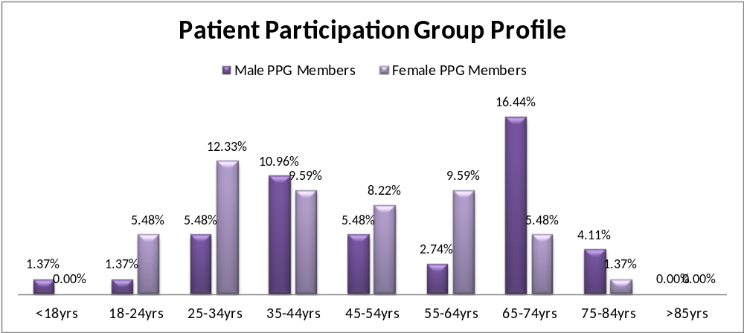
Figure 1 – Patient Participation Group Profile

Review of 2013 Action Plan

The patient survey of 2013 identified several action points:
- Advertise the website via posters and letterhead
Posters were displayed in the waiting room and the letterhead was changed to include the website address on 27th March 2013.
- Consider extra option on the phone for cancelling appointments
When the phone system was reviewed, an extra option for cancelling appointments was not deemed necessary as access via phones had improved over recent months. This was related to the implementation of the new reception rota on 1st April 2013 and also related to the introduction of the walk-in clinics as patients do not have to ring back for appointments.
- Improve access via phones – new reception rota
A new reception rota was implemented on 1st April 2013. In addition, the processing of prescriptions was transferred from reception (to the administration team) to ensure prescriptions are dealt with in a timely manner, alleviating the pressure on the receptionist.
- Improve follow up appointment system
Options were discussed amongst the GPs; the appointment system was changed in July 2013 to provide additional follow up appointments.
- Improve waiting times for patients
Due to the wait for patients’ consultations to start, the GPs decided to insert additional ‘catch up’ slots.
- Increase GP hours
Due to no additional funding being available from the Department of Health, it was not feasible to recruit another GP. The appointment system was changed in July 2013 to offer more pre-bookable appointments up to two weeks in advance. Furthermore, walk-in clinics were introduced in August 2013 to offer appointments to patients whose medical condition was not felt to be urgent but could not wait up to two weeks.
- Increase Nurse Practitioner Hours
Additional Nurse Practitioner hours were introduced on 14th June 2013, Nurse Practitioner appointments are now offered Monday to Friday.
- Increase use of Electronic Prescription Service and Online Prescription Service
There has been a significant increase in the number of patients using the Electronic Prescription Service and Online Prescription Service.
- Move self check-in machine and look at waiting time option
The Account Manager at InPractice Systems (clinical system provider) advised that there is no immediate plan to provide a waiting time on the self check-in machine. Consequently, a board, indicating current waiting times, was introduced and is updated on a regular basis by the receptionist on the front desk. There is a poster next to the self check-in machine advising patients that current waiting times are displayed on the board behind the reception desk.
- Ongoing training and mentorship for reception staff
Training and mentorship regarding communication skills is ongoing for all reception staff in order to improve the service offered to patients.
- Patient education sessions
The Leek & Biddulph Locality are in the process of procuring funding for the patient education sessions.

Questionnaire Design

Over the last 12 months, we have agreed areas of priority with our PPG members and these have been included in the survey. Furthermore, planned practice changes, practice priorities and concerns raised via complaints have been addressed in the survey. Detailed below are the areas of priority and the related survey questions:

Topic | Survey Questions | Reason(s) for inclusion
Appointment system | Q1 When you want to see/speak to a Doctor, how quickly are you able to get an appointment?  Q2 If your answer to Q1 was ‘2 or more working days’, why was that?  Q6 Think about the last time you tried to see someone ‘urgently’. Were you able to see/speak to a Doctor or Nurse Practitioner on the same day?  Q7 If you weren’t able to be seen on the same day, why was that? Please tick one box only. | - Discussed in the PPG meeting on 18.12.2012  - Changes within, and complaints about, the appointment system
Opening hours | Q9 How do you rate our opening hours?  Q10 Would you like the surgery to open at additional times? | - Discussed in the PPG meeting on 18.12.2012  - Changes to the extended opening hours over the last 12 months
Prescription Service | Q15 How do you rate the Online Prescription request Service? | - Discussed in the PPG meeting on 18.12.2012 and 17.04.2013 and 04.09.2013  - Changes within, and complaints about, the prescription service
Reception team | Q12 How do you rate the way you are treated by the Receptionists? | - Changes to the reception team within the last 12 months
Waiting times | Q4 How long do you usually have to wait for your consultation to begin?  Q5 How do you rate this? | - Discussed in the PPG meeting on 18.12.2012 and 04.09.2013

Practice Survey 2014

A draft survey was developed at the beginning of November 2013; the questions were adapted from the National Association for Patient Participation (N.A.P.P.) website http://www.napp.org.uk/Sample%20Questions.pdf. The PPG members were consulted via e-mail/post on 11th November 2013 and given the opportunity to express their thoughts and suggestions for improvement. Following consultation with GP Partners, NHS North Staffordshire and our PPG members, the survey was finalised on 4th December 2013. NHS North Staffordshire offered Leek Health Centre the opportunity to input the survey responses via http://www.keysurvey.com. Completed paper questionnaires were entered onto the keysurvey.com website by practice staff; enabling efficient analysis of all results. Patients’ comments written against questions (not within the comments box) were entered in the ‘Any other comments?’ box.

To ensure credibility of the survey, the following methods were utilised to target patients for 5 weeks, from 9th December 2013 to 10th January 2014:
- All 73 PPG members were asked to complete the patient survey.
- The information was published on Leek Health Centre website and also the NHS Choices Website.
- The survey was sent to a random sample of 20 patients aged 16-18.
- An e-mail was sent to all 606 patients with an e-mail address asking them to complete the survey.
- Patients who presented to the front desk throughout the day were asked by the receptionist to complete a survey; there was a box available in the waiting room for patients to post completed questionnaires. 200 questionnaires were handed out.
- Several posters were displayed in the waiting room asking patients to complete the survey.
- Handouts were made available next to the self check-in machine and were given out with prescriptions.
- The Pharmacists gave out the handouts to patients signed up to the Electronic Prescription Service.
- The handouts were also included in all outgoing mail sent to patients during the above period.
Furthermore, the Public and Patient Engagement Officer at NHS North Staffordshire sent the survey to patients in the Membership Scheme on our behalf (as we do not have details of these patients).

Analysis of Results

A total of 278 responses were received, 112 of these were via the paper questionnaires handed out in the surgery. 53.85% of the patients surveyed were female and 46.15% were male. Responses were not truly representative of the patient population in relation to age; however a wide range of ages were incorporated.

A summary of the results were circulated to the PPG members (including the virtual group) on 14th January 2014. Virtual members were asked to feed back their thoughts and suggestions by 29th January 2014. A PPG meeting was held on 30th January 2014; the findings of the survey were discussed and an action plan was agreed.

Overall, the results of the survey were positive with the majority of patients being satisfied with the service provided. Several action points were raised and these are explained below.

Appointments
Improvements have been made to the appointment system over the last 12 months and more appointments are available to book either on the day or 48 hours in advance. We will continue to review this.

59.49% of patients said when they want to see or speak to a Doctor they have to wait 2 or more working days (44.16% last year). Upon further questioning, 66.5% said there were no appointments available, 24.23% said they wanted to see a particular GP, 4.64% said the times offered did not suit and 4.64% did not know. Over the past couple of months, walk in clinics have been held to allow open access to GPs; the feedback has been positive. The walk in clinics will continue periodically, when there are 3 or more clinicians in, to manage demand and reduce waiting times.

Patients were asked to think about the last time they tried to see someone ‘urgently’ and if they were able to see or speak to a Doctor or Nurse Practitioner on the same day. This area has improved over the last 12 months as 64.10% agreed they were able to see someone the same day, compared to 58.16% last year. It is important to note that 16.48% of patients said this question did not apply to them. The receptionists will encourage use of the Pharmacy First Scheme where appropriate, enabling patients with minor ailments to receive treatment over the counter when a GP or Nurse Practitioner appointment is not necessary.

Waiting times for consultations to begin
The vast majority of patients stated that they have to wait between 11 and 20 minutes for their consultation to begin. The practice charter states that we aim to see 50% of patients within 10 minutes of their appointment time and 90% within 20 minutes. Immediate action is required as only 24.09% of patients were seen within 10 minutes of their appointment time and 87.23% within 20 minutes. The appointment system needs to be reviewed in order to reduce the waiting time for patients, with a view to inserting additional ‘catch up’ slots for the GPs. To raise patient awareness, information regarding 10 minute appointments will be made widely available in the waiting area and also included in the next newsletter. Members of the Patient Participation Group feel that, although useful, the board behind the reception desk displaying the delay in waiting times could be better situated; members will feed back suggestions to the Chair of the group. Enquiries have been made with the provider of the clinical system; unfortunately there is no facility to show waiting times on the self check-in system at present.

Opening Times
The access at Leek Health Centre is flexible, accommodating the varying needs of patients; this is reflected in the survey as 81.01% rate the opening hours as good to excellent, compared to 74.58% last year. The core and extended opening hours are shown below:
Day | Core Opening Hours | Extended Opening Hours
Monday | 8am – 6.30pm
Tuesday | 8am – 6.30pm | 7.30 – 8am
Wednesday | 8am – 6.30pm | 7.30 – 8am, 6.30 – 7.45pm
Thursday | 8am – 6.30pm
Friday | 8am – 6.30pm | 7.30 – 8am

NHS North Staffordshire are responsible for commissioning the Out of Hours service. If patients contact Leek Health Centre outside core working hours, they are advised how to contact the Out of Hours doctor.

Patients were asked if they would like the surgery to open at additional times; 59.02% are satisfied with the current opening hours and 40.98% said they would like the surgery to open at additional times. Of the 40.98% who commented, 85.06% preferred weekends, 1.72% specified more early morning appointments, 8.62% favoured more evening appointments, 1.15% said Bank Holidays and 3.45% did not specify. At present, Leek Health Centre are unable to offer further extended opening times but will continue to accommodate patients who work during the day by offering early morning and late evening appointments.

Access via phone
A major concern expressed by patients is the ability to get through to a receptionist on the phone. Our receptionists work extremely hard and we already have a number of incoming phone lines. The receptionists receive ongoing mentorship and training to ensure they deal with phone calls efficiently. The reception rota is reviewed on a monthly basis to ensure adequate staffing levels; the receptionist’s hours have recently been increased to accommodate the increase in patient demand via telephone.

The practice has offered online appointments for flu vaccine appointments (although the uptake was very low); we are currently considering routine GP appointments online. All patients currently registered for online services have been notified via e-mail that appointments made in the surgery can be cancelled using the online service; this will also be included in the next newsletter, in addition to information on how to register for the online services.

We will look into having an extra option on the phone for patients wishing to cancel appointments; the option could link directly to an answer machine for patients to leave their name, Date of Birth and date and time of the appointment they wish to cancel. However, it will be made clear to patients that the answer machine service must not be used to order prescriptions, request a phone call etc.

A Patient Participation Group member requested that the phone line opening times are published in the newsletter alongside the surgery opening times, as patients are led to believe that they can contact the surgery via phone during the surgery opening times.

Reception/waiting area
In order to continually improve the service offered, patients were asked how they are treated by the receptionists. 83.34% of patients rate the way they are treated by the receptionists as good to excellent. Many of the general comments made about the reception team related to patients being asked what the medical problem is when booking an appointment, which some patients did not agree with. The receptionists follow the practice protocols established by the Partners and ask patients for a brief description of the medical problem to signpost the patient to the most appropriate clinician or service (i.e. Pharmacy First Scheme). If patients do not wish to divulge personal information, the receptionist should explain the reason for asking whilst acknowledging that the patient does not wish to provide the information. The receptionists receive ongoing training and mentorship and will be reminded to advise patients that they do not have to divulge the information. In order to improve confidentiality at the front desk, we will consider a privacy screen and also consider marking out the floor area for patients waiting to make a privacy zone.

5 general comments were received from patients related to the tannoy system and music played in the waiting room; all of these patients were aged over 55. Music is played in reception for confidentiality purposes to help obscure conversations held between the receptionist and patients at the front desk. The receptionists endeavour to play a range of music to accommodate all ages, including young adults.

Prescription Service
The Electronic Prescription Service was implemented in July 2012, allowing prescribers to send electronic prescriptions to a pharmacy of the patient’s choice. There are 3,828 patients with at least one item of medication on a repeat prescription, at present there are over 2,400 patients signed up for the Electronic Prescription Service. We recognise that pharmacies work in different ways in relation to the Electronic Prescription Service and are keen to resolve issues that arise; a meeting will be arranged with the Pharmacies concerned to improve the service for patients.

In October 2012, the practice introduced the Online Prescription Service, allowing patients to request medication online; this service has been popular with an uptake of over 600 patients to date. When asked about the Online Prescription Service, 48.82% of patients had no experience whilst 32.68% rate the service as good to excellent. It is important that utilisation of both the Electronic and Online Prescription Service is maximised therefore the reception team will continue to promote use of the services to reduce congestion at the front desk and help to improve the prescription service.

Action Plan
An action plan setting out the priorities and proposals arising out of the survey was developed in the form of a chart; the action plan was agreed in the PPG meeting on 30th January 2014, and circulated to all PPG members via e-mail/post on 3rd February 2014. The chart shown in Figure 2 delineates the action plan for Leek Health Centre based on the aforementioned priorities and proposals. The start of the green line indicates the estimated time of implementation; 0 = February 2014, 6 = August 2014.

Survey Results
The survey report has been circulated to PPG members (via e-mail/post) and members of staff, published via posters in the waiting room, on our website www.leekhealthcentre.co.uk and the NHS Choices website.
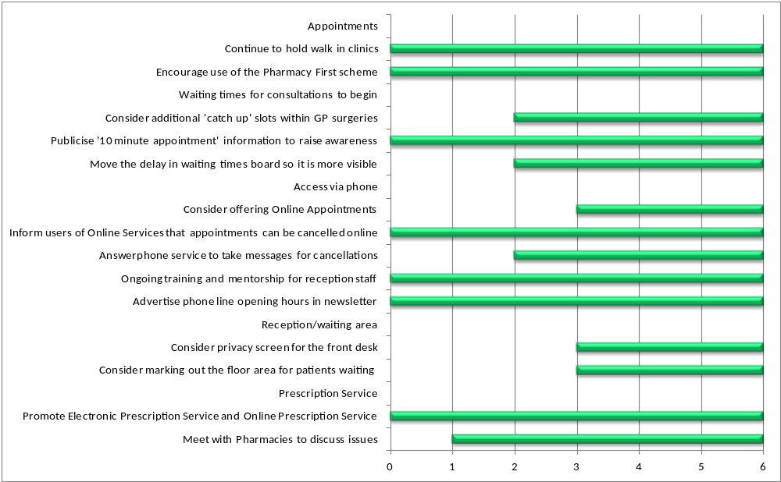
Figure 2 - Chart to show implementation of the action plan

