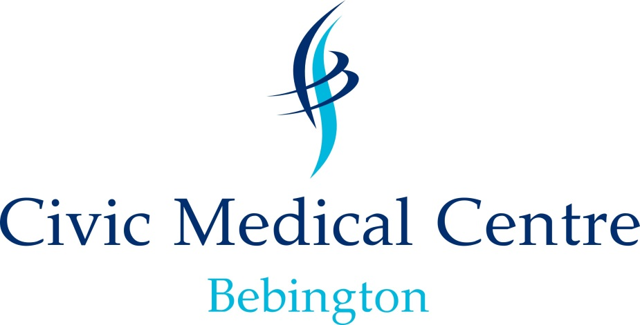

Patient Participation Group

The practice has an active Patient Participation Group which meets every 4-6 weeks. These meetings are attended by our practice manager and on occasions by one of our GP’s. The group act as the patients’ voice to provide us with feedback to help us improve our services.

It is also an opportunity for the practice to communicate important updates and changes to services. If you would be interested in joining our patient group then please give your details in to reception.

Examples of what the Patient Participation Group can do:

- Provide a patient perspective to service changes that are under consideration.

- Review responses to patient feedback questionnaires and help develop action plans to address patient concerns.

- Provide support for specific events.

- Assist in evaluating and prioritising demands on surgery resources.

- Provide surgery management with a sounding board for future plans.

- Improve communication between the surgery and patients.

Mission Statement

Civic Medical Centre aims to offer safe, effective, responsive, caring and well led primary care medical services to our practice population.

We aim to improve the health, well-being and lives of those we care for by:

- Focusing on disease prevention by promoting healthy lifestyles and offering the best care and advice to our patients.

- Working in partnership with our patients, families and carers, treating them as individuals with the same care and respect we would expect for ourselves or our own families, listening and respecting their wishes and enabling them to maintain the maximum possible level of independence and choice.

- Encouraging patients to communicate with us by joining the PPG, talking to us, participating in surveys and feeding back on the services we offer.

- In return we will respond to all concerns in a timely fashion, offer explanation or an apology when needed.

- We aim to maintain the highest standards of the profession by continually learning and improving through education, audit and quality improvement activity.

- Ensure confidentiality at all times.

- To ensure all our staff are competent to deliver the required standard of service and that the team have the correct skills and training to complete their duties.

- To care for our staff and offer them the support they need to do their jobs and protect them from harm or abuse.

- To provide all staff and patients an environment that is safe and friendly.

- To adhere to all guidelines and regulations and work in conjunction with our partners to ensure sound financial management.

