COVID 19 Support
Information is changing quickly, and it can be hard to keep up with the relevant information. This document will attempt to collate all the up to date information.

National Support
Government
Information, Announcements and updates relating to the virus.

Website: https://www.gov.uk/government/topical-events/coronavirus-covid-19-uk-government-response

Support for those extremely vulnerable

Website: https://www.gov.uk/coronavirus-extremely-vulnerable

Advice and Financial Support

Christian’s against poverty (CAP)
Debt Counselling and support

Website: https://capuk.org/

Citizens Advice

General Advice:
Text ADVICE to 78866

Financial Advice:
Text DEBT to 78866

An advisor will aim to call you back within 48 hours excluding weekends.

Helpline: 03444 111 444 available Monday to Friday 10:00am to 4:00pm

Website: https://www.citizensadvice.org.uk/

Entitled to
Specific advice for financial support during Covid-19

Website: https://www.entitledto.co.uk/help/coronavirus_help

The Money Advice Service – Budget tool
Budget Planner to manage finances

Website: https://www.moneyadviceservice.org.uk/en/tools/budget-planner

Turn to Us
Providing financial support to help people get back on track

Website: https://www.turn2us.org.uk/get-support/Benefits-and-Coronavirus

Utility Supplier Information

Support from utility providers to help customers during Covid 19

Website: https://www.moneysavingexpert.com/news/2020/03/energy-firms-move-to-help-customers-unable-to-top-up-due-to-coro/

Arts, Culture and Heritage

March Network – Creative Isolation
A resource page of creative activities to do whilst in isolation at home

Website: https://www.marchnetwork.org/creative-isolation
Food and Supermarkets

Foodbanks
Offering food and basic supplies to those in a crisis

Website: https://www.trusselltrust.org/get-help/find-a-foodbank/

Community Fridges
Community Fridges

Website: https://www.zerowastenear.me/community-fridges-surplus-food

Long Term Health Conditions

Age UK

Advice for the ageing and elderly

Website: https://www.ageuk.org.uk/information-advice/health-wellbeing/conditions-illnesses/coronavirus/

Asthma UK
Advice for people living with Asthma

Website: https://www.asthma.org.uk/advice/triggers/coronavirus-covid-19/

British Heart Foundation

Advice for people living with Heart of Circulatory diseases

Website: https://www.bhf.org.uk/informationsupport/heart-matters-magazine/news/coronavirus-and-your-health

Cancer Research

Advice for those with Cancer

Website: https://www.cancerresearchuk.org/about-cancer/cancer-in-general/coronavirus-and-cancer

Diabetes UK

Advice for people living with Diabetes

Website: https://www.diabetes.org.uk/about_us/news/coronavirus

Mind UK

Advice for Mental Health

Website: https://www.mind.org.uk/information-support/coronavirus-and-your-wellbeing/

National Autistic Society

Advice for individuals with Autism

Website: https://www.autism.org.uk/services/helplines/coronavirus.aspx

Royal College of Obstetricians and Gynaecologists

Advice for Expectant mothers

Website: https://www.rcog.org.uk/coronavirus-pregnancy

Scope

Advice for those with a disability

Website: https://www.scope.org.uk/coronavirus-information/

Mental Health Support

Mental Health Directory
January 2020 latest addition of mental health directory

Action for Children
Action For Children online digital support for parents is up and running for parents of 0-19 year olds. (previously was under 5s). Parents can speak either online or via phone about anything really from finances to behaviour to worry and anxiety.

Website: https://talk.actionforchildren.org.uk/

Blurt

Increasing Awareness and understanding of Depression

Website: https://www.blurtitout.org/2020/03/17/coronavirus_mental_health/

Childline
Childline is yours – a free, private and confidential service where you can be you. Whatever your worry, whenever you need help, however you want to get in touch. We're here for you online, on the phone, anytime.

Website: https://www.childline.org.uk/
Helpline: 0800 1111

Kooth
Free, safe and anonymous online support for young people

Monday – Friday 12pm – 10pm
Saturday – Sunday 6pm – 10pm
Website: https://www.kooth.com/
Help

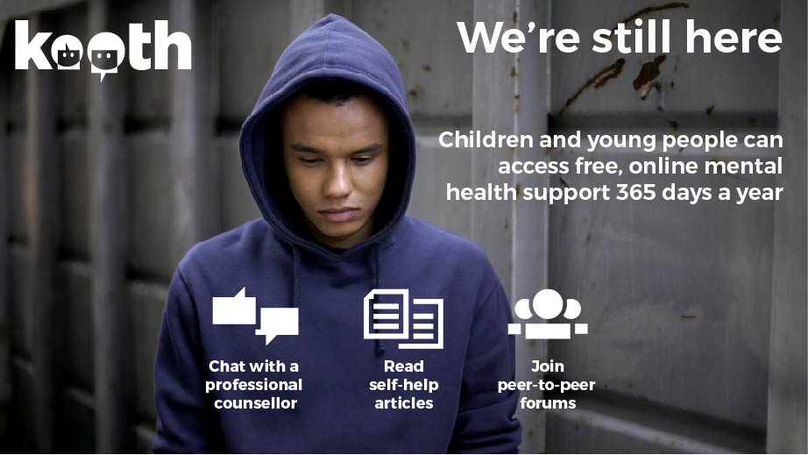

Mood Swings
Aimed at anyone affected by a mood disorder, including friends, families and carers. Their helpline is open 10am to 4pm Monday to Friday.
Telephone: 0161 832 37 36
E-mail: info@moodswings.org.uk
Website: www.moodswings.org.uk

Moodzone NHS
Whatever you need to know about coping with stress, anxiety or depression, or just the normal emotional ups and downs of life. It offers practical advice, interactive
tools, videos and audio guides to help you feel mentally and emotionally better.
Website:
Papyrus
Support for under 35’s, prevention of young suicide
Hopeline UK: 0800 068 4141

Website: https://papyrus-uk.org/
Samaritans
Talk to us any time you like, in your own way, and off the record – about whatever’s getting to you. You don’t have to be suicidal.

Helpline: 116 123 24 hours a day free helpline

Website: https://www.samaritans.org/

Saneline
Saneline is a national mental health helpline providing information and support to people with mental health problems and those who support them.

Helpline: 0300 304 7000 (4:30pm‐10:30pm)
Website: www.sane.org.uk/what_we_do/support/helpline

Shout
Shout is the UK’s first free 24/7 text service for anyone in crisis anytime, anywhere. It’s a place to go if you’re struggling to cope and you need immediate help. Shout is powered by a team of volunteers, who are at the heart of the service. We take people from crisis to calm every single day.

If you’re experiencing a personal crisis, are unable to cope and need support, text Shout to
85258

Website: https://www.giveusashout.org/

Stay Alive App
This app is a pocket suicide prevention resource for the UK, packed full of useful information and tools to help you stay safe in crisis. You can use it if you are having thoughts of suicide or if you are concerned about someone else who may be considering suicide. In addition to the resources, the app includes a safety plan, customisable reasons for living, and a LifeBox where you can store photos and memories that are important to you. You can also read the strategies for staying safe, explore the tips on how to stay grounded when you’re feeling overwhelmed, try the guided‐breathing exercises and support your own wellness by creating your own interactive Wellness Plan.
The app links you directly to local and national crisis resources, so you won't need to carry around slips of paper with contact details on, it's all stored there within the app.

Online Learning & Education

Range of Free Educational Resources

Local Support – Cornwall

Cornwall Council

Cornwall Council will publish information on Coronavirus and how it is affecting services in Cornwall. This is a fast-moving situation and information will be added as soon as it is known.

Website: https://www.cornwall.gov.uk/health-and-social-care/public-health-cornwall/information-about-coronavirus-covid-19/

The Government has announced it will provide local authorities with funding of £500m. This is for a Coronavirus hardship scheme to support vulnerable residents. Initial details were released to all local authorities on 24 March 2020. Most of the funding is to be used to offer extra support through each local authorities own Council Tax Support scheme.

The intention is that every working age household in receipt of Council Tax Support will receive an extra award of £150 in the next few weeks. This will be in addition to any Council Tax Support already calculated for the period 1 April 2020 to 31 March 2021. These awards will be applied to accounts as early as possible after the beginning of April. There is no need to apply for the extra help. Awards will be made automatically and new Council Tax bills will be issued in due course.

Once the £150 awards have been made, the Government will allow local authorities to use any remaining funds to offer further support to those residents most affected financially by the Coronavirus outbreak. Cornwall Council will work quickly to confirm how any remaining hardship funding will be awarded including more information on eligibility criteria and any application process.

In the meantime, Cornwall Council have three discretionary funds to support residents in need of extra financial help.
- Discretionary Housing Payments for residents who rent their home, are in receipt of Housing Benefit or Universal Credit and need extra help to pay their rent.
- Exceptional Relief for working age residents in receipt of Council Tax Support and who need further financial help to pay their Council tax
- Crisis and Care Award scheme which can provide extra help in emergency or disaster situations.

Benefit advice can be found below

Website: https://www.cornwall.gov.uk/advice-and-benefits/benefits/benefits-and-coronavirus/

Advice and Financial Support

Community Energy Plus
A Cornish charity which provides energy advice and practical help for vulnerable householders in Cornwall to achieve warmer, healthier homes.
To keep people safe and to minimise the spread of COVID-19 we have suspended home visits.

However we are continuing to provide advice over the phone to people living across all housing tenures in Cornwall. This includes:
- Advice for pre-pay meter clients about topping up meters during COVID-19.
- Help to understand energy bills, switch tariffs, manage energy debt and other issues with energy suppliers. We can advocacy support to help you speak to your energy supplier if needed.
- Access to grants for heating repairs and upgrades, insulation and other energy efficiency measures.
- Advice on saving energy and money.
- Advice on reducing condensation and mould.
- Links to services provided by other local and national organisations.

Contact: 0800 954 1956 freephone or 01872 245566
Email: advice@cep.org.uk
Website: https://www.cep.org.uk/

Cornwall Council Benefits and Coronavirus
A handy guide from Cornwall Council to understanding benefits and coronavirus and a site with announcements about the governments Coronavirus crisis grant

Website: https://www.cornwall.gov.uk/advice-and-benefits/benefits/benefits-and-coronavirus/

Growth Hub – Business Support
The Growth Hub is offering advice to businesses affected by closure.

Website: https://www.ciosgrowthhub.com/
Telephone: 01209 708 660

Outset Cornwall Self-Employment Support

For those seeking support with self-employment Outset Cornwall is now able to continue its support and reach out to communities by switching to an online programme delivery with of all training.

The use of online training room to hold Outset Cornwall sessions seems like a great alternative. Individuals will still be able to interact with their advisor and the other people that attend the session, as well as see the slides that they are using on your computer screen.

Their advisors will connect through webinars, phone calls and maintain contact with each individual. This might also be a good time to introduce you to their additional training platform, Outset Online, which they automatically get free access to once they have signed up to the programme.

There is a wealth of experience on the platform, and clients can work through the online lessons to create a business plan, or dip in and out to find out more information about a certain topic to help with their business idea.

Email: rosie.laurent@outset.org
Website: https://www.outset.org/cornwall/
Telephone: 01209 311 063
Community Support & Funding

Cornwall Community Foundation- Emergency Fund

CCF's Emergency Fund Appeal enables us to offer grants to frontline organisations running additional work in response to the impact of COVID-19 to your members or beneficiaries.

The aim of the Emergency Fund is to primarily support:

- Groups that support the ongoing needs of vulnerable people to ensure that their health and wellbeing is maintained
- Groups and activities that support vulnerable people self-isolating (the elderly, people with pre-existing medical conditions etc)
- Support for foodbanks and organisations working to combat hardship caused by the pandemic including child hunger
- Community response coordination
- Volunteer costs for new and existing organisations responding to the effect of the pandemic.
- Additional costs of working remotely and adapting services delivered in the wider community
- Additional support as required for emotional support, mental health and bereavement support

Grants of £500-£3000

Website: https://www.cornwallcommunityfoundation.com/grants/emergency-fund/?dm_i=1Z6I,6PDE6,WX8D55,QRATT,1

Domestic Abuse Support

Cornwall Domestic Abuse 24hr Helpline

Contact: 01872 225629
First Light
Cornwall Domestic abuse and sexual violence service (not gender specific)

Helpline: 0300 777 4777
Website: https://www.firstlight.org.uk/

Women’s Centre
Rape & Sexual Abuse Helpline: 01208 77099
Domestic Abuse Helpline: 01208 79992
Email: admin@womenscentrecornwall.org.uk
Website: https://www.womenscentrecornwall.org.uk/

Family Support

24 hour Maternity Triage Line for Cornwall and the Isles of Scilly.
This is an uncertain and anxious time for everyone who is pregnant or recently had a baby.
If you have any queries or questions or need to talk to a midwife please call: 01872 258000.
This line has been launched to take all maternity related calls from women, birthing people and their families and is staffed by wonderful midwives, 24 hours a day.

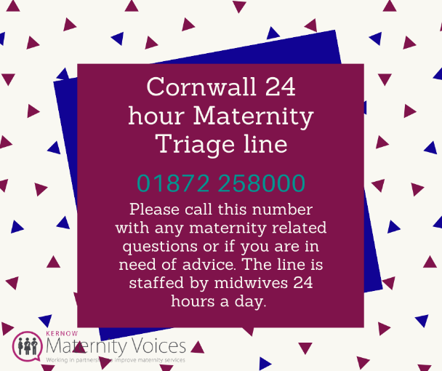

Breastfeeding Support
In order to support parents at this time, there is the following advice on who to contact:

• Contact your health visitor or midwife directly for breastfeeding advice or any other concerns. See below website for central line contact details: https://www.cornwall.gov.uk/…/childrens-co…/health-visiting/

• National Breastfeeding
Helpline: 0300 100 0212
Website: http://www.nationalbreastfeedinghelpline.org.uk/

• La Leche League
Website: https://www.laleche.org.uk/call/#West
• Association of Breastfeeding Mothers: The ABM Breastfeeding
Helpline: 0300 330 5453 (9.30am -10.30pm).
Website: https://abm.me.uk/get-breastfeeding-support/

Community Development Workers
Volunteer Cornwall has appointed six Community Development Workers across the county who are getting to know about children and families in communities like yours. Their job is to find out what fantastic things you might already be up to in your community, as well as what you think is missing.

With their links and contacts to other voluntary and community sector organisations, their job is to help people who want to make a difference in their communities do just that! It might be finding the right support for an existing group or help with getting something off the ground.

These roles have been commissioned by Cornwall Council under the One Vision Partnership Plan which looks to change the way we work together to help improve the lives of Children, Young People and Families.

All contact details are for the contact in your area is on the website below.

Website: https://www.volunteercornwall.org.uk/how-we-help/children-and-young-people/one-vision-community-development-workers

Home Start Kernow – Family Support
#StayConncected Plan
What we can offer: 1-1 digital support for parents. This can be by text, phone call, video call or messenger - Mon-Fri
- support can be provided by a Coordinator on an ad hoc basis by Jayne in North Cornwall; Helen in Central and Julia in West.
- Or by an agreed time slot on a weekly basis by a HSK volunteer
- Access to a closed and monitored FaceBook group providing ideas for activities with children; craft, exercise, songs, cooking, stories etc. An opportunity for peer support and sharing ideas.

Referral Process
- Via the website www.homestartkernow.org.uk/contact-us
- Or Home Start Kernow Facebook page pinned post with message button

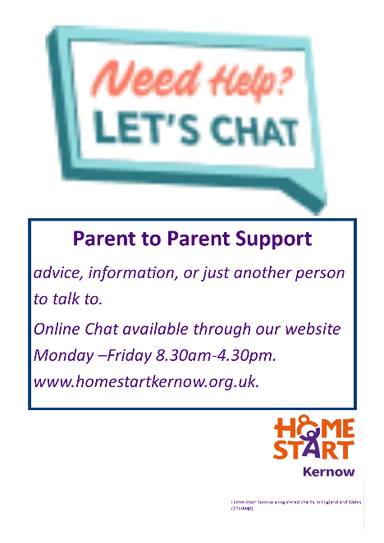
Families will need to leave their name, mobile number and area they live in only.
A Coordinator will make initial contact and discuss the above options.
Not time limited, can be just one call, calls are not recorded.
Volunteers are Home-Start trained.

Website: https://homestartkernow.org.uk/
Contact: 01209 214 490
Email: info@homestartkernow.org.uk

Parent to Parent Support
Online Chat available for parents through the website available Monday – Friday 08:30am to 4:30pm

Health and Wellbeing

Age UK Cornwall

Contact: 01872 266 383
Website: https://www.ageuk.org.uk/cornwall/

Cornwall Hospice
From the therapy team: Lymphoedema advice, Managing breathlessness, Overall wellbeing, Mindfulness and relaxation, A short relaxation meditation, A short mindfulness session
Website: https://www.cornwallhospicecare.co.uk/our-care/therapy-team/self-help-resources/

The Cornwall Football Association
Offices have now closed but all staff are still working remotely. Cornwall FA understands the impact and power of football so they are launching the #footballsstayinghome campaign. Over the next few weeks there will be a range of challenges posted via their website / social media for the whole community to get involved with.

Website: http://www.cornwallfa.com/
Facebook: https://www.facebook.com/CornwallFA/

Kernow Carers
Helpline: 01872 323535

Website:https://www.supportincornwall.org.uk/kb5/cornwall/directory/service.page?id=DpW6IBqhS9o&adultchannel=9-3-3

Hobbies & Learning

Borrow Box – Cornwall Libraries

Library services in cornwall are closed but you can access the Borrow Box to download eAudiobooks and eBooks on your tablet, smartphone, PC or Mac.

You'll need to download the BorrowBox app to read them on your smartphone or tablet.

Website: https://www.cornwall.gov.uk/leisure-and-culture/libraries/your-library-online/ebooks-eaudiobooks-and-emagazines/borrowbox-ebooks-and-eaudiobooks/
Mental Health Support

Cornwall Council – Mental Health Safety Plan
A Mental Health Safety Plan is a preventative tool designed to help support those who struggle with mental wellbeing. It may be difficult to think clearly when you’re feeling really low, or feel incredibly overwhelmed, and it may be difficult to ignore these feelings. Safety plans are best created when not in crisis.

By having a safety plan, you’re making sure that there are strategies you can use to keep yourself safe and can help you feel more in control when everything feels out of control. Think of your safety plan as your ‘mental health first-aid kit’; it includes different things that will help you through a crisis

Website: https://www.cornwall.gov.uk/health-and-social-care/mental-health/mental-health-safety-plans/

Counselling for social change –

Free 30-minute phone/online 'emotional support' sessions for people in Cornwall.
You can book the sessions online (https://www.c4sc.org/coronavirus). We are not taking block bookings, so please only book one session at a time so people can access this service. Please note that this is not a ‘crisis’ service. Please visit http://www.counsellingforsocialchange.org.uk/…/urgent-supp…/
Mind Your Way

Made for young people by young people. A place to get help with your mental health and wellbeing

Website: https://mindyourway.co.uk/

The Mix
If you're under 25 you can talk to The Mix for free on the phone, by email or on their webchat. You can also use their phone counselling service, or get more information on support services you might need.

Freephone: 0808 808 4994 (13:00-23:00 daily)

Website: https://www.themix.org.uk/

Valued Lives
Changing mental health care

Telephone: 01209 901438
Website: https://www.valuedlives.co.uk/

Young Minds Crisis Messenger

provides free, 24/7 crisis support across the UK if you are experiencing a mental health crisis.

If you need urgent help text YM to 85258
All texts are answered by trained volunteers, with support from experienced clinical supervisors.
Texts are free from EE, O2, Vodafone, 3 Virgin Mobile, BT Mobile, GiffGaff, Tesco Mobile and Telecom Plus.

Website: https://youngminds.org.uk/find-help/get-urgent-help/youngminds-crisis-messenger/

Parents Helpline: 0808-802-5544
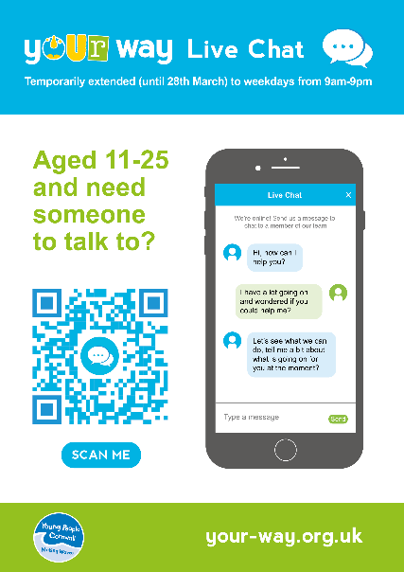
Your Way Chat
Young People Cornwall will be offering a digital option across all of our services. During this time we will continue to do our best to offer our service. The Your Way web chat – weekdays 9am-9pm, Skype, Telephone and Text.

The chat service is accessible via the website.

Contact: 01872 613001
Website: https://your-way.org.uk/

Signposting & Support

Cornwall Link Networking Platform –
Covid-19 Community Support site on Cornwall Link to help keep Cornwall connected (#ConnectedCornwall) during this challenging time. This support site has been developed by Age UK Cornwall and Made Open Communications. It forms part of the Inclusion Matters Partnership led by Cornwall Rural Community Charity (CRCC) including Disability Cornwall, Inclusion Cornwall and the Digital Inclusion Team at Cornwall Council.

Website: https://cornwall-link.madeopen.co.uk/
Helpline: 01872 266383
Inclusion Matters Helpline is available for telephone advice and to help stay connected.
Volunteer Cornwall - Volunteer Cornwall have volunteers across the county who can help those who are self-isolating with things like shopping, picking up prescriptions, telephone befriending etc.

Available to offer support
There is an online referral if you would like to be part of their Coronavirus support service (for vulnerable people who need assistance during isolation) .

Requiring Support
If you are isolating and need help you can register with them, if you need help please email requestforhelp@volunteercornwall.org.uk

Attached is the referral form for anyone who needs assistance due to Coronavirus.

The completed referral form should be emailed to JudyT@volunteercornwall.org.uk.

You can also call head office to make a referral - 01872 266988.

Corona Cornwall
A website connecting people and signposting to local services and information to provide support during this challenging time.
Contact: 01566 788865
Website: https://coronacornwall.org/
Inclusion Cornwall
Is still open and here to help. We operate a remote model of working and we’re confident that we can keep our core services going however long the UK is affected by the Covid virus.

Contact: 01872 326440
Email: hello@inclusioncornwall.co.uk
Website: http://inclusioncornwall.co.uk/

Farming Community Network
Support service for the farming community
Telephone: 03000 111 999
Email: help@fcn.org.uk
Website: https://fcn.org.uk/

Cornwall Countywide
Mobile Bread Van – Baker Tom’s
Starting from 18 March they are offering a mobile bread delivery route.

See their full information on their facebook page: https://www.facebook.com/bakertoms/
Caradon
Local support available to those in the former Cardon district
Provided by: Laura Chapman
Email: LauraC@volunteercornwall.org.uk

Falmouth
A2B Taxis
A2B are offering a ‘Food Collection Service’.
Contact: 01326 505050.

Falmouth Food Coop Kitchen – Meals
The Falmouth Food Coop Kitchen have cancelled their feast on Sunday but are acquiring a space in Falmouth where they will be creating and delivering meals for vulnerable and isolated people. They have created an online form for people to fill out who require meals.

Website: https://falmouthfood.us19.list-manage.com/subscribe?u=08eec1c221b3f51842cd695f8&id=41dc184c11
Email: ffckitchen@protonmail.com
Contact: 01326 567 526
Spar, Albany Road, Falmouth
Will endeavour to deliver to the elderly and vulnerable
Penryn
Pips Pasties
Starting from today and ongoing – deliveries will leave the premises at 11.00am and 12 noon and can include anything from their full menu to frozen pasties.

Contact: 01326 374799

Spar
As from 19 March they will be offering a delivery service to the residents of Penryn who are having to self-isolate or are unable to leave their home. Please phone between 9am and 1pm Monday to Friday to place your order and they will do their best to get the shopping to you within a few hours.

Contact: 01326 373269.

Penryn Surgery Dispensary
There is a daily delivery service for prescriptions to local post offices in the area.

Doggies and Moggies
They are providing a delivery service in the local area.

Contact: 01326 379281.

Baileys Country Store
Offering a free delivery service.
Mabe Premier Stores and Post Office
Deliveries on Tuesdays and Fridays initially. They will also deliver prescriptions that would normally be collected from the store.

Truro and surrounding areas
Iceland Stores
Opening exclusively for senior citizens and vulnerable people on Wednesdays from 8am to 10am.

Cornish Food Box Company
Currently offering free delivery for over 70s.

Contact: 01872 211533
Website: https://www.thecornishfoodboxcompany.co.uk/
Community Fridge at Cafe Chaos, Truro
The community fridge is free of use, every person, you don’t need to be registered, be a client at the Café CHAOS, they truly believe by this way it takes away the stigma/shame that this subject is associated. The Community Fridge is open Monday – Friday between 8.30AM and 5PM.

Website: http://chaosgroupcornwall.co.uk/community-fridge/

AsOne Community Fridge, Perranporth
AsOne are working with FareShare South West offering food to locals to collect from our community fridge. Dates for the community fridge advertised on the facebook page

Website: https://www.facebook.com/AsOnecsc-595489770875635/

Coast to Coast
Food Support
The specific providers would need to be checked to ensure they are still operating.

Volunteer Support
Specific groups and contacts for volunteer support in Coast to Coast and surround areas

Area Specific Community Support

Feock Parish
Threemilestone

The Roseland

St Austell
For a directory of services and support available in St Austell and surrounding areas.

Use this website to see the latest updates from businesses in the town, what is on offer and where you can get help. This is a community-run page to help everyone get the
latest updates from businesses and community groups.

Website: https://staustellcovidsupport.com/

Local Support – Devon
Resources
Fact Sheets for Parents

Fact Sheet for Young People

Easy Read Coronavirus document

Easy Read Update 24th March 2020

