Thank you for applying to register with Newton Drive Health Centre.
Please complete this form fully as it will help us to provide the best care for your needs.

The information provided on this application form will in no way discriminate against you being accepted on to our practice list.

Your Contact Details
Title Surname

Date of Birth First Names

Occupation Previous Surnames

Home Address Home Tel No

Work Tel No

Mobile No

Email
Postcode

Have you ever been known by any other names? If so please give details:-

Information About You:

Please specify your Ethnic group & Gender:
White British Irish Other (olease specify) ___________________________
Black Caribbean African Other (please specify) ___________________________
Asian Indian Pakistani Chinese Other (please specify) ________________
Mixed White + Black Caribbean White + Black African
White + Asian Other (please specify) ___________________________

What is your first language?

How would you describe your gender?
Male Female Transgender etc ……………………………………………………….

Next of Kin
Please give name, address, telephone number and relationship of next of kin

Previous GP
Name & Address of Previous GP [if you are unable to provide this information it may result in a delay in the practice obtaining your full medical records]

Have you ever been registered with our practice before? Yes No

If yes, please provide approximate date & reason for leaving the Practice. This will allow us to link your past medical history to the new registration.

Carers A “carer” is someone who looks after a relative, child or friend who, because of old age, physical or learning disability or illness, including mental illness, cannot manage without support
Do you have a carer? (If yes please give details) Yes No

Are you a carer? (If yes please give details) Yes No

Will

Do you hold a Living Will? Yes No
(A Living Will is documentation regarding your personal wishes in respect of medical intervention at the time of serious illness)

Smoking
Do you smoke? Yes No
If ‘No’, have you ever smoked? Yes No
If you do currently smoke, how many cigarettes, cigars or ounces of tobacco do you smoke per day/week?

For help and advice in stopping smoking please ask for a referral to the Smoking Cessation Service

Family Medical History
Please state any serious illness, in particular heart disease, strokes, high blood pressure, diabetes or any inherited diseases (please attach a separate sheet if necessary).

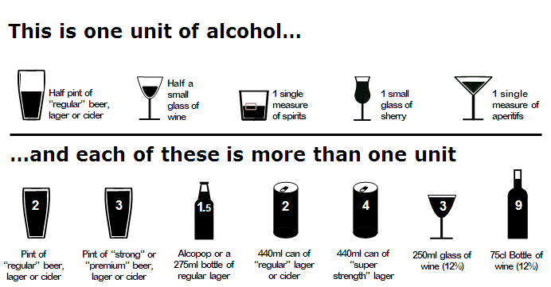

Alcohol
FAST | Scoring system |  |  |  |  | Your score
 | 0 | 1 | 2 | 3 | 4
How often have you had 6 or more units if female, or 8 or more if male, on a single occasion in the last year? | Never | Less than monthly | Monthly | Weekly | Daily or almost daily
Only answer the following questions if the answer above is Never (0), Less than monthly (1) or Monthly (2). Stop here if the answer is Weekly (3) or Daily (4).
How often during the last year have you failed to do what was normally expected from you because of your drinking? | Never | Less than monthly | Monthly | Weekly | Daily or almost daily
How often during the last year have you been unable to remember what happened the night before because you had been drinking? | Never | Less than monthly | Monthly | Weekly | Daily or almost daily
Has a relative or friend, doctor or other health worker been concerned about your drinking or suggested that you cut down? | No |  | Yes, but not in the last year |  | Yes, during the last year

Medical Information

As part of the registration process you may be asked to attend for a new patient health check. Please indicate below if you suffer from any of the following conditions:

Epilepsy Yes No Blindness/Glaucoma Yes No
High Blood Pressure Yes No Diabetes Yes No
Heart Attack/Stroke Yes No Depression Yes No
Asthma Yes No COPD Yes No
Cancer Yes No
Please list any medicines being taken and the amount [please continue on a separate sheet of paper if necessary]

Are you registered disabled? [If yes please give details] Yes No

Are you allergic to any medications and if so, which? Yes No

Have you ever refused treatment/screening of any kind and if so, what? Yes No

Women
Have you ever had a cervical smear? (If yes please state where and when) Yes No

Are you pregnant ? Yes No - If yes how many weeks?

ELECTRONIC PRESCRIPTION SERVICE
Newton Drive Health Centre is enabled for electronic prescriptions, if this is something you would like to take advantage of this service please state your preferred pharmacy.
My nominated pharmacy is:

Please note that the Practice policy is not to prescribe the following drugs unless you provide written evidence from your previous G.P.

Benzodiazepine including: -
- Diazepam Temazepam Oxazepam Nitrazepam Lormetazepam Chlordiazepoxide

Morphine Derivatives including: -
- Dihydrocodeine Codeine

Sleeping tablets including: -
- Zopiclone Zolpidem

These drugs can be dangerous in long-term use and all patients of the practice are required to commit to a reduction strategy.

We do not prescribe Methadone, Diamorphine or Buprenorphine (Subutex) at all.

UNDER NO CIRCUMSTANCES WILL THE PRACTICE REPLACE LOST OR STOLEN PRESCRIPTIONS.

Summary Care Records (SCR)

All patients have a Summary Care Record (SCR) unless you have chosen not to have one. Your SCR contains the following basic information: the medicines you are taking - your allergies - bad reactions you may have to certain medicines

It also includes your name, address, date of birth and unique NHS Number which helps to identify you correctly.

An SCR is used in a number of healthcare settings and will provide healthcare professionals with important information they wouldn't otherwise have. For example, when you're visiting an urgent care centre or being admitted to a hospital. Should you wish to opt out of having a summary care record please ask reception for an opt out form.

Patient Access

Patient access can be used for re-ordering repeat medication, booking routine GP appointments and some nurse appointments and updating your personal information: address, telephone number etc. by signing this registration form and providing us with proof of your ID we will automatically accept you for this service. For more information and details of how to log in please go to our website: www.newtondrivehealthcentre.co.uk

Detailed Care Record (DCR)

Patients may request access to their detailed care record through patient access, this provides an additional level of access above the standard online patient access. It includes coded information and documents. Please ask reception for further details.

* * * * * * * * * * * * * * * * * * * * * * * * *
The practice operates a call system where patients may be contacted to confirm the date and time of pre-booked routine appointments. Would you please confirm whether you are happy to be contacted for this purpose and if you are happy for a message to be left on your voicemail/answerphone from the surgery to confirm the appointment. [Unless otherwise indicated we will assume you are happy to be contacted in this way]

I am / am not happy to be contacted by the surgery to confirm a routine appointment.

I am / am not happy for the practice to leave a message on my mobile voicemail / home answerphone. I am / am not happy to be contacted by email at the address supplied.
[Please delete as appropriate]

Signature of Patient……………………….………………………………. Date………………………..

Print Name…………………………………………………………………………………………………………..

To be completed by receptionist. Initials:
NPHC APPOINTMENT (if applicable) Date : Time:
Type of ID seen

