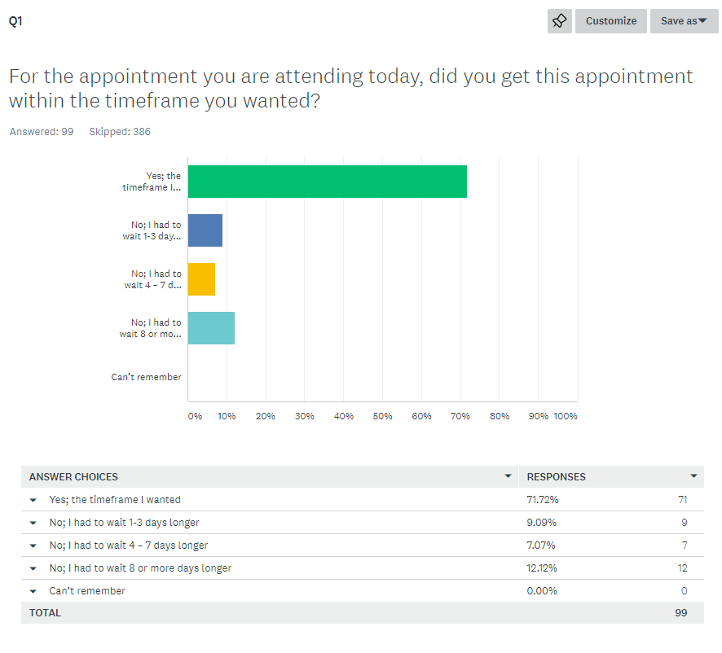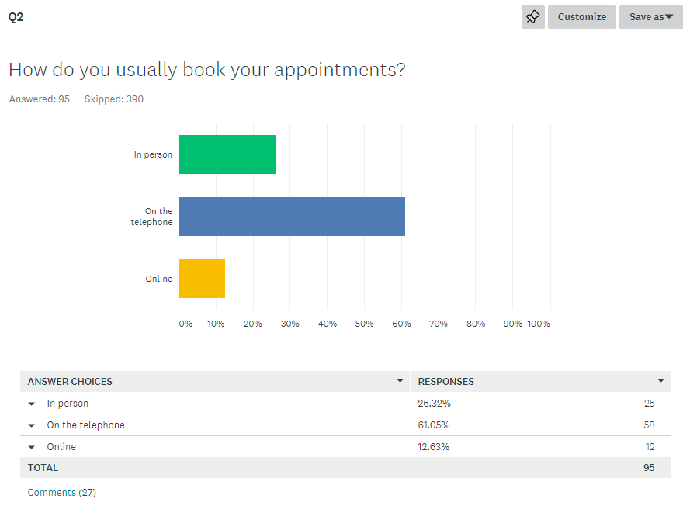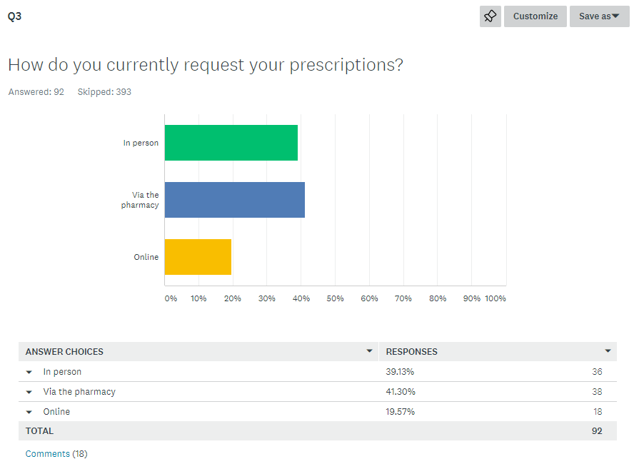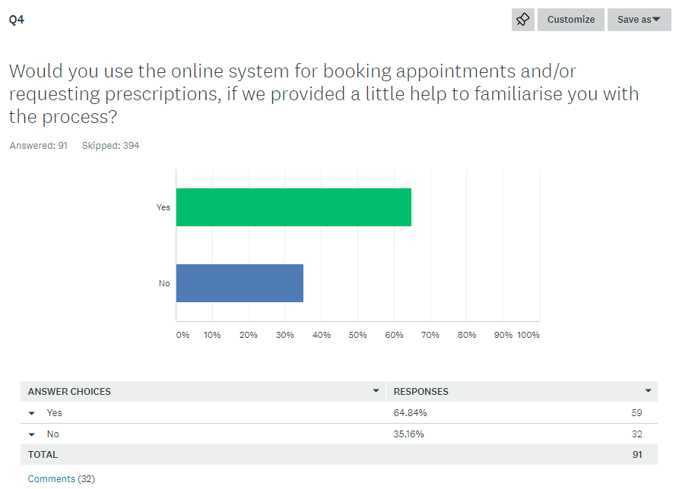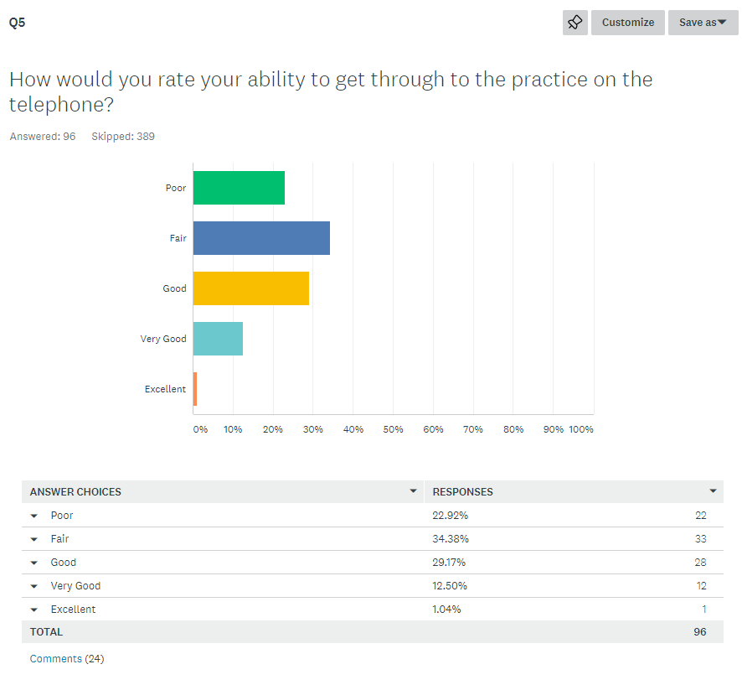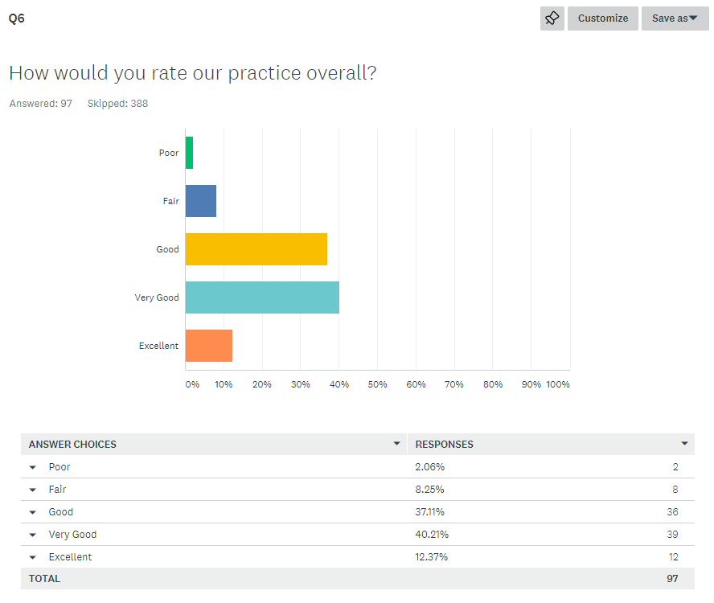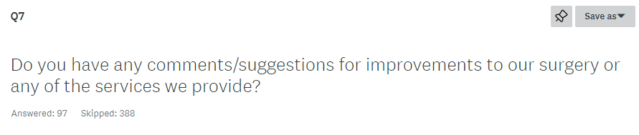
- contact patient if repeat prescriptions cannot be processed or if no longer available by prescription
- Fortunately I don't come to the practice often but you have given excellent service to my husband. The chairs in the waiting hall look well worn and it is a loss that Lloyds chemist is no longer on site. I would welcome a 'well woman clinic' as when I asked for an appointment, it was no longer available. It is a false economy!
- 24 hr surgery, or at least longer hours for drop ins.
- A better way of ordering prescriptions, eg by phone
- A need for shorter waiting time for appointments
- Ability to book appointments online and in advance
- advice on how to book things on internet.
- Alert system to let you know when prescriptions are ready to collect from pharmacy. I have gone multiple times and they have received my prescription (4-5 days after requested.).
- Allow next day appts. Expecting sick people to queue at 8am for same day appt is ridiculous
- Always found disclosing private information to a receptionist uncomfortable, especially in a echo'y room
- Always had good medical service here, once you are able to get an appointment
- An idea of when the duty doctor can call would be helpful and if I've missed the two attempts at a call back, eg toddler needs something urgently, then you need to go through the whole phone process again and even though I've called straight back, I've missed my chance. A way of giving a time for the callbacks would be so helpful.
- Another receptionist dedicated to the telephone
- Appointments that can be book on the day for after 5pm and plenty of appointments. AND pharmacy on site.
- Availability of appointments for people who work full time.
- Be good to have the pharmacy open again
- Being able to make .........appointments via the telephone would be very helpful. It's difficult when you are working to be able having fist thing in the morning and hold the line waiting for the queue.
- Being able to see the doctor you want, and to see without waiting 14 days or more.
- being guided to pharmacist first when conversation with doc would have resolved it.
- Better car park facilities
- Better coordination of prescriptions and medications in a dossett box, particularly when adding new regular medications. Why can only the surgery organise the dispensing of Dermacream? Why spend more of our time and yours dispensing it?
- better phone system
- Better tie up with results and need to book appt. Texts have been confusing at times, needed to call as incorrect info. Having same Dr may help
- better time keeping
- booking an appointment with the doctor is very difficult time scales, availability too long
- Booking appointments
- bring back the pharmacy
- Bring back the pharmacy.
- More access to urgent appointments
- Calls to be answered more quickly. Usually takes 15 minutes.
- Can never get an appointment other than 3 weeks, hence cannot discuss problems. When do get an appointment as can only discuss 1x problem. No follow-up - EVER - NONE.
- can't make appts for children online
inability to get sameday appt
length of time it takes to get through on phone
- Change the way you book appointments. Last time I tried to book I was offered an appointment four weeks later. If possible have more full time doctors
- charge for missed appointments and give the proceeds to charity
- Consistency of same GP.
Reception need to smile more, listen more.
- Continuity of doctor would be more useful. Employing receptionists that are helpful would be an improvement
- Difficult to get an appointment in a reasonable timescale unless it's very urgent.
- difficult to get appointment on preferred day
- Difficulty see same GP regularly - not sure how this could be resolved though. Improvements have been made to telephone system but still difficult to get a same day appts when (rarely) required.
- Doctors seem to care more about time that patient. Appointment system doesn't work for me at all
- Easier phone access. Needed to see a doc about 2 things. Was told couldn't have double appt,; that 1 appt wasn't enough, so had to book 1 appt at 9am with 1 doc, and 5.30 with different doctor
- easier to get through for appointments
- evenings and weekend appts - need more of for them not to be allocated to non working patients.
- extend hours for routine treatments such as blood tests
- For children's appts you can only telephone surgery and can't use the online system. This makes it difficult to get an appt.
- for the nurses to be able to do multiple tasks as in vaccinations etc to save having to book multiple appointments
- Getting an appointment for a blood test is very poor. Always a long wait (2 weeks)
- Getting appointments are difficult. Needs to be more consistency of doctor seen with long term disability, it can be difficult seeing different doctors all the time with complex history and waiting weeks if want to see the same doctor
- Had to wait for a telephone appt for 3wks.. could get a face to face - 2wks. Only needed telephone (required by doctor) but had to come in and see one as needed quicker. Was told one blood test needed to start treatment then 2nd doctor said it's 2 for some consultations. Continuity is key - I work in Cardiff. Drs are amazing - Dr Pullen - best.
- I believe the receptionist are now taking any minor medical queries, would be good to have availability at a basic line i.e. chasing prescriptions etc.
- I can appreciate the reception team face pressure as we all do at times when I have have tried to book appointment.
- I don't know what to suggest but in my opinion, the doctors are fabulous at this surgery but trying to get passed reception is hard work and often I find them not nice/sympathetic. Got told I had to come in to request a telephone call even though I was on the phone to reception. Just seems absurd and not efficient.
- I don't like the discussing at reception, why I want to see the doctor. It's a private matter that I feel should not be discussed in front of the waiting room.
- I have always had a very helpful experience
- I have always had very good care and think everyone is great. The phone system is terrible though and if you want an appointment for something that perhaps isn't urgent, you can wait a long time. Saturday/Sunday opening would be good.
- I have been coming here for years. I think the staff are friendly, helpful and very patient. Thank you for your kind and professional service. I realise that there are huge demands placed on the service and understand why I can't always get appointments. To be able to use a variety of booking methods is very valuable.
- I have waited nearly five months to access my medical record
- I know it can be tricky getting appointments sometimes
- I think it is sometimes hard to get an appointment. I have to walk and queue up before 8 in the morning. I do not have a car so I have to walk, which is not nice when it's raining.
- I think it's out of practice control for any improvements, eg budget
- I think you should charge people £20 when they miss an appointment with the GP
- I would encourage use of e mails as another form of booking
- I would like it easier to see 'my' GP' to ensure continuity, much less stressful too.
- I would like to see a GP consistently. I think building a relationship is good and they will know more about my background
- I would like to see the same doctors if possible
- If a doctor requests a follow up meeting with you, then they should book it there and then with the patient.
- If it happens that appointments are running late, would it not be possible to inform patients so they can decide if they want to rebook?
- If the doctors asks you to come back within a certain timescale it is not always possible to book this at reception, which is very frustrating. Also there are times when I book an appointment when all I needed was a conversation, but I am not able to book a call.
- If there were a doctor that was at this surgery in the mornings maybe twice a week, that patients could queue for, it would help with immediate symptoms which could be seen.
- If we can make booking for Doctor. Make it easier for working person to book a time and day suitable
- If you are going to advertise appointments online, it needs to be realistic. Having to try to get appointments on a first come first served basis is ridiculous for those who work. Can't be trying a lottery at 8am
- If you cancel appts (ie the surgery) could there be a preferential system for rebooking. I have had two appts for my children cancelled. On one occasion I phoned to try and rebook, and could not get through. I then walked to the surgery to find you had a training session 12-1pm. I could not rebook a cancelled appt.
- Improve appointment making - more people answering phone. Having to be there at 8am to get an appointment and then queue when you are ill is ridiculous
- improve online facilities
- improve seating. bring back chemist and tell people about delays
- improve waiting time for routine appointments
- Improved booking system. More appointments readily available on line.
- Information is difficult to obtain e.g. referrals take too long and consultant reports take large amounts of time to get into the system leaving patients in need waiting for too long
- Insufficient appointments for people who work full time.
- Insufficient available for same day appointments. This is not acceptable. On one occasion told to go to A&E
- It has proved difficult to access district nurses. At times I have required a home visit but I have not been successful in getting one. At 93 it has been necessary to attend a nurse on site!
- It is difficult to make appointments for non urgent matters. But I'm not sure what the answer is
- It is very difficult to get an appointment for adults. Response time for children's appointments is excellent
- It would be helpful to get same day appts but without having to come into the surgery at 8am in the morning. Very tricky when you have young children
- it would be useful to be able to book telephone consultations online
- just appointment booking. You need more capacity for same day appointments for urgent/child illness
Allocated doctor
- Just the phone system. Rather than being put on hold then having to answer. There must be a better way.
- just the phone system. Rather than being put on hold and then having to answer. There must be a better way.
- Keep up the good work
- less of a barrier to get through to reception on the phone. The disclaimer on the phone is too much.
- less wait times.
clock in reception
not to feel rushed during appoints
more online appts
- longer hours, weekend appointments
- longer surgery hours to accommodate people who are working
- make it easier to book online appointments. Sometimes you can't get an appointment that day or next day
- Make it easier to obtain an appointment with doctor of choice
- make more appointments available
- Maybe make more next day, same day appointments online instead of waiting sometimes weeks.
- Medical staff are very good but sometimes find it difficult to get our message past the reception staff. Feel like we can be judged. It's probably due to their workload. Reception area is not very private
- Medical staff very good but admin, whilst all seem like nice people, are hampered by systems/technology rather than helped.
- more appointment availability
- more appointments available online. Ability to book telephone appts online. Think people would use these more in first instance - help to get right help quicker ie see right nurse/doctor
- more appointments on line, waiting times better for getting blood test results in the afternoon. more HCA for T/room B/T etc.
- more appointments. more people answering phones. too long waiting to get through
- More appts on the day. More online bookable appts 2-3 days in advance. Better telephone lines, ie more people answering phones at peak times. Nominated GP to aid continuity of care - never see the same doctor. Appts in evening and weekends. Employ GP's that seem interested in people!!
- more availability of appointments and more available via app, particularly when wanting to book a future appt. Current system is frustrating and stressul
- More doctors and nurses, so more appts can be offered. Not adequate for a town of this size. My partner is with PMG and is always offered an appointment the same day. this never happens here. Once here the service is excellent, it's just the poor booking. Phoning at 8am for cancellations is not practical for most people who have work, school etc.
- More doctors and staff. Less patients!!
- more doctors who work days of the week. difficult to build relationship with doctor
- more doctors would help
- More doctors. Less waiting time. Means less visits to A&E. Often little choice or chance of seeing same GP
- More evening/weekend appts. More receptions to answer phone calls
- More GP's. Longer hours to accommodate
- more late appointments
- more mail doctors please
- More online appointments - esp for nurses, blood tests etc. More people answering the phones
- More online appts available to book. There appear to be different ones online to via phone, particularly at 8am.
- more out of hours appointments. Working full time is difficult and often I just don't bother to make an appointment.
- more parking
water machine in waiting area
pharmacy next door again!
- more receptionists
- more staff to take phone calls and desk enquiries. Maybe one extra person would make a difference.
- more time with GP's. more available appointments
- NHS should charge for GP appointments
- No improvements but I'd like to congratulate you on such a great front of house team - very refreshing after my last doctors' surgery.
- no. Happy with the services
- Nurses excellent. Some doctors excellent.
Some doctors don't have the medical records or not familiar with the patient.
- Obviously appointment systems could be improved. Usually I would prefer to see the same doctor every time. If i miss an appointment Would prefer to pay a small fine.
- offer more appointments to book online
- On arrival at the surgery, logging on at the machine says 'on time' which should indicate if the doctor is running to time. It is used to tell the patient they are on time which is pointless. This software is being incorrectly used.
- Once had very poor experience with receptionist who was extremely rude and discussed my health issues very laoudly and publicly - considering I had a miscarriage it was very poor conduct. Also find they don't help when trying to make appointments and understanding people who work shifts etc. Doctors have always been fine with me.
- Online booking for same day appointments would help
- Online bookings should be for doctors only!
- Only got quick appt because doctor wanted it.
1. Remember your patients also have full time jobs.
2. Don't patronise
- Open earlier and later, 7 days a week
- Open the surgery on a saturday to cater for people who work full time and can't always take time off work
- Phone service has improved but still hard to get through
- Please give us back our in house pharmacy
- Please make more appts available for patients who work and want to carry on working but need to see a doc for follow ups, annual check ups etc. It is impossible to phone every day to get an appt when you are working.
- Please note that it is the vulnerable who cannot use computers who are penalised in the modern system. Deaf or not capable of using computers. it is not right that people who wait outside should be last to make appointments in the morning.
- please reopen pharmacy. It was a godsend. Now a total waste of space. Seats are very tatty but it's a minor issue. Staff go out of their way to help me, particularly in reception.
- Please, please, please, let us see the same Dr who knows me/my family/my story - like the old days when a doctor knew the background without repeating the same story about our problems. This has got to save time and pressure. Like the soothing music!
- Privacy at the desk is always an issue. I know Peta is looking at this.
- Privacy in the waiting room. People can hear personal discussions face to face and on the phone. Not very nice when handing in samples. Too much queuing on the telephone. Too long to wait for appointments
- Probably not feasible but it would be nice to see the same doctor if possible. So far in five visits they all have been different, but most helpful.
- promotion of online appointments - I am unsure whether these can currently be made
- providing I can see Dr Allinson, practice is excellent
- quicker appointment times please
- rarely use the practice so unable to comments
- receptionist should do what patient needs and asking for, and not what she would like us to do.
- refurbishment
- same day appointments are very hard to book. |I think you should perhaps offer a 10-11.30 sit and wait service?
- Saturday appts would be very helpful
- Saturday surgeries, budget permitting. Perhaps paid/fixed free for weekend surgeries for those who can afford it?
- Sometimes appointments for future dates have run out and no more available until next day.
- sometimes difficult to get doctor's appointment in reasonable time scale
- Sometimes it is not appropriate to tell receptionist your problem, as the reception is very open and echo's
- specialist clinics. prescribing nurse. clear patient pathways on illness - show how you do things/make decision on your website/waiting rooms.
- Stop repeat patients booking when well. Can't walk to practice before 8am to get appt as 84 yrs old and appts always gone by 8.30, if able to get through on phone.
- Telephone access
- Telephone booking. I understand that it is difficult to meet the demand but I work and arrive there at about 7:50am. I can't wait on the phone for an appointment at that time and the alternative is nothing or a ten day wait.
- Telephone lines
- The chairs in the waiting room are looking a bit tired. Maybe some new ones?
- The obvious answer is as the size of Portishead has grown, do we have sufficient doctors and nurses to cover the population?
- The online booking is usually excellent but this morning I logged on at 8am and no appointments for the day were available. However, when I got through on the phone the receptionist I spoke to and later the duty doctor were both really helpful in getting my son seen as he is a baby
- The phone lines
- The phonelines can be extremely busy in order to make appts. As a parent of young children this can make the experience of calling the GP a little stressful. I understand that services are stretched at the moment. I do however, appreciate the opportunity to have a GP call back for a telephone consultation.
- The team are all great - I get good service and all the staff are helpful and professional. It would be helpful if you were open later.
- the telephone booking system
- The website could be a bit easier to navigate
- There seems to be a shortage of male doctors
- They are doing their best with the resources available
- Think doctors have too many patients in the area to cope with.
- Think doctors should be able to book appointments there and then if they want you to see them again. The current process seems quite flawed, and the gatekeepers on reception decline your request to see a specific doctor even if it was asked for. Also seeing another doctor becomes quite a lottery dependent upon the quality of the notes entered by the first doctor.
- to be able to book appointments the day before for the next day
- To be able to see the same doctor I usually see for feminine hygiene (ie smear) appointments would make me much more confident about come to them.
- To have more telephone staff available, as sometimes long wait on phone
- to include more alternative therapies
- to make it easier and quicker to make appointments. I would also like to see the same doctor on all appointments
- to see same doctor
- treatment very good, once you are actually able to book an appointment.
- Turn the music OFF
- Vaccination appt times limited to certain days.
Emergency appt process first thing in morning can be a bit stressful getting through on phone
- very good
- very long wait for blood tests
- Very poor practice overall. Can never get an appointment other than 3 weeks hence. Cannot discuss problems - when I DO get an ppointment as can only discuss one problem. No - follow up - EVER - NONE
- Waiting outside at 8am to book appointment. Speedier return of prescriptions. It says three days - lucky if it's a week.
- We could do with our chemist back. Also would like to see the same doctor each time I come.
- weekend availability for those working during the week?
- When booking online there are often no appointments available
- Wish I could get appointments more easily
- would be good to have the pharmacy back at Harbourside. Good to have everything in one place.
- Would like more slots available for non-urgent appointments. Think the waiting room is looking tired and shabby!
- would like to see same doctor for continuity
- Would love if the surgery was open on Saturdays but understand it may not be possible.
- You used to give me an annual blood pressure/test/cholesterol test, which I thought was good, but this has stopped.
- Young people are more likely to pick up the SH/chlamydia test kits if they're not at the front of the surgery, in front of everyone. Should be at the desk - it works at my uni.
