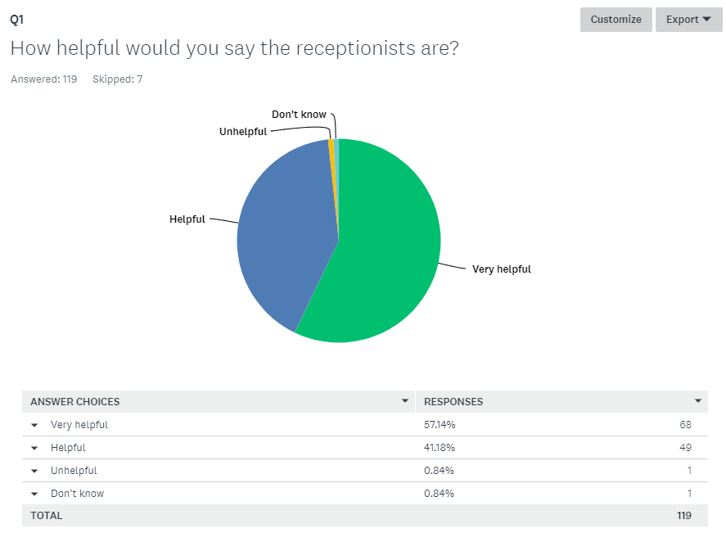

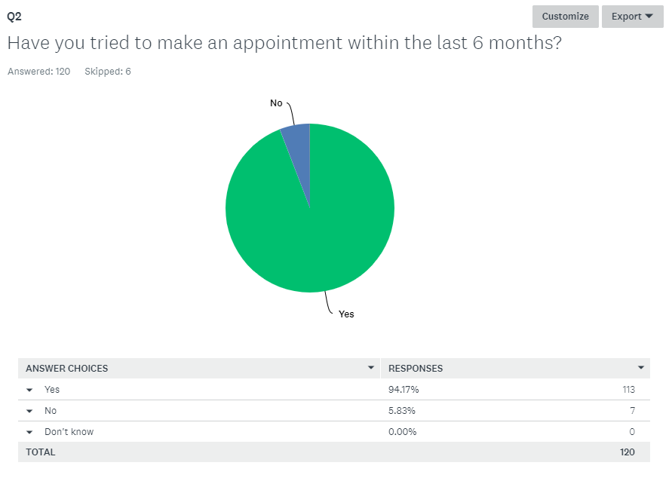

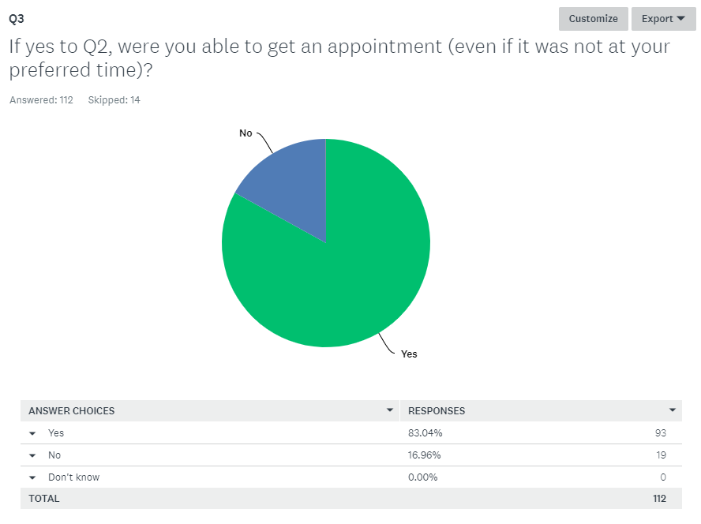

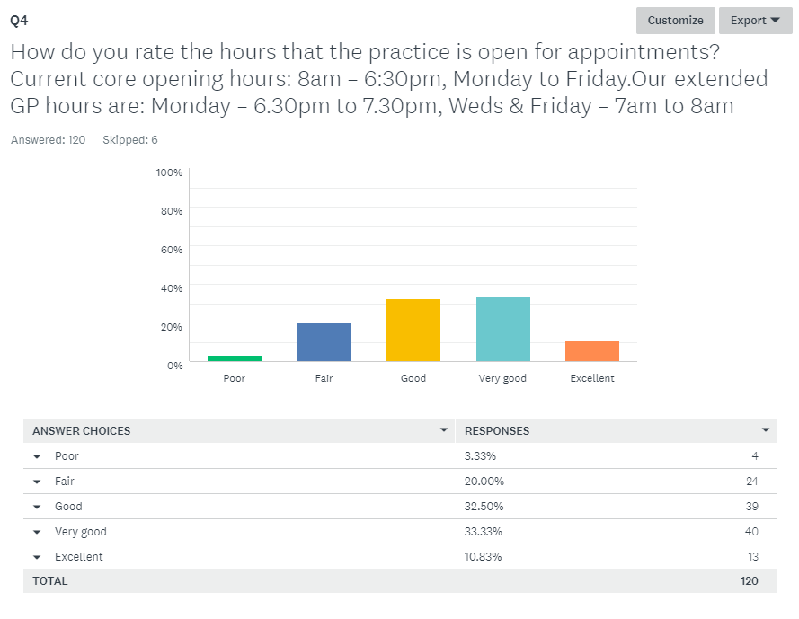

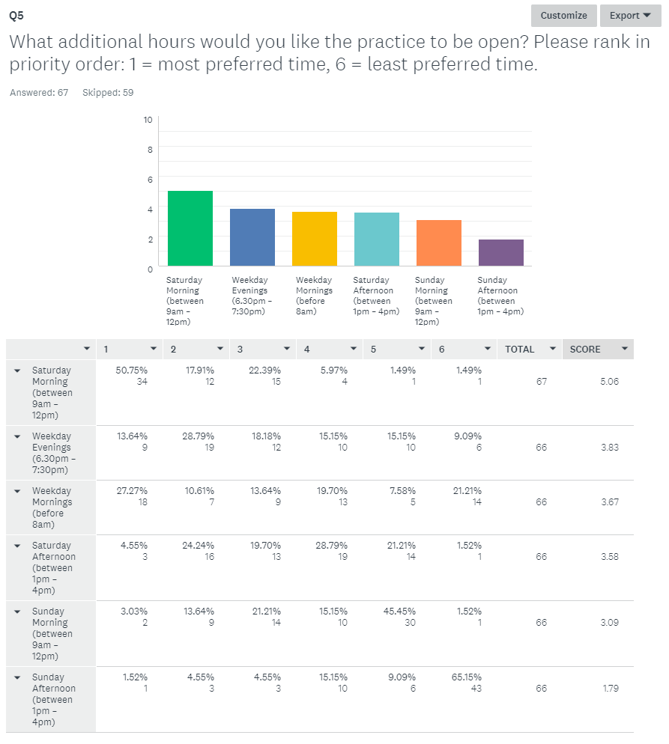

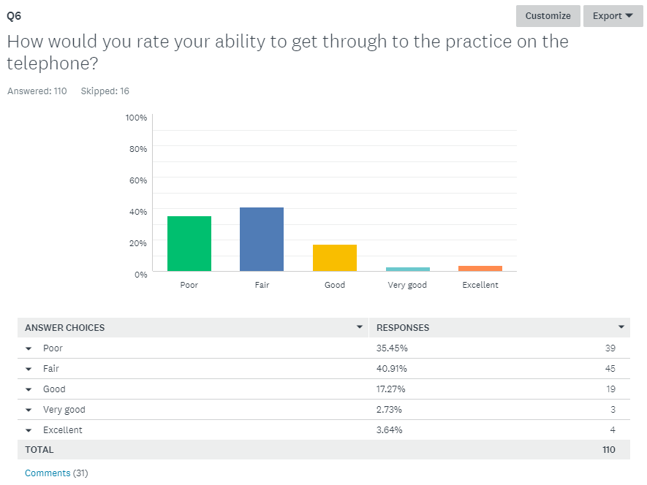
- Always walk round live close by phoenix way.
- Very Frustrating. I walk down to speak to them
- Takes over an hour to get through or just goes off when busy
- I have found that the only way to get an appointment recently is online as the phones are often so busy at times I am unable to ring that I don't get through.
- It varies considerably
- At peak times in the morning you can sometimes take 15-20 mins to get through.
- Can never get through at 8am for same day appointment
- Horrendous to get appointment at 8am.
- Frequently engaged or disconnects - always make appointments online or in person
- Can be a nightmare and ring for ages
- Call in morning at 8am. When call as instructed, no appointments left.
- Although you have to be smart about not ringing first thing or late in afternoon
- Often no answer or engaged but has improved in the past few months.
- morning impossible to get through
- long queues at times
- always busy
- Phones always engaged
- Depends what time you call
- Early 8am, cannot get through.
- Much easier since number change
- Sometimes difficult
- Would have been poor but I got through straight away today so a huge improvement
- Can take several minutes to get an answer at busy times, i.e. first thing in morning
- takes too long
- Phones ring forever - please sort your contract out. New number - I found on Facebook through hello Portishead!
- Haven't tried the new system. The old one was completely useless.
- on the phone more than 30mins on 26/4/18 trying to get through
- Try a couple of times, if urgent will keep trying, then book online.
- This is the worst thing about the practice. Although if /when I do get through, the receptionists are helpful.
- I tend to arrive before 8am outside if an urgent appointment
- very polite and helpful

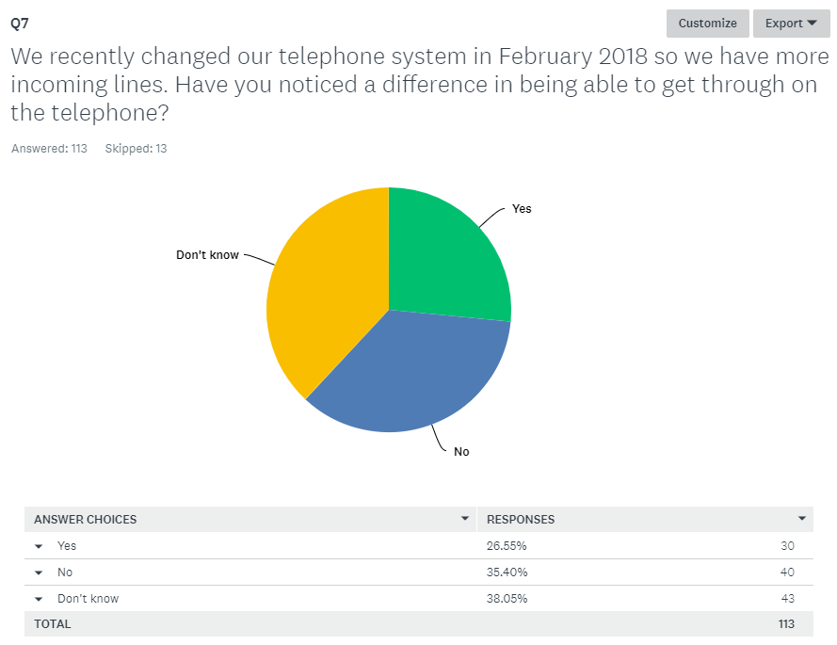

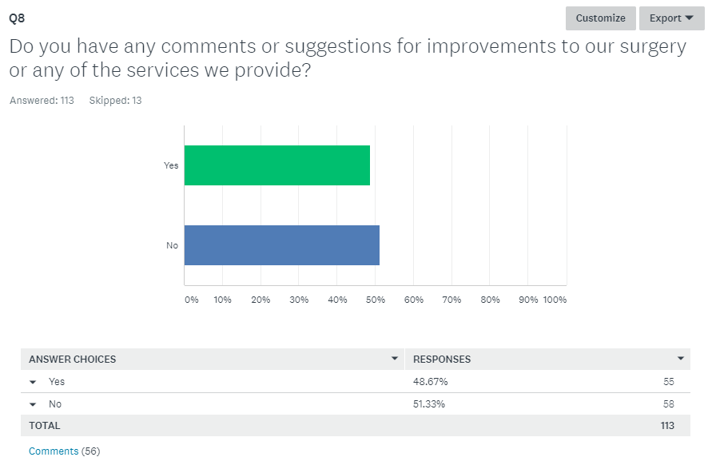
- I always book online appointments. Existing opening times are fine
- Online could be better not many appointments on there to choose from for example Dr Ashley online? Weekday evenings, sat mornings and sun mornings, my son is a diabetic and cannot get to see GP as he’s always working so the above hours would be useful.
- To get through better as can’t get down practice by 8am with two young children so getting through on telephone better
- Offer more appointments online
- More privacy when speaking to receptionists. Reception is very noisy especially when you feel very unwell. More organised display boards. Staffs are so committed and helpful in tough situations - Thank you.
- A way of saying how long a wait doctors get busy sometimes you can wait 20-30 mins. It would be good to know expected delay.
- Disappointed that the Lloyds pharmacy ha now closed.
- I was told by DR to buy hydrocortisone cream for my daughter age 9 no prescription provided. It is not licensed to sell to under 12s.
- Phone impossible - Come down to make appointment
- Apart from opening times, I think the services provided are good
- Music in the waiting room
- Need to get through quicker on the phone
- Waiting time. Not able to book ahead. More difficult to book appointment.
- It's an excellent surgery, no complaints
- I am new to the practice so need more time to properly evaluate the services offered.
- Accept my request for meds when I need it, I know when I need it.
- more appointment accessibility and choices for appointments
- Typically trying to get a standard dry’s appointment can take 2-3 weeks in my experience, unless I call on a day and ask to speak to duty doctor. I often feel bad about this as my condition would not be an emergency, but I couldn't wait the 2-3 week alternative. Early or late appointments work well for me and my family as my husband and I both work full time.
- You have covered the main area for me - being available outside of normal working hours, including Saturdays.
- Difficulty to get appointment with specific GP. Must remember how appointments are released.
- more phone lines in, more appointment slots
- More urgent appointments available on the day pick up phone.
- Engaging with Portishead residents through social media i.e. 'Next door' and 'hello Portishead fb page' to share useful tips/information especially when there is a bug/virus doing the rounds may help reduce pressure on the surgery? Just a thought :)
- if I have an appointment with nurse for blood test then appointment for results, then unable to book any further appointments online
- Make it easier to book appointments
- more doctors, guaranteed appointments within 5 days
- More phone lines or staff answering. Phone lines are always busy then the receptionist asks what's wrong, I think it is wrong as it could be personal. Waiting area for children is dirty and poor effort of toys/books. I know it’s not a play area but sometimes you could be waiting more than 20/30mins to be called. Bring back a chemist.
- more online access
- More flexible opening times
- More opening hours and weekends.
- More information and training on drug (abuse) related patients for doctors, more understanding from doctors in regards to comments above. Stop working alongside ADDACTION.
- I do like the queue system on the telephones
- Phone lines answered quicker, waiting times for appointments to be monitored, access to 1 GP only, more online appointments to be available.
- adult appointments more available, children are very good though
- Make it easier to get appointment with same doctor. NB: no appointment but very pleased that there was a ring round and appointment was found. very happy with diabetic nurse
- Patients with known complex or multiple conditions be allocated to a dedicated doctor. This would save so much time going through everything with different doctors.
- Some chairs with arms
- aircon
- Make appointments easier for emergencies
- More appointments available on the day
- Parent and child parking
- Have full tie doctors who have own patient lists. currently no overlap or coherency
- I'm new to the practice - it has worked well for me so far.
- How about embracing technology: facetime appointments for minor illnesses. Podcasts on your website for minor illness. Specialist clinic drop in days (asthma for kids, INR, orthotics etc.). Please run on time - 15mins waiting time max on all appointments as I have waited over an hour before now.
- I have always thought that our doctors are extremely good. I sometimes hear negative comments and couldn't understand why. Would highly recommend to others and feel our family are well looked after.
- I came to the practice for the first time in Feb18 and had to come back a couple of times (due to condition). It's been a very good experience all the way through - staff at reception always very friendly and ever so helpful, doctors very good, too.
- We have used the surgery a lot and found them very good generally. There have however been 3 times I can count where referrals or follow-ups haven’t' happened or been missed and I have had to call to get it done.
- I often had to queue outside for up to half an hour (7.30 - 8.00) to get an appointment. In winter this is horrific - cold windy and wet. If we have to queue, this should be somewhere sheltered.
- Sharing availability of dr appointments at another practice. Patients just need access to a dr!
- Very difficult to see same doctor especially as most part time. Would be helpful if more appointments were made available and not held back. Also to have to wait outside at 8am to get an appointment is not good (especially if you are feeling unwell).
- No appointments just come and wait to be seen. Less waste of time with DNAs. Was registered at Whiteladies road health centre and this worked well. Close off number of people waiting at a certain time.
- waiting times every time myself or children come to an appointment we book in, it says they are on time but we have had to wait over an hour before we are seen which the kids get bored
- Very pleased we have another couple of nurse, as when Belinda left, had to wait a long time to see anew nurse, but very pleased with the results.
- Please stop people parking in the little area next to the disabled spaces. It's not a marked space but there are always cars there which make getting in and out unnecessarily difficult. Better children's play area please.
- The waiting room can get very hot when sun is shining through windows and the check-in point is very close to seats which is a bit awkward
- please keep doing the wonderful job you are currently doing

