Covid Vaccinations Update

- Our vaccine centre has now passed the 80000 doses given. The success of this programme has been driven by the support of our communities, our volunteers, our health staff and our patients.
- We are looking forward to seeing you for your second dose shortly. We enclose a list of our dates below which shows you when your second dose will be.
- Your appointment will be at the same time as your first dose.
- Please do not turn up at any other time as we cannot guarantee you a vaccine.
- If you have forgotten your time or wish to check your date, please call us on 0333 332 0855 and our team will be happy to help
- Similarly if you are over 50, or with underlying health conditions we can get you booked in for a first dose, please call us on 0333 332 0855.
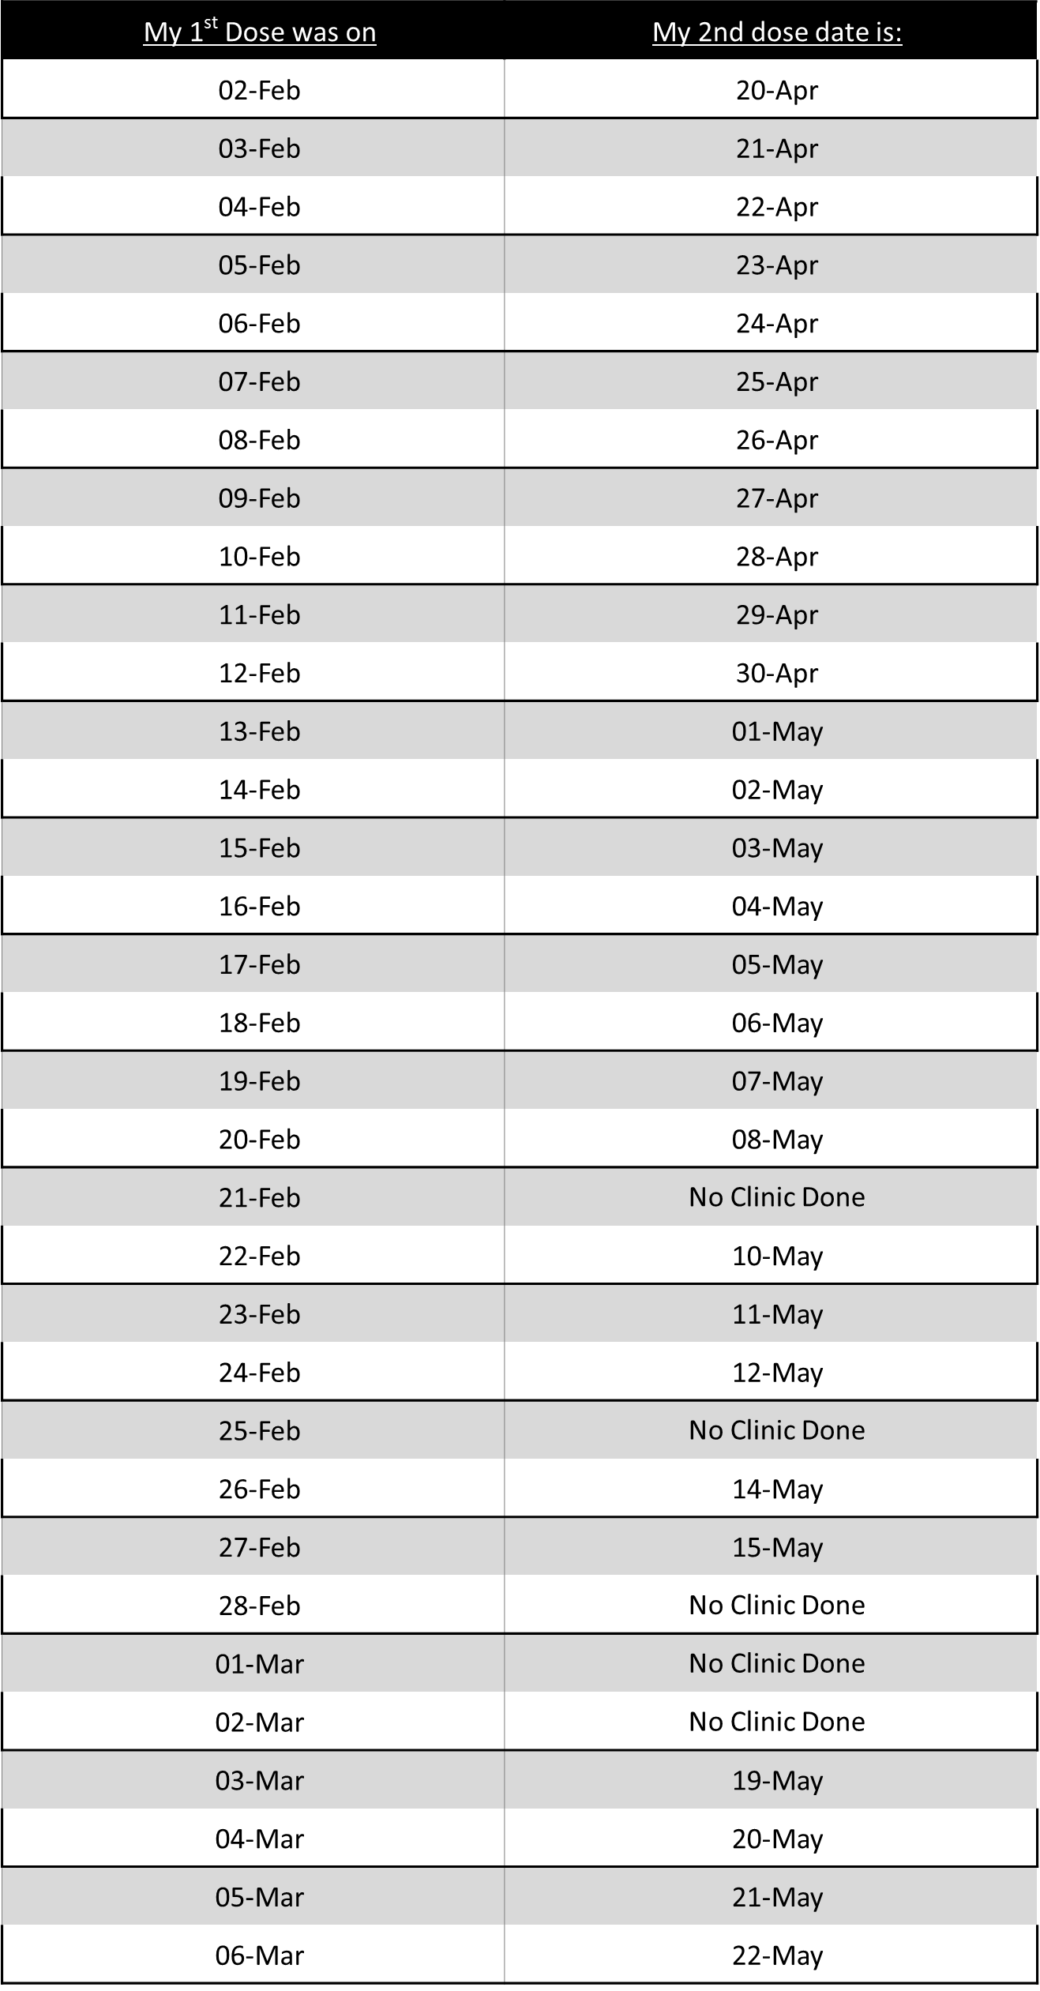
- Vaccines are helping to keep us all safe.

