NHS App Guide

- Get the NHS app
Download the NHS App from the Google Play or Apple app store.
- Find your GP surgery
The app prompts you to find your GP surgery: enter RG22 4EH
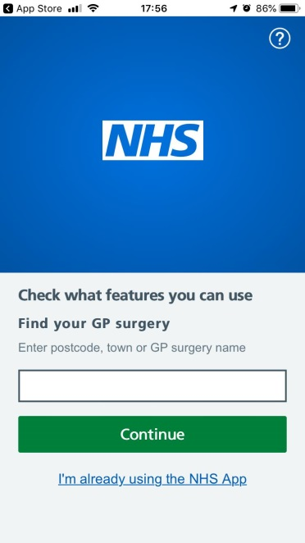
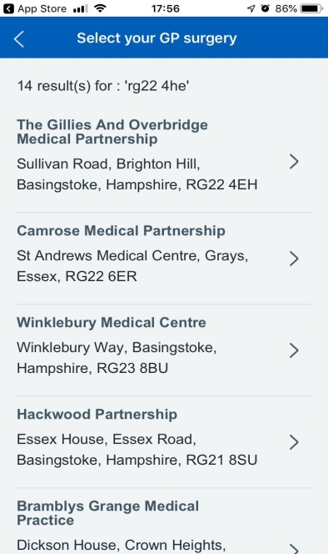
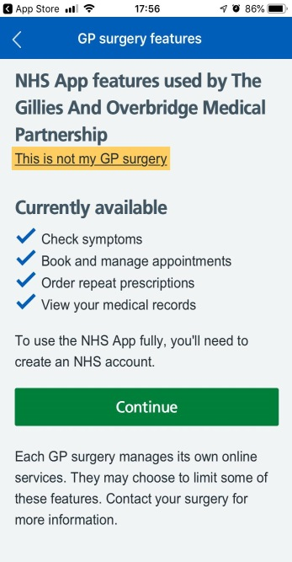
If it is not yet connected, you can choose to enter your email address. When the surgery is connected, you will be sent an email telling you that all the features of the NHS App are now available to you. You will be asked if you have an NHS login

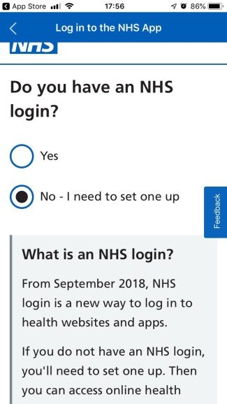

As the NHS App is the first live service to use NHS login, most patients will have to set one up, step 3, but if they have already done this they can log in and go straight to step 4, proving who they are. Some patients may set up their NHS login when they first download the app, and come back to prove who they are later, when their GP surgery is connected
- Set up an NHS login
You will be asked to set up your NHS login by entering an email address and password.

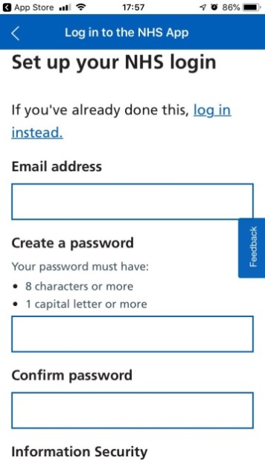
You will be asked to agree to the terms and conditions and click to continue.

You are then sent an email. You need to click the Confirm button in this email to confirm your email address.
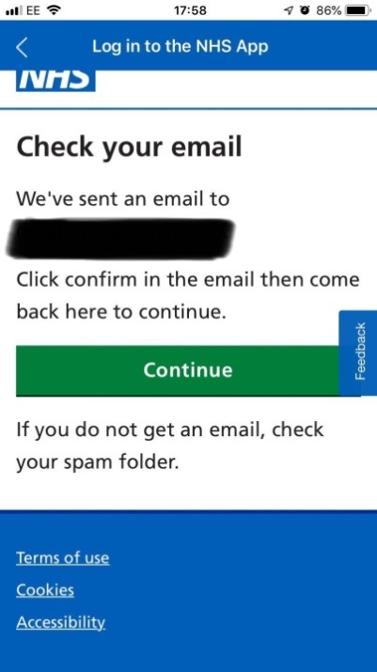

Clicking the button takes you to a screen in your web browser, which tells you that you have confirmed your email address and should return to the NHS App.
When you next open the NHS App, you will be asked to log in with the email address and password you previously entered.
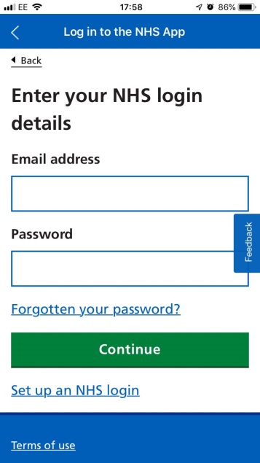

You are then asked to enter your phone number.

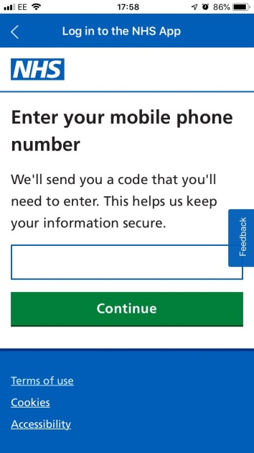

A 6 digit code is sent to this phone number, and you will be prompted to enter it and press continue.

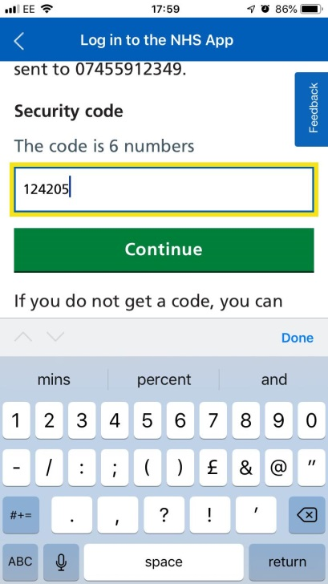

- Prove who you are
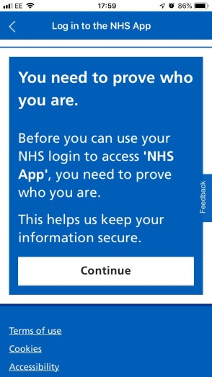
You will then have to prove who you are so that you can be given secure access to our online services. This can be done in 2 different ways:
- by entering the details given to you when you registered for online services.
- by proving your identity using photo ID, through NHS login
You will first be asked if you have signed up for GP online services and have the 3 registration details:
- Linkage key (could be called a passphrase)
- ODS code (organisation code or practice ID)
- Account ID
These are the details we give to patients, after confirming their identity, so that they can access any other online services.
If you choose Yes, you will be taken to a screen to enter the details.
If you choose no, you will then be taken to the next screen which tells you how to prove who you are. There are 3 steps to this process.
- Enter your demographic details so your GP record can be found – your NHS number (if you know it), or your full name and postcode (which must match the details held on your GP record).
- Take a picture of your photo ID document to prove who you are – you will be given instructions and a chance to check it, before you submit it.
- Take a short video of yourself communicating (by saying or showing) 4 randomly generated numbers provided by the system, to prove you are the same person featured in the photo ID you will be given instructions and a chance to check it, before you submit it.
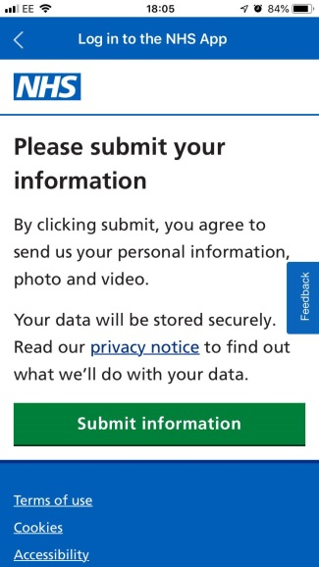
Your details will be checked and your application will be approved or declined. The checks should be completed within 2 hours, and you will be sent an email telling you if your ID check has been successful.
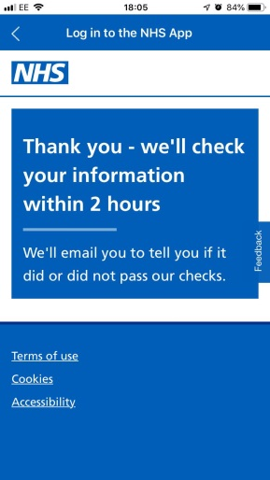

If it has not been successful, or if you do not have the photo ID, or cannot use the online service to prove who you are for another reason, you will be told to visit the GP practice and complete an Online Application Form. We will then confirm who you are and will give you your GP online services details, so you can use them to set up your NHS App account
5. Log in and use the NHS App
Once you have completed these steps, you will be able to use the NHS login to access all the features of the NHS App, including appointment booking, managing repeat prescriptions and viewing your record.
You can choose to:
- continue using two-factor authentication to log in each time you open the NHS App, entering your email address, password and 6 digit code sent to your mobile number
- set up fingerprint or Face ID if your device allows it

You should now be set up to access booking appointments (you will only be able to see your usual GP and non-list GPs) and blood test appointments. You will also have access to requesting repeat prescriptions.

