OPEN DAY AT WAWN STREET SURGERY

WEDNESDAY 6TH SEPTEMBER 2017
10AM – 4PM
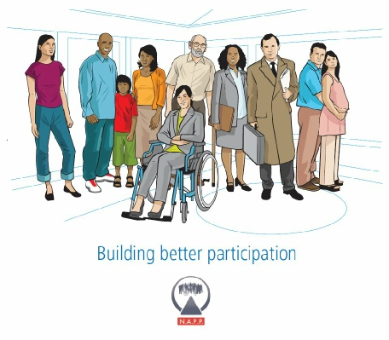
MEET NEW PEOPLE
MAKE A DIFFERENCE

HELP SHAPE THE FUTURE OF YOUR SURGERY
SHARE IDEAS

JOIN OUR PATIENT PARTICIPATION GROUP AND WAWN STREET SURGERY

WORKING TOGETHER TO IMPROVE AND DEVELOP PATIENT SERVICES

MORE INFORMATION ABOUT THIS EXCITING PARTNERSHIP WORK CAN BE FOUND AT
www.napp.org.uk

